Wallington High School for Girls

Ella HORNE

Candidate number: 3309

NEA

Computer Science GCSE Quiz

Contents

Analysis 3

Overview 3

Client 3

Background to the Problem 3

Description of Current System 4

Identification of Prospective Users 4

Current system flowchart 5

Identification of User Needs and Acceptable Limitations 6

Data Source and Destination 6

Data Volumes 7

Data Storage 8

Data Dictionary 9

Entity Relationship Diagram 11

Research 13

Interview with primary client 13

Secondary client – Yr 11 GCSE Computer Science student 15

Questionnaire 16

Existing System 20

Types of question 28

Objectives 35

Solution Overview 36

Design 37

Overall System Design 37

Modular Design 38

Form based design 38

Definition of Data Requirements 39

Definition of Record Structure 40

Validation 41

File Organisation and Processing 43

Database Design including Normalised Relations 43

Samples of Planned SQL queries 45

Select 45

Insert 46

Update 46

Delete 46

Data Definition Language 47

Types of question to be expected 48

Identification of Suitable Algorithms for Data Transformations 50

Key Data Structures 55

Class Definitions 56

User Interface Design Rationale 58

Client communication 62

Technical Solution 67

Testing 68

Evaluation 73

References 73

# Analysis

## Overview

My project is based on supporting student education within Computer Science at a GCSE level. I aim to provide a question system which helps students to assess their current subject knowledge, and allows a student to view their progress over a period of time. The reason behind this is due to the lack of effective Computer Science resources at GCSE, and the difficulty of the subject. I also aim to support teaching at a GCSE level for Computer Science in order to ease work load for both students and teachers. This program could help teachers assign work and manage students in their classes, therefore meaning teachers have more time to individually support students in their education rather than marking.

## Client

Client 1: Wallington High School for Girls Computer Science department

* Amarjeet Ghundale
* Steepana Krissan

Client 2: GCSE Computer Science student at Woodcote Green High School

* Shivang Dave, Year 11

## Background to the Problem

Computer Science is still a fairly new and complex subject in high schools. This can make it difficult to revise for students to revise for it, and may dissuade some students from studying it. On top of this, there has been a recent GCSE syllabus change which means there is a lack of resources to help the students to study for the new course. This can be especially difficult considering the number of subjects they take at GCSE and that their time must be carefully managed when it comes to revising.

The Computer Science department at Wallington High School for Girls consists of two teachers for Year 9 to Year 13. This results in limited time for the teachers, and limited support for the students as a consequence.

The lack of current resources for the new syllabus – such as past papers and revision guides/questions – as well as the lack of teacher time, can make it difficult for teachers to help students revise effectively in class, and can make it difficult for students to revise at home or independently. As well as this, due to teachers having little time, any work or homework or revision papers done in class can take a while to mark, which can be detrimental to the students’ education, and to the teachers’ time as a whole.

This problem can be computerized to make it easier for Computer Science GCSE students to find relevant questions to topics in which they are struggling, as well as help the teachers to prepare their students in the best possible way. This could also save teachers time in terms of marking as the system could automatically mark questions set for students. This could mean there is more time in class to go over topics that require the most focus, as it would be easier to identify the areas where most students struggle.

## Description of Current System

The current system involves teaching the Year 10 GCSE students all of the theory for the course, and then revising that in Year 11. As well as this, Year 11 students have a 20-hour NEA project to complete in lesson time. In Year 10, students learn the GCSE syllabus using the textbooks loaned to them by school, and PG online worksheets and PowerPoints. These resources can be quite uniform and repetitive, which might result in students just memorizing answers to questions instead of learning why that is the correct answer. This does not benefit the students’ education.

In Year 11, while students still use textbooks and PG online resources, they also use past papers to find the areas of most struggle. This is still a limited amount of resources and may not always be tailored towards the topics the individual student struggles in. When revising in class, the teachers move through the specification in order. This might not be beneficial to all students, as while some students may have quite a few areas they need help with, others may not. Another problem is that some students may struggle more with topics at the end of the specification instead of at the beginning, which means there is no guarantee their areas of struggle will be addressed, due to each class only having 2-hours of Computer Science a week, and a shorter amount of time in Year 11, due to finishing at the beginning of May in order to take their exams. This can result in some students sitting around not learning or doing anything beneficial to their education which can be wasteful, especially as they approach GCSEs.

Having a quiz program/website could mean that students who feel they don’t need to revise that part of the course can complete a quiz that has been set for them or practice individual topics that they feel would be more beneficial to their education, while the teacher can help others who need help in that subject area.

## Identification of Prospective Users

The primary users of my project will be the students and teachers. The teachers will be able to set questions for the students to answer, and the students will be able to answer the questions. The users who will be impacted the most from the system, however, will be the students as this will affect their revision and grades potentially, however, this system should increase the time teachers have for other classes as well.

The skills for the students and teachers should be fairly advanced as they are Computer Science students/teachers, however, I cannot assume that as every person is different. However, it could be fair to make that assumption when we are constantly surrounded by technology, and Computer Science students have constant access to devices such as computers and tablets.

There is not currently a platform linked with Wallington High School for Girls for students to answer questions on, so this solution will need to cater to both students and teachers. There will need to be a UI designed for both students and teachers, which will likely limit what else I can do with the program in the time frame allowed.

As students will be answering the questions to help them prepare for their exams, the questions the teachers can set should be in an exam style format following the AQA exam board – the chosen exam board for GCSE Computer Science at Wallington High School for Girls.

## Current system flowchart

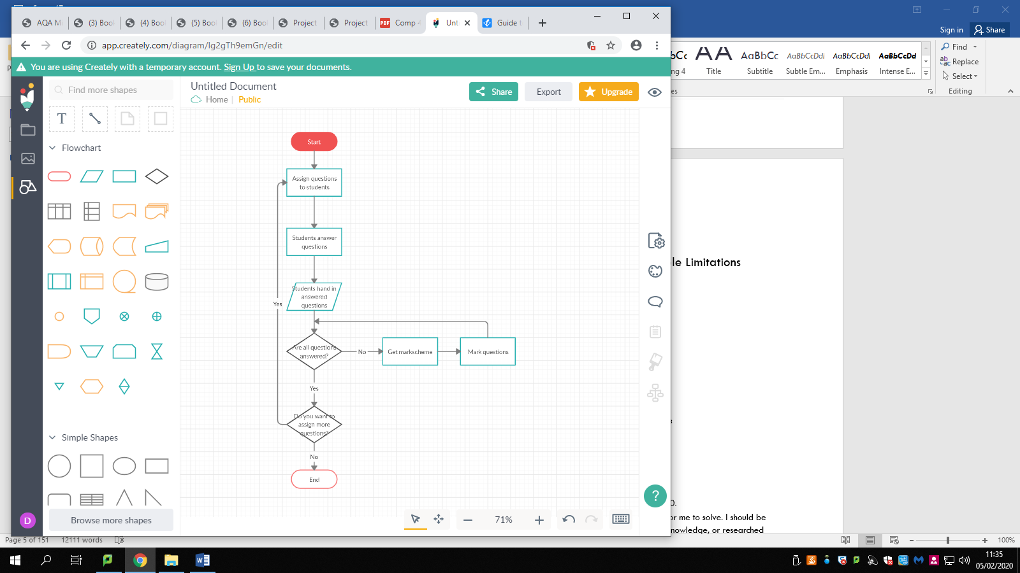

Figure 1

This flowchart of the current system allows me to view how the system works as a whole, and how it can be improved to make it easier for students and teachers. For example, the repetitive loop of marking questions could be computerized to save time for teachers.

## Identification of User Needs and Acceptable Limitations

Both user needs:

* To be able to log in and log out of the program

Teacher user needs:

* To be able to set quizzes for the students
* To be able to create, edit and delete questions
* To view students in their class
* To view student marks and progress

Student user needs:

* To be able to answer questions and submit responses to questions
* To view their score
* To have an option of what topic to answer
* To answer a variety of exam style questions

Limitations

* Time constraint – this project should be finished by Easter of 2020.
* Skills and knowledge – the problem should not be too complex for me to solve. I should be able to solve the problems presented to me using either current knowledge, or researched information.
* Question types – the questions that can be used or answered must be able to be marked automatically. This can restrict the question types used on the system.
* Resources – while every student has access to a computer during lessons and in school, they might not necessarily have a device or smart phone at home which limits how I can create this solution.

## Data Source and Destination

Current system

|  |  |  |
| --- | --- | --- |
| What is it? | Source | Destination |
| Paper based question | Teacher | Printed and given to students to complete |
| Markscheme – paper | Teacher | Teacher |
| Paper based question | Teacher | Given to students on shared area |
| Student scores | Completed quizzes | Teacher records on a spreadsheet on excel or on SIMs |

Proposed system

|  |  |  |
| --- | --- | --- |
| What is it? | Source | Destination |
| Online questions | Teacher | Sent to students online |
| Online markscheme | Teacher | Online database |
| Student scores | Completed quizzes by student | Teacher and student |

## Data Volumes

* There are approximately 40-50 students in each GCSE year that take Computer Science
* This totals to about 100 students – 102 including teachers
* Therefore, there should be about 102 log ins
* Each quiz should have a maximum of 30 questions
* There will be 30*50 responses to these questions so 1500 responses per year group

The types of questions that may appear in an AQA GCSE Computer Science exam are as follows:

* Multiple choice – this is possible to computerise as responses can be directly compared with answers
* State – this is possible to computerise as the answers that would need to be stored may be specific and one or two words only
* Describe – this could be possible as the user response could be scanned for specific words, provided the answer is short. This could be marked efficiently by an automatic marking algorithm.
* Fill the gap – this is possible as it is the same type of format required for a state question
* Write an algorithm – this will likely not be possible to automatically mark due to the variation and complexity of algorithms that can appear in exams.
* Explain – this is likely not possible to computerise for this project due to the time constraints. This would require a more in depth algorithm that could understand sentence structure and word combinations in large volumes
* Complete trace table – this could be possible to computerise as it is the same sort of algorithm required for a state question. The format of this type of question would have to be taken into consideration
* Sort – a type of question involved with sort algorithms, for example, from biggest to smallest. This may be possible as there is only one correct answer, making it easy to mark automatically
* Reasons – reasoning questions are very complex and varied. They depend a lot on the student opinion and context. As this can widely vary and have various different responses, in order to automatically mark this, more time would have to be dedicate to the problem.
* Logic circuit – this type of question would not be possible to have in this project as it would involve a lot of focus on user interface and can be varied. More time would have to be spent on this type of question in order to display it efficiently and correctly for the user.
* Calculations – this could be possible as there would only be one correct answer. This could be formatted like a state question, due to there being only one answer to compare to the user input.

## Data Storage

* Details for the students will be stored in database tables, along with the questions that have been asked or can be asked. This will also include the answer(s) – multiple answers if multiple choice

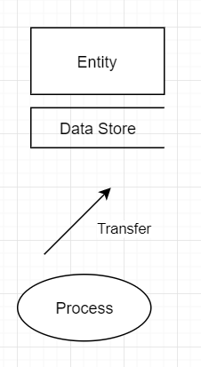

Key

Figure 2a

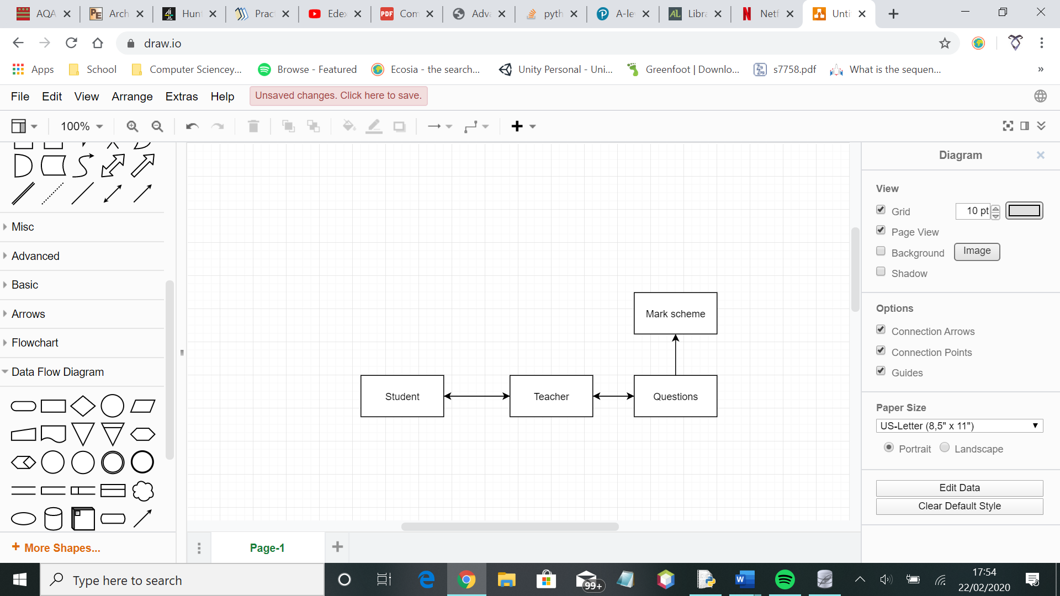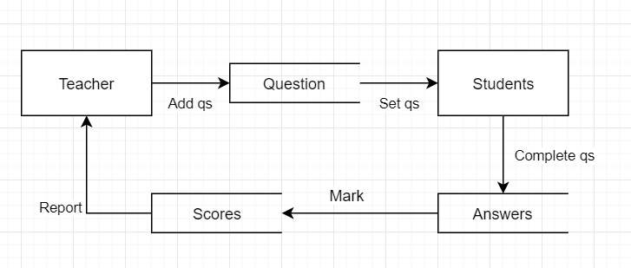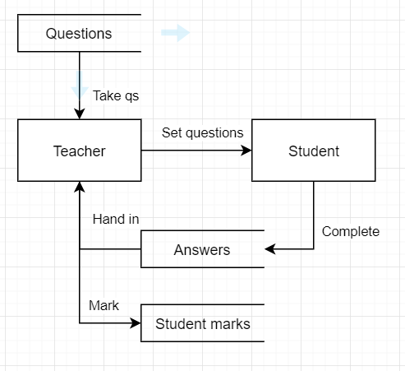

Proposed system

Figure 2b

As seen by the data flow diagrams, the current system is not very complex, whereas the proposed system involves various parts to be stored and used.

In the current system, questions are found by the teacher and assigned to the students. The student then hands the questions back to the teacher once answered, for marking.

In the proposed system, questions are still sourced by the teacher, and the teacher sets questions for the students. However, the student answers the questions which are then stored elsewhere. The marks the student receives are stored elsewhere for the student and teacher to access. The system can use these marks to calculate progress and understanding of various topics.

## Data Dictionary

|  |  |  |  |  |  |
| --- | --- | --- | --- | --- | --- |
| Field Name | Field Purpose | Field Type | Field Size | Example | Validation |
| Student ID | Uniquely identify the student | Integer | 4 | 1234 | Not empty |
| First Name | Stores name of user | String | 30 | John | Is a string with no integers |
| Last Name | Stores name of user | String | 30 | Smith | Is a string with no integers |
| Username | Uniquely identifies user | String | 30 | JSmith1 | Matches a username in the existing database |
| Password | Verifies unique user | String | 30 | Pass12.3 | Matches a password and the relevant username in the existing database |
| Question – multiple choice | Questions that give the student a choice of answers that might be correct | String | 200 | Which is an example of binary? | Options not empty |
| Response – multiple choice | Can only respond with one character per answer | Character | 1 | A | At least one checkbox is ticked |
| Question – state | A question type in exams where the answer is one word | String | 200 | State the arithmetic effect of applying a left binary shift of 3 to a binary number. | Answer not empty. Question not empty. |
| Response - state | Student only needs to answer question with one word or a very short answer – max 10 words | String | 100 | Multiplying by 8 | Textbox not empty |
| Question – describe | Question designed to have a short answer | String | 200 | Describe one difference between system software and application software. | Question not empty |
| Response – describe | The response should be short but explain the answer in sufficient detail | String | 300 | Application software is for end user tasks. | Textbox not empty |
| Question - calculations | Designed to have the student find the answer through mathematical processes | String | 200 | What is the file size of an image with 60x60 resolution and colour depth of 3? | Question not empty |
| Response - calculations | Question should only have one correct answer | Integer | 20 | 10800 | Textbox not empty |

## Entity Relationship Diagram

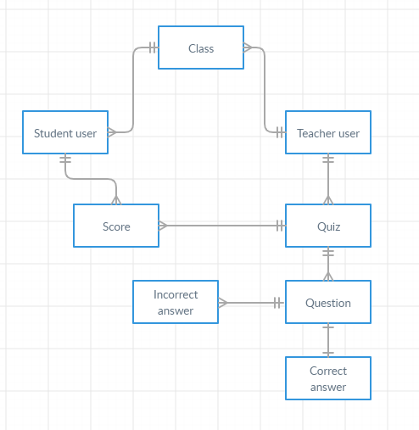

One to manyOne to one

This entity relationship diagram shows an idea of what the system might look like for the databases. Many students can belong to one class, and many classes can belong to one teacher. The student can have many scores for different questions, and a quiz can also have many scores due to various students. A quiz can have many questions, and a question can only have one correct answer most of the time, and multiple incorrect answers. In this system, a quiz could be properly formatted, or a session for the user.

## Research

### Interview with primary client

I have conducted an interview with Computer Science teacher, Amarjeet Ghundale, at Wallington High School for Girls, to understand a little more about the subject at GCSE, and what I can do to help. This can also help me to understand how I can help the teacher with work load and class management.

**How do you currently set questions and tests for students?**

**Generally, on screen and on paper. Tests are mostly completed on paper as that is the format for exams at GCSE, but we also share worksheets through the Student Shared Area for students to complete on their computer log ins.**

**How much support do you think, as a teacher, you are able to offer your students individually?**

**It depends on the class size and their needs. A level and GCSE students have a higher priority, and because it is an option for them to do Computer Science, class sizes and numbers are smaller.**

**What are the benefits to the current system?**

**As the curriculum keeps changing, it’s easier to change how we set questions as we have control over that. It is also easier to mark as I can give feedback to my students and understand where they are struggling.**

**Do you have any problems with the current system?**

**Generally, the whole process is time consuming. Other than that, the system works.**

**Are there any features you might like this program to have?**

**I would like;**

* The quizzes/questions to be automatically levelled and marked
* To have something where the students can’t go back and change their answers once they have submitted their questions and received their mark.
* An element of randomization – for example, there might be 15 questions stored for that quiz, but only 8 used at a time, in random orders. It would mean the students can’t memorise the answers, and can’t copy off the person next to them.

**How often would you use this program, and what for?**

**It would be mostly used for end of topic tests. It might be used periodically, for example, every 2 months.**

**What form would you like this program to be in?**

**Web based would be preferred because then most/all students will have access to it.**

**What resources do you use to help the students revise for their exams?**

**Things the students use to revise are revision and class notes, as well as the revision work books we give them, and the loaned textbooks. In class, we use AQA past papers, mock timed tests, and bought in resources.**

**How much revision is done in class to help students with their exam preparation?**

**For Year 11, because the NEA doesn’t take up too much time, and the course has generally been covered in Year 10, we have the whole year – until May – to revise. We generally do past questions and go through the specification.**

From this interview, I have gained some more ideas and another perspective on my project. It also tells me that while there are a lot of resources, there is limited time to revise in class. As my project is mostly aimed at GCSE students, while this interviewee provides a different perspective, they will not be the primary user. However, as a teacher who has multiple students, they will be my client in order to provide summarized feedback rather than having multiple views which can be difficult to consider.

This interview has provided me with a non-bias perspective of the course and specification, as well as the students who take the course as a whole. This can give me an idea of what to expect from the students, and how to tailor this system to both their needs and the teachers’. This research tells me that teacher resources and time is limited, and that a more accessible program would be preferred in order to cater towards multiple students.

### Secondary client – Yr 11 GCSE Computer Science student

### **How do you currently revise for Computer Science?**

Currently, I revise using active recall.

**Can you go into a bit more depth as to how you do this?**

**Yes. So, I go through the information and attempt to create this mental model of the topic in my head.**

**Ok. Are there any program you find useful, either to accomplish this active recall or in general?**

**We don’t use any programs for revision in school, and out of school I don’t use any either.**

**So, is there a part of Computer Science you excel at, and why?**

**I excel at data representation, probably because it is logical. I also enjoy transmissions, and find I understand that the most.**

**Are there any parts of Computer Science you struggle with?**

**I struggle with logic gates and barcode scanners.**

**Why do you think this is?**

**I think it may be due to the complexity behind it. It tends to take a while to understand or answer, and there is a lot of information to remember and apply.**

**What kind of features might you like in a Computer Science revision system?**

**In a revision system, I would like the system to teach me more of my weaker topics and not spend so much time on my stronger points.**

**And finally, how much teacher support do you get in school?**

**I receive good teacher support as we are given a textbook at the start of the year that we use to revise, and the lesson slides are available on SharePoint so anyone can access them for revision.**

**So, do you have support outside of lessons, such as student-teacher drop ins?**

**Not really. Our teachers are always available for questions but no clubs are run and no formal student support is offered.**

### Questionnaire

I used SurveyMonkey to send out a questionnaire for GCSE students. I asked Year 10 and 11 students.

However, I must appreciate that this questionnaire only represents a fraction of GCSE Computer Science students, so may not be completely accurate.

The questions asked are as follows;

* What school year are you in?
* What do you do to revise for Computer Science?
* If other, or revision app, please state what?
* How much revision do you do in class?
* How much revision do you do at home?
* If there was a program to help you revise for Computer Science, what would you want it to do?
* How could you improve on your revision?
* How much homework do you get from Computer Science?
* What computing devices do you have access to?

Key responses

* Most of the responses were from Year 11 students, with one in Year 10. This means that majority of responses are from students who have completed end of year exams in Year 10, therefore meaning they have an idea of their revision and subject.
* Past papers and revision notes are the main things used for revision. This can be seen in figure 3c.
* A revision app that a few students use is Seneca. Students also use the textbook and specification to revise. Some feedback can be viewed in figure 3g.
* Not much revision is done in class, however, these results may not be accurate as this questionnaire was completed at the beginning of the academic year, so there had not been many lessons in Computer Science for these students so far. Figure 3b shows the responses received for this question.
* Students seem to do a lot of revision at home, as seen in figure 3c.
* A lot of students wanted notes on the specification to help them learn, and automatic marking of questions. Some wanted some help with coding. One response mentioned wanting to be tested on topics they were unsure on which suggests tailoring future quizzes to each individual student. Figure 3d displays some of the responses received.
* Students seem to want more practice questions, and to create flashcards. Some mentioned wanting to do more revision on topics they find harder. Revision notes seems to be a key area students would like help in. Figure 3e shows some of the feedback received.
* Students get very little homework from Computer Science. This indicates that it may be an area that needs improvement, as shown in figure 3f.
* All students have access to a computer or laptop, as well as majority having access to a smart phone. However, because the laptop/computer had 100%, it suggests the solution to this problem should be suitable for a computer, for example, a downloadable program or a website. The results can be compared in figure 3g.

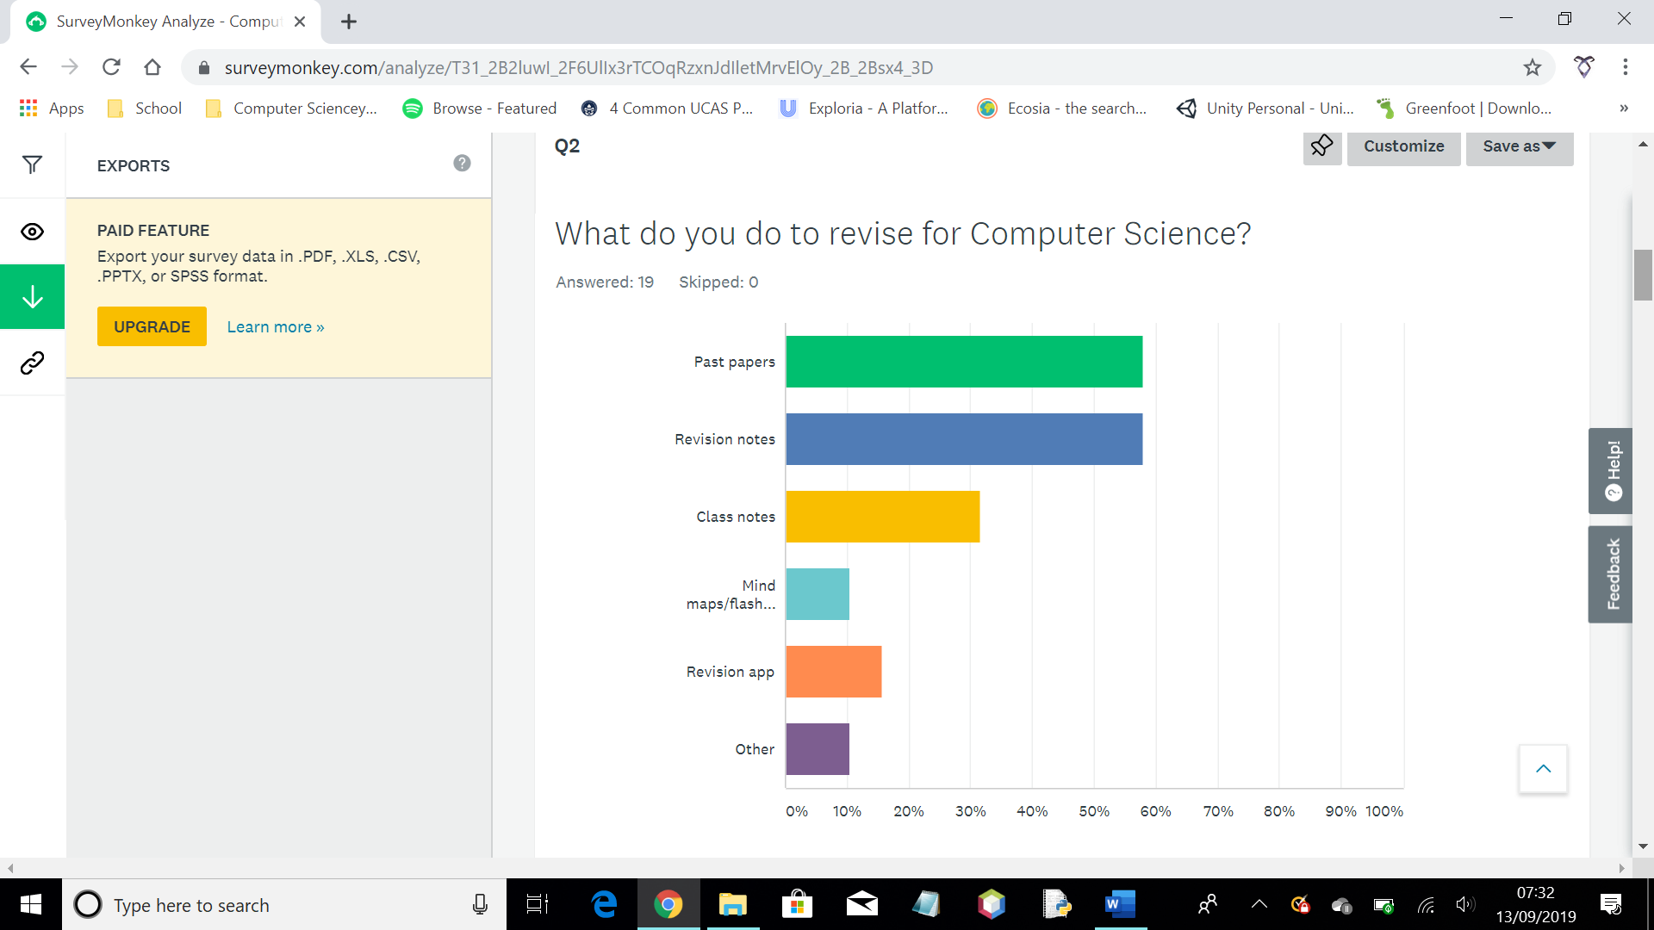

Figure 3a

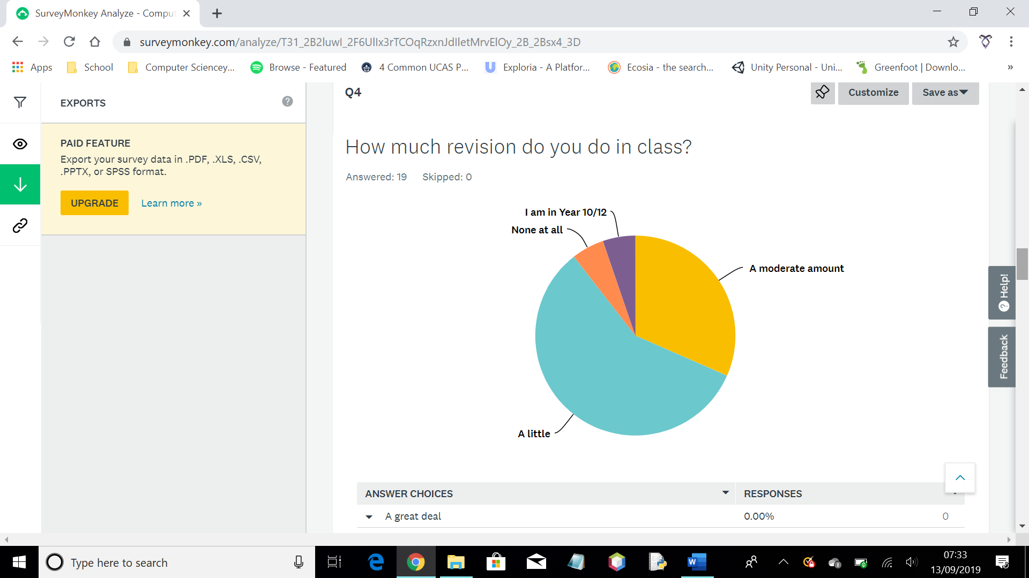

Figure 3b

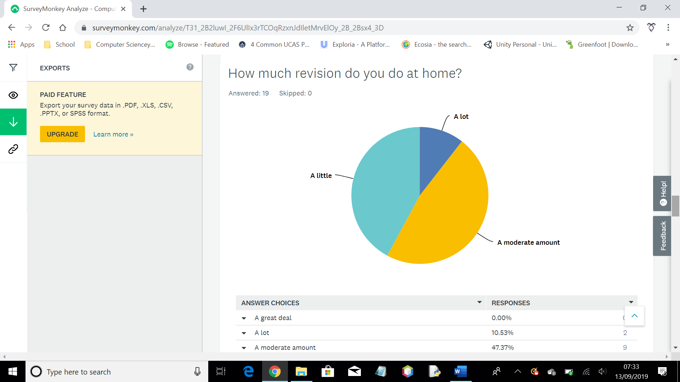

Figure 3c

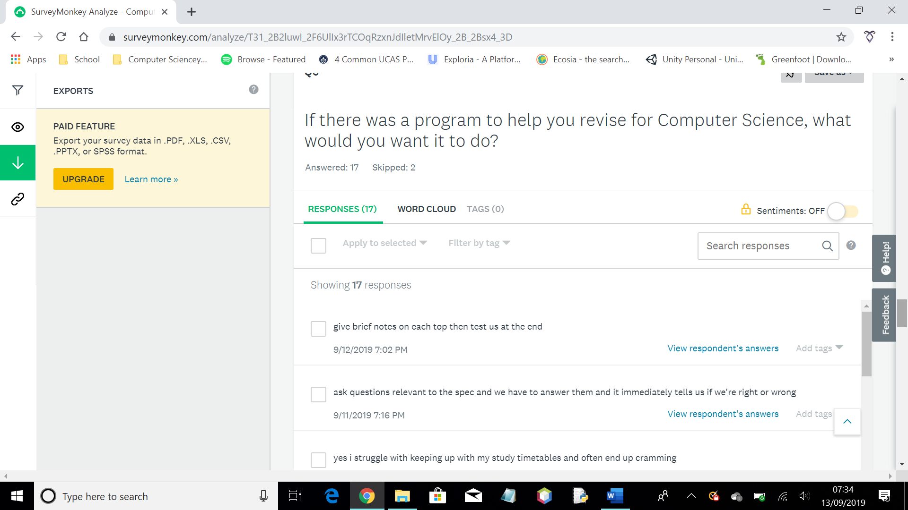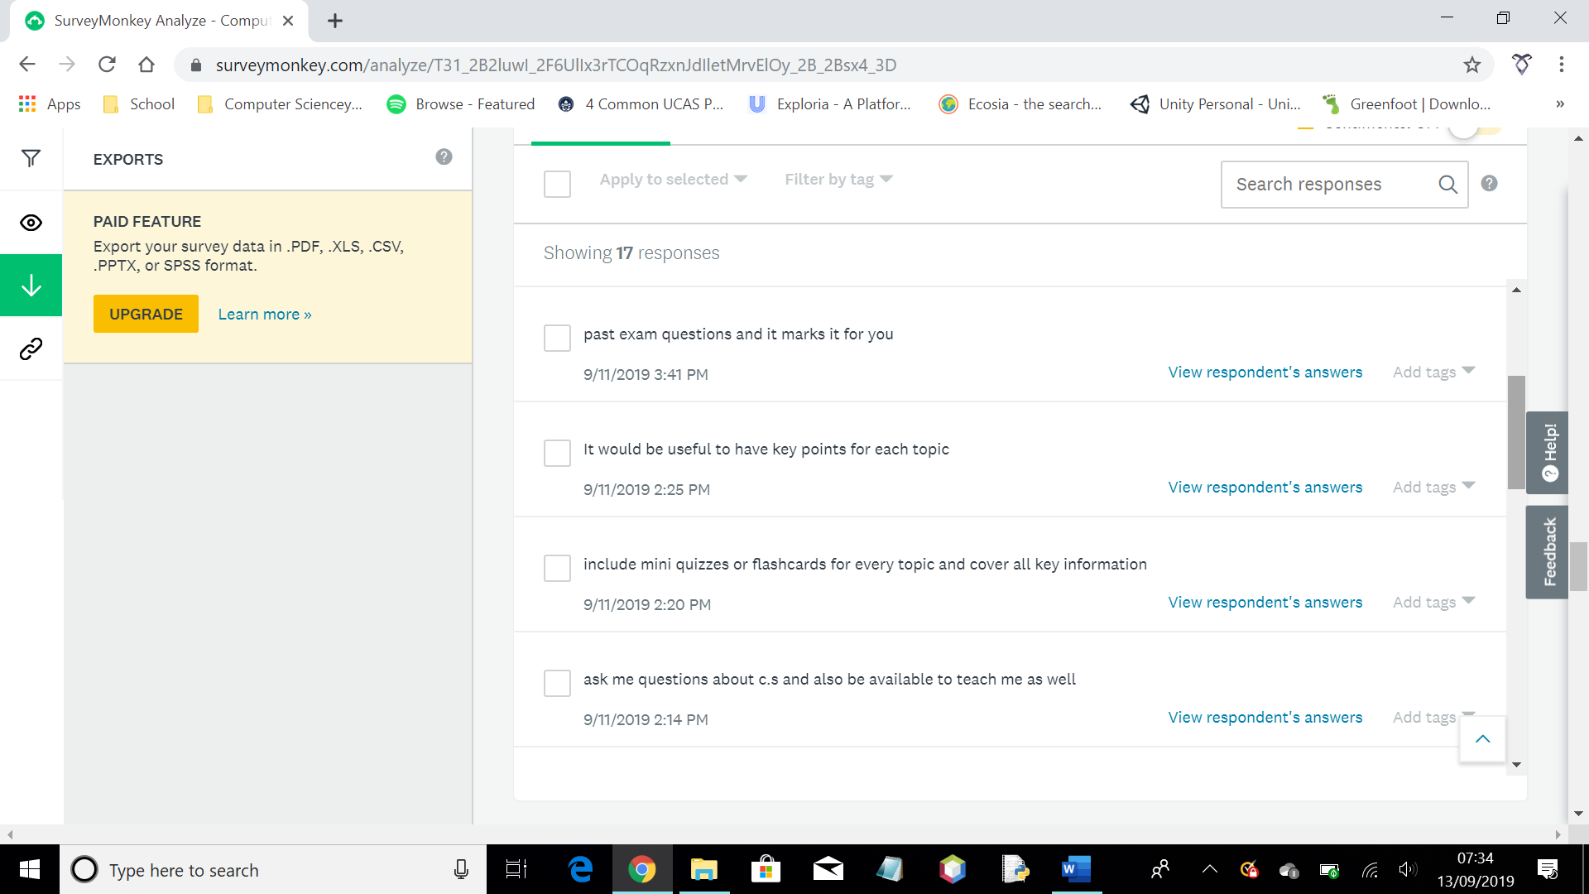

Figure 3d

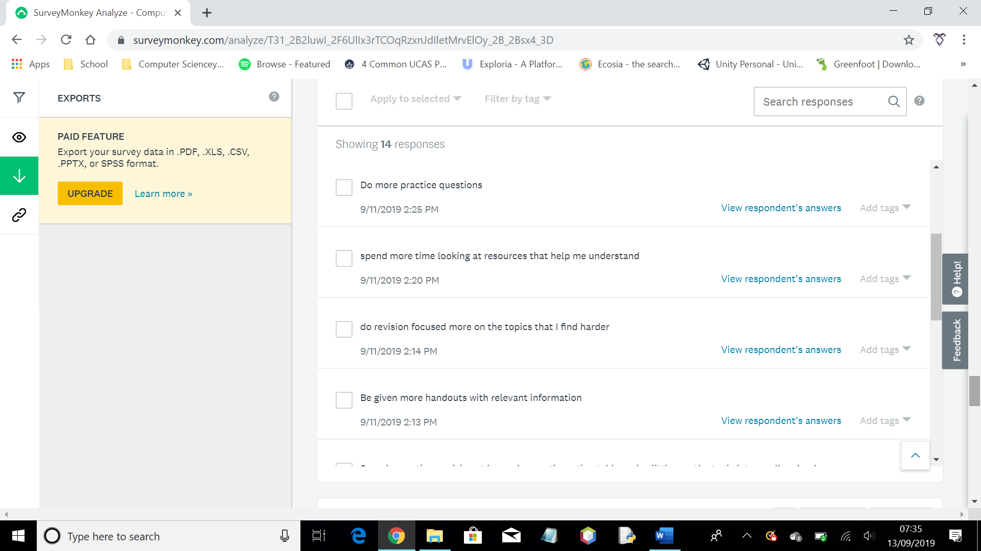

Figure 3e

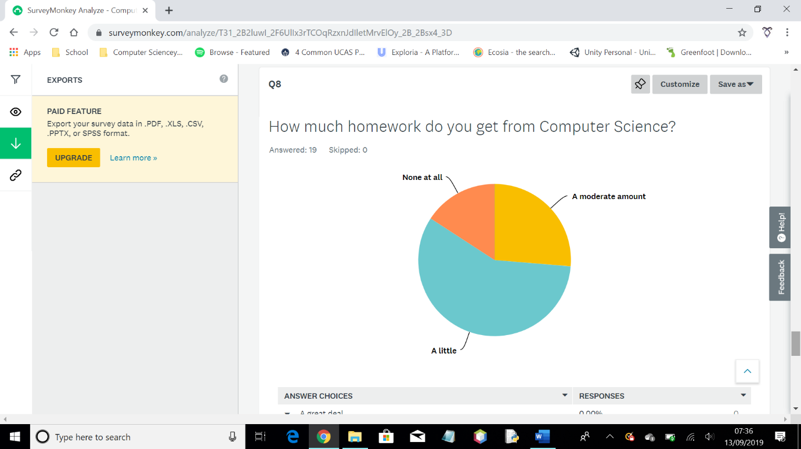

Figure 3f

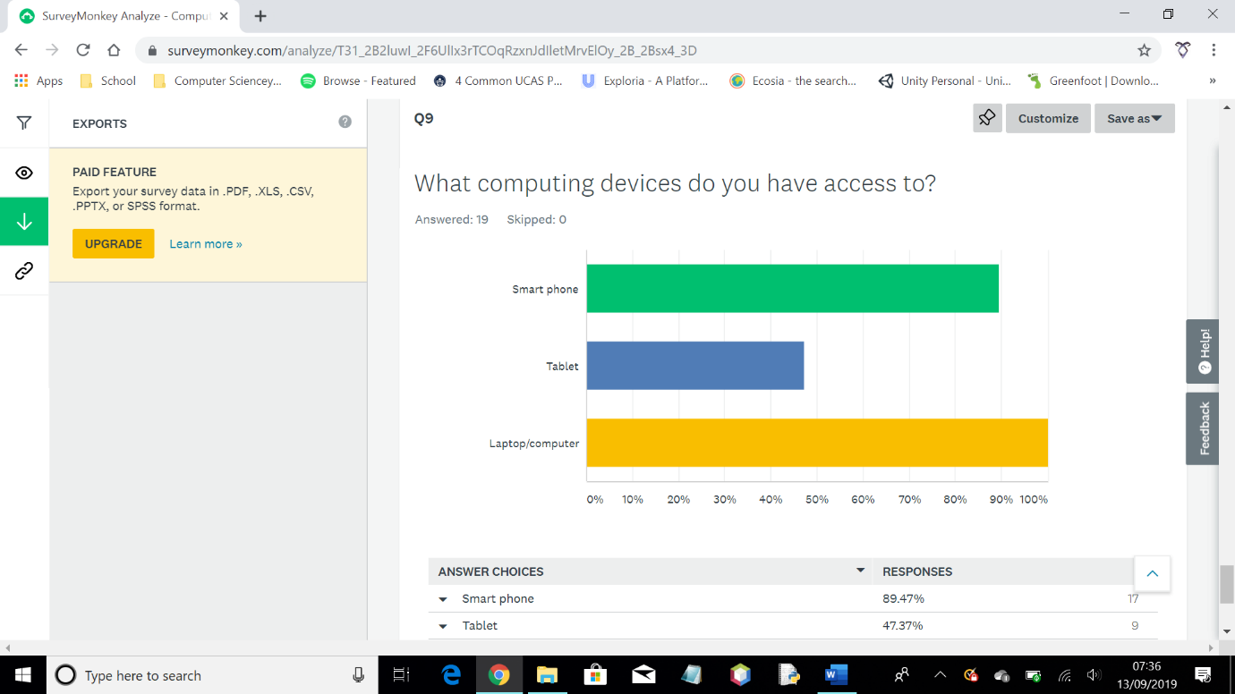

Figure 3g

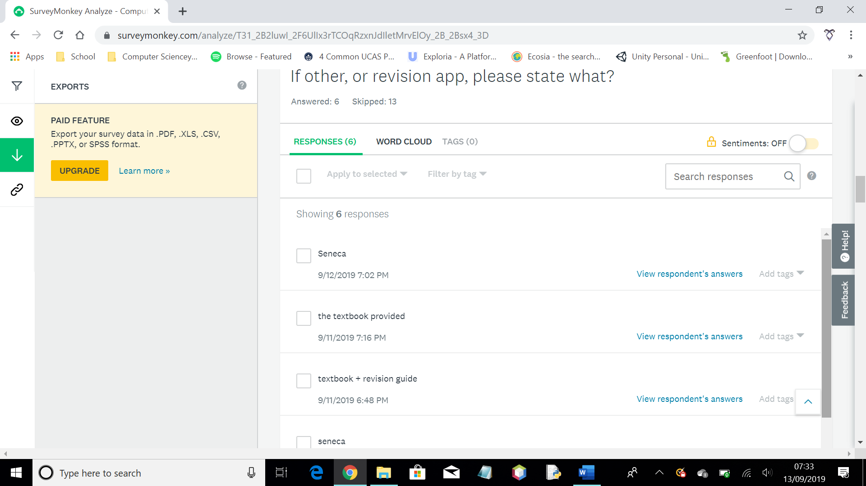

Figure 3h

### Existing System

As part of my research, I am going to analyse an existing quiz system called Socrative. Socrative is an online quiz system that can be used by teachers to quiz classes. Students taking the quiz cannot see what each other got, the system has an element of randomisation, and it is not timed.

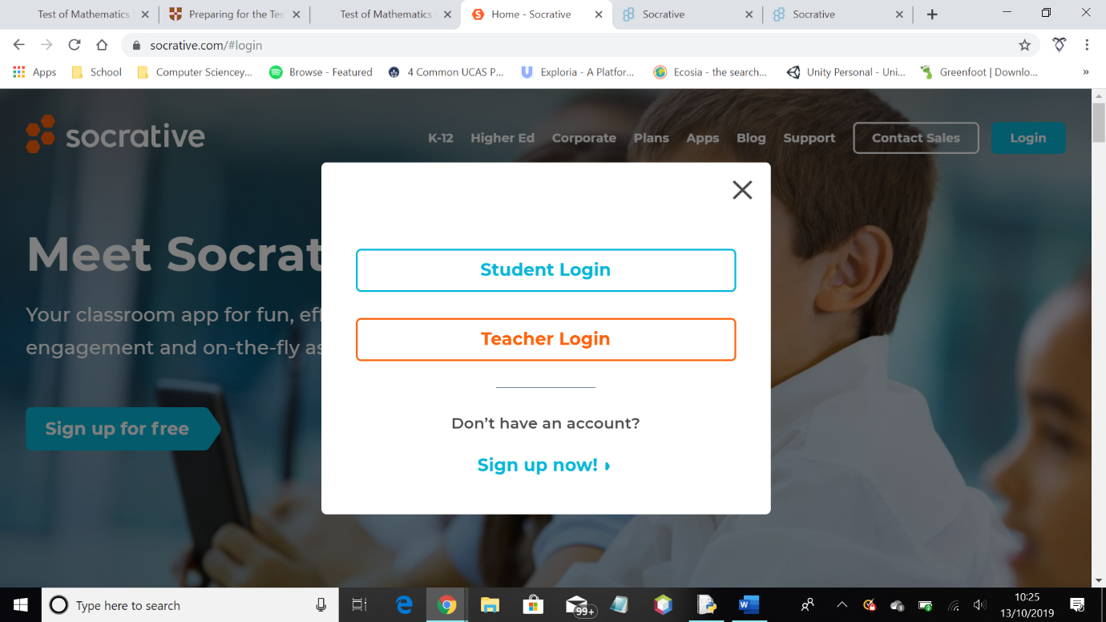

Figure 4a

When logging in, there are three options. Student log in, teacher log in, and sign up now! This presents all of the required options for the user, and accommodates for them being a new user. This therefore creates a good user interface and user experience.

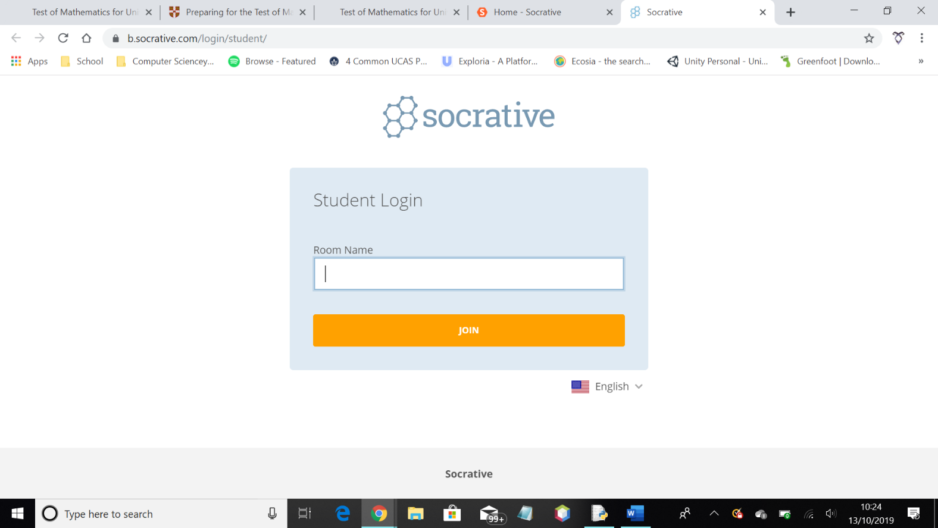

Figure 4b

The student log in page consists of a single text box requiring the room id for the existing quiz, meaning student progress isn’t necessarily saved to a unique account. This quiz system is therefore not tailored towards the student needs.

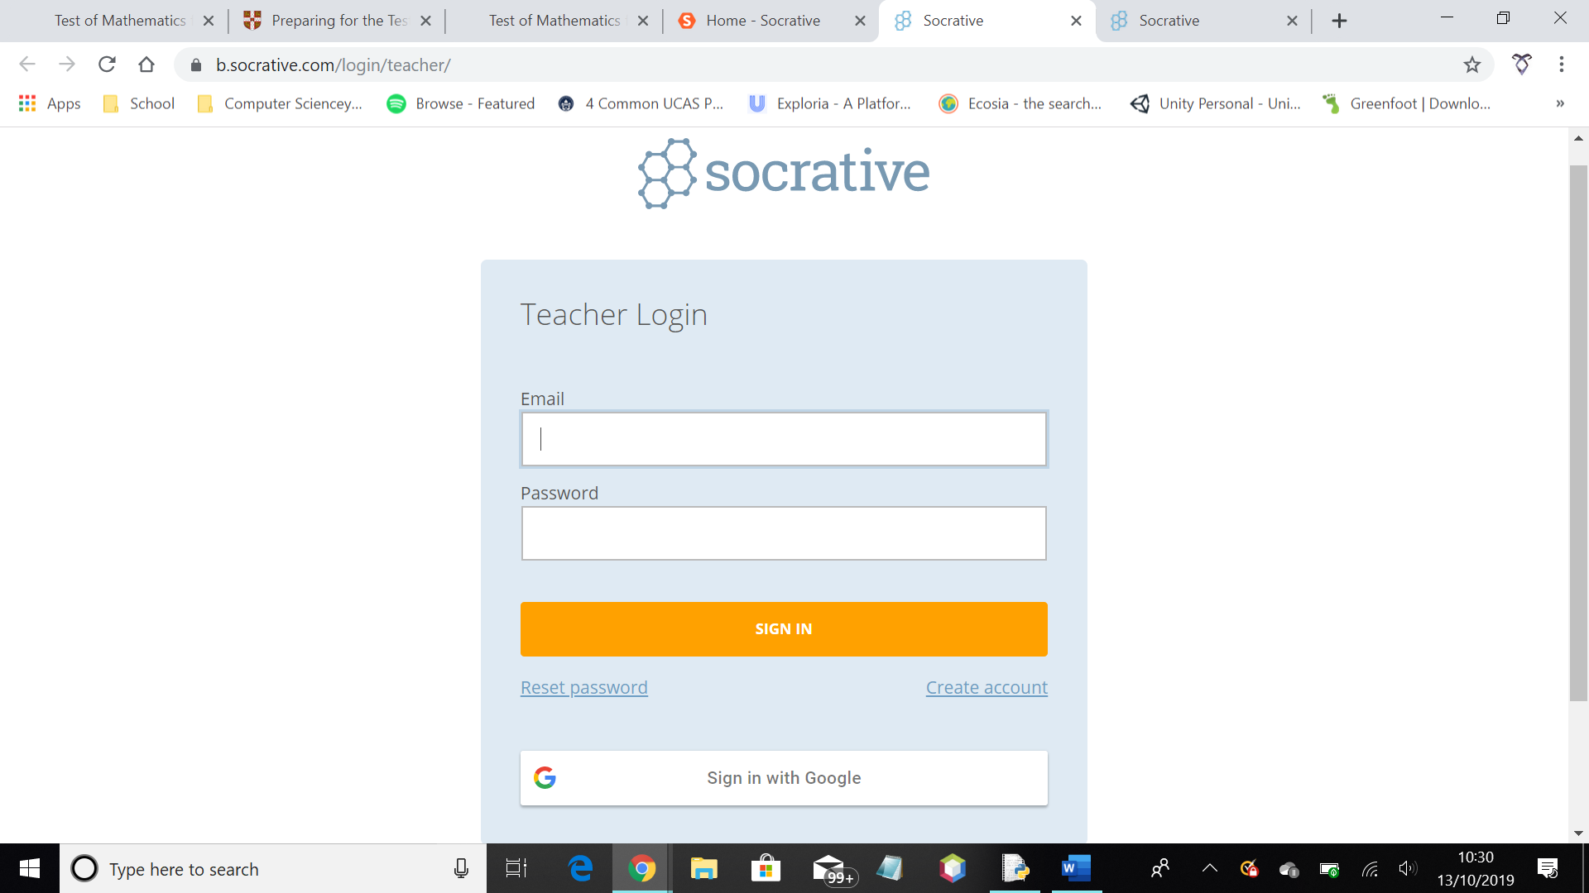

Figure 4c

When logging in as a teacher, it is clear that each teacher has a unique log in which saves various things, such as quizzes and student progress per quiz. There is an option for an email and password in order to log in. You can also sign in with google which improves user experience as it makes things easier for the user. You can also reset the password and create an account which allows for any issues the user might come across – validation.

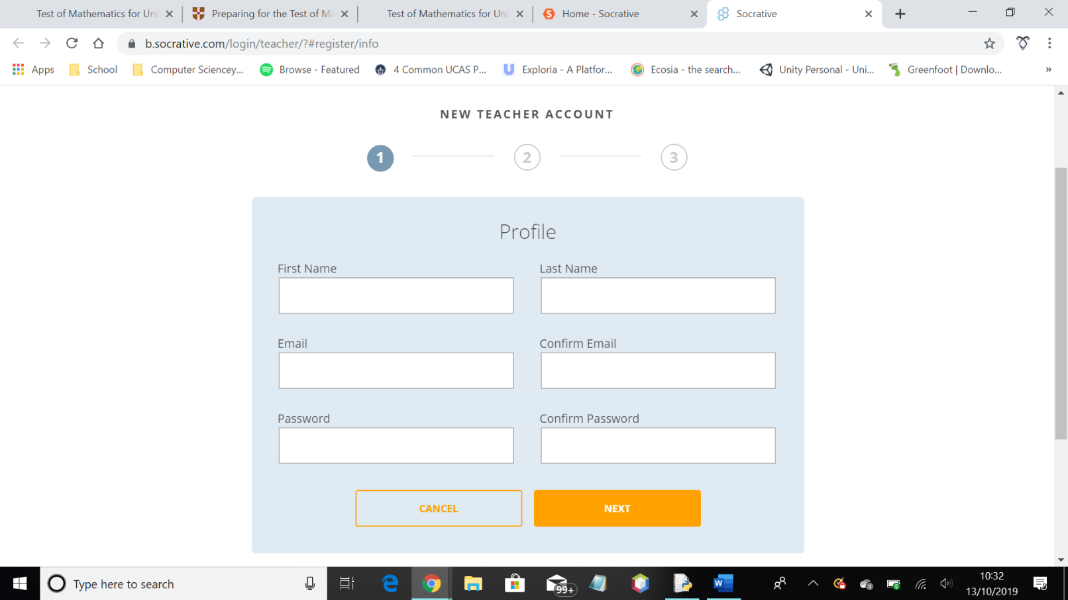

Figure 4d

When creating a new account, basic details such as name, email and password are required to start. This is likely saved into a database of log ins that can be fetched from at any one time.

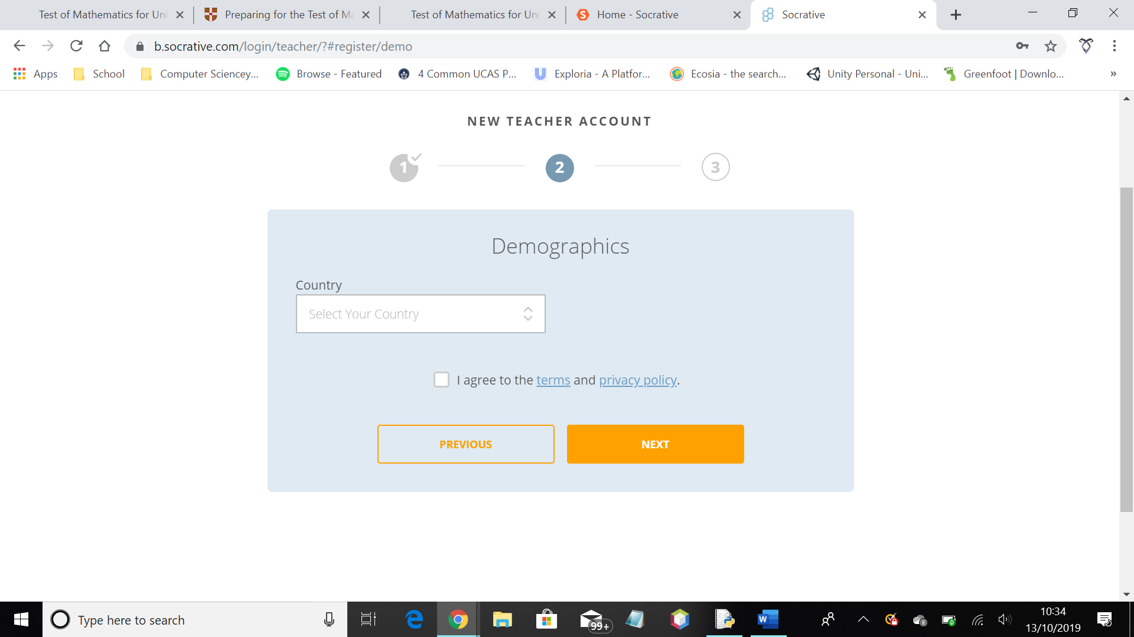

Figure 4e

The next step is likely for research purposes of the company. It first requires your country which could be needed information when linking the user to servers.

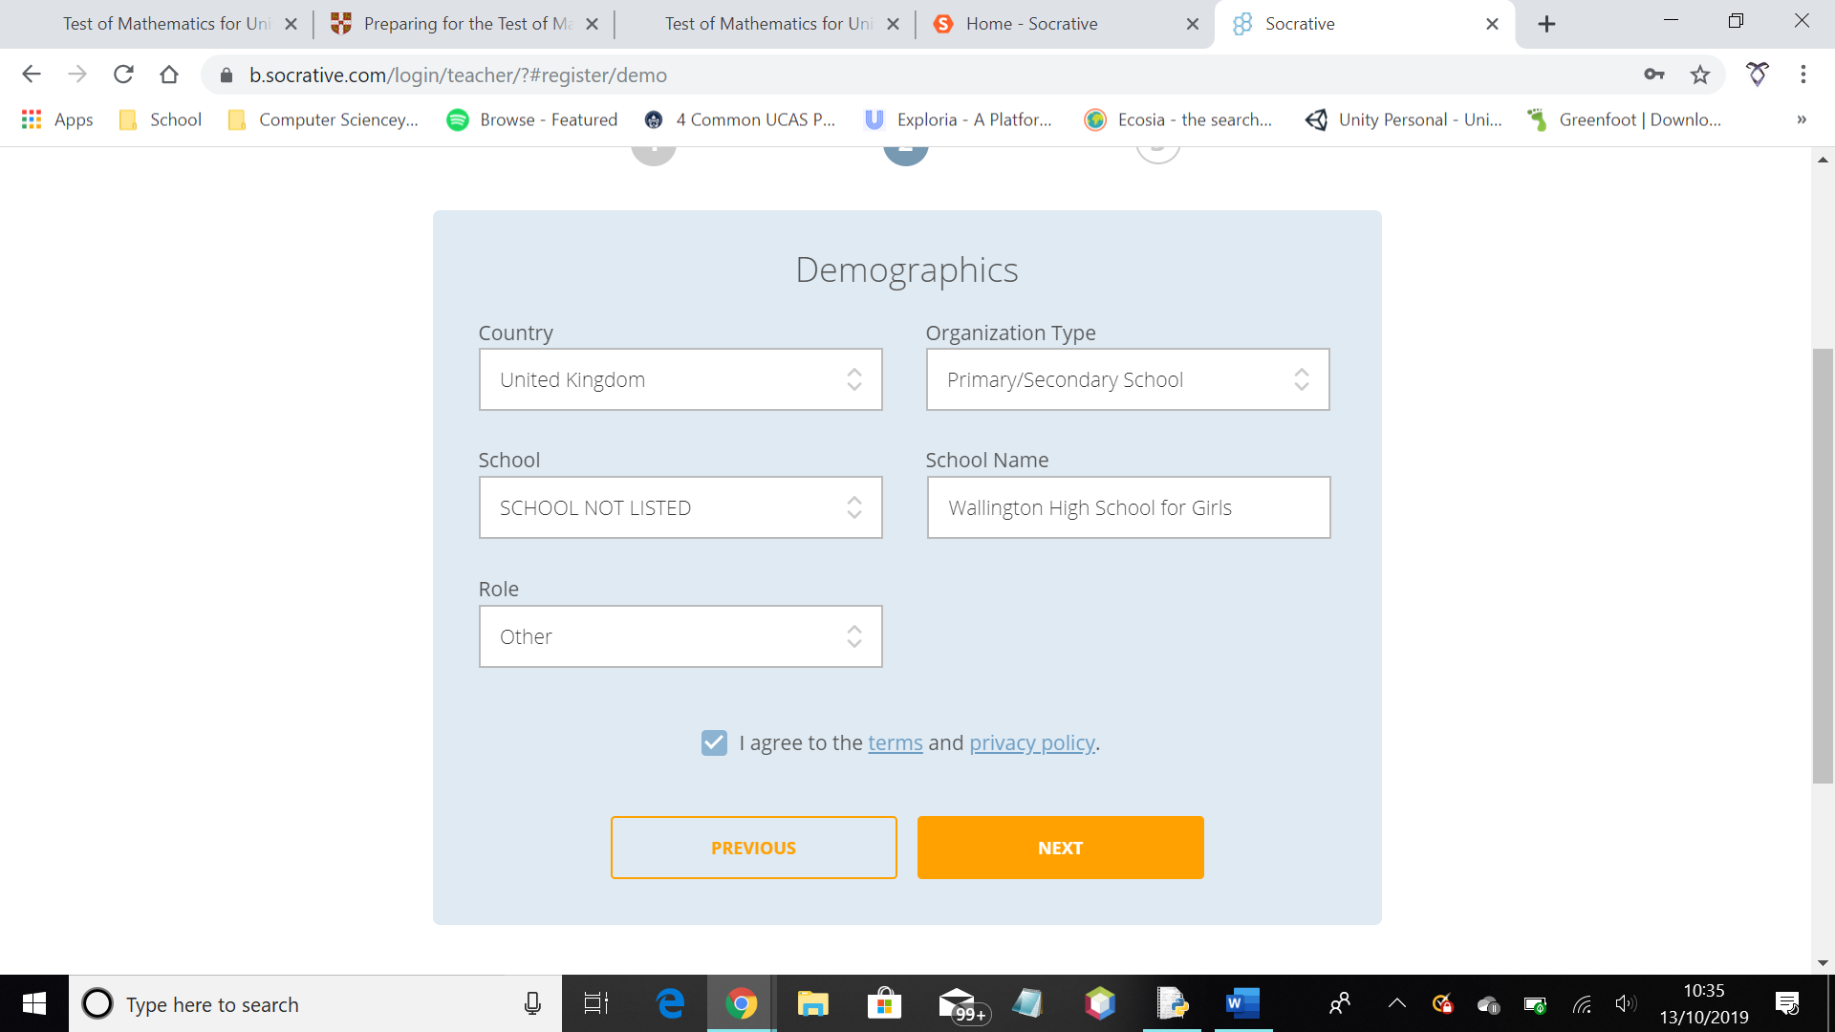

Figure 4f

When entering your country, it then results in more details being needed, such as school and organisation etc.

There are two options when signing up – free and paid. The paid version of Socrative has more available to users, however, I will only be able to analyse the free version as a result.

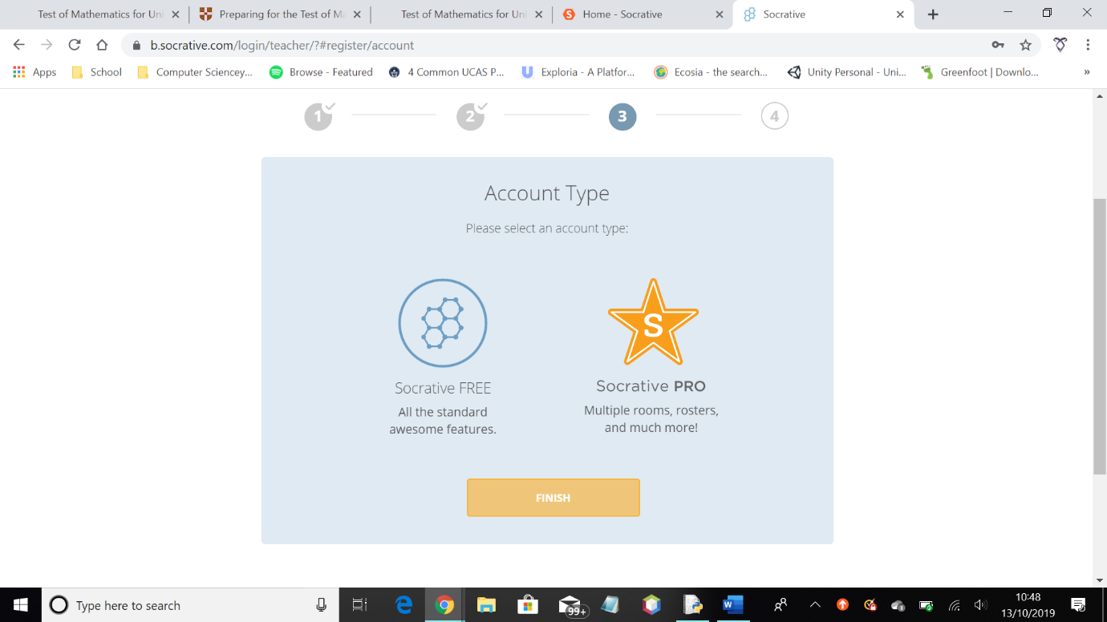

Figure 4g

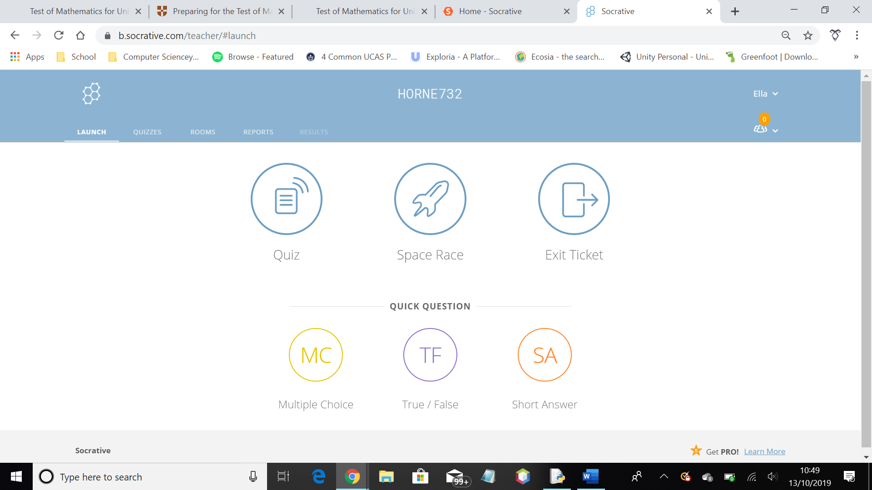

Figure 4h

This is the first page the user sees when they log in. As you can see, in the top left of the screen, the webpage is clearly organised to make it easier for users to navigate. The buttons in the centre of the screen are for different types of quizzes. The “Quiz” button makes a quiz available to any student in the room. The “Space Race” is a game that can be played. This seems like it would be more motivating to younger students. The “Exit Ticket” seems to be a quiz that teachers can give at the end of the class to evaluate what the students learnt within the class. This can also be used by teacher to work out where to improve in their teaching.

This window shows the user what quizzes they have created. These quizzes can be organised into folders, which helps the user with organisation. The existing quizzes can be ordered in alphabetic order, or in order of creation. There is also the option to copy, delete, move, merge, download and share quizzes. This is very user friendly, and has a clear layout.

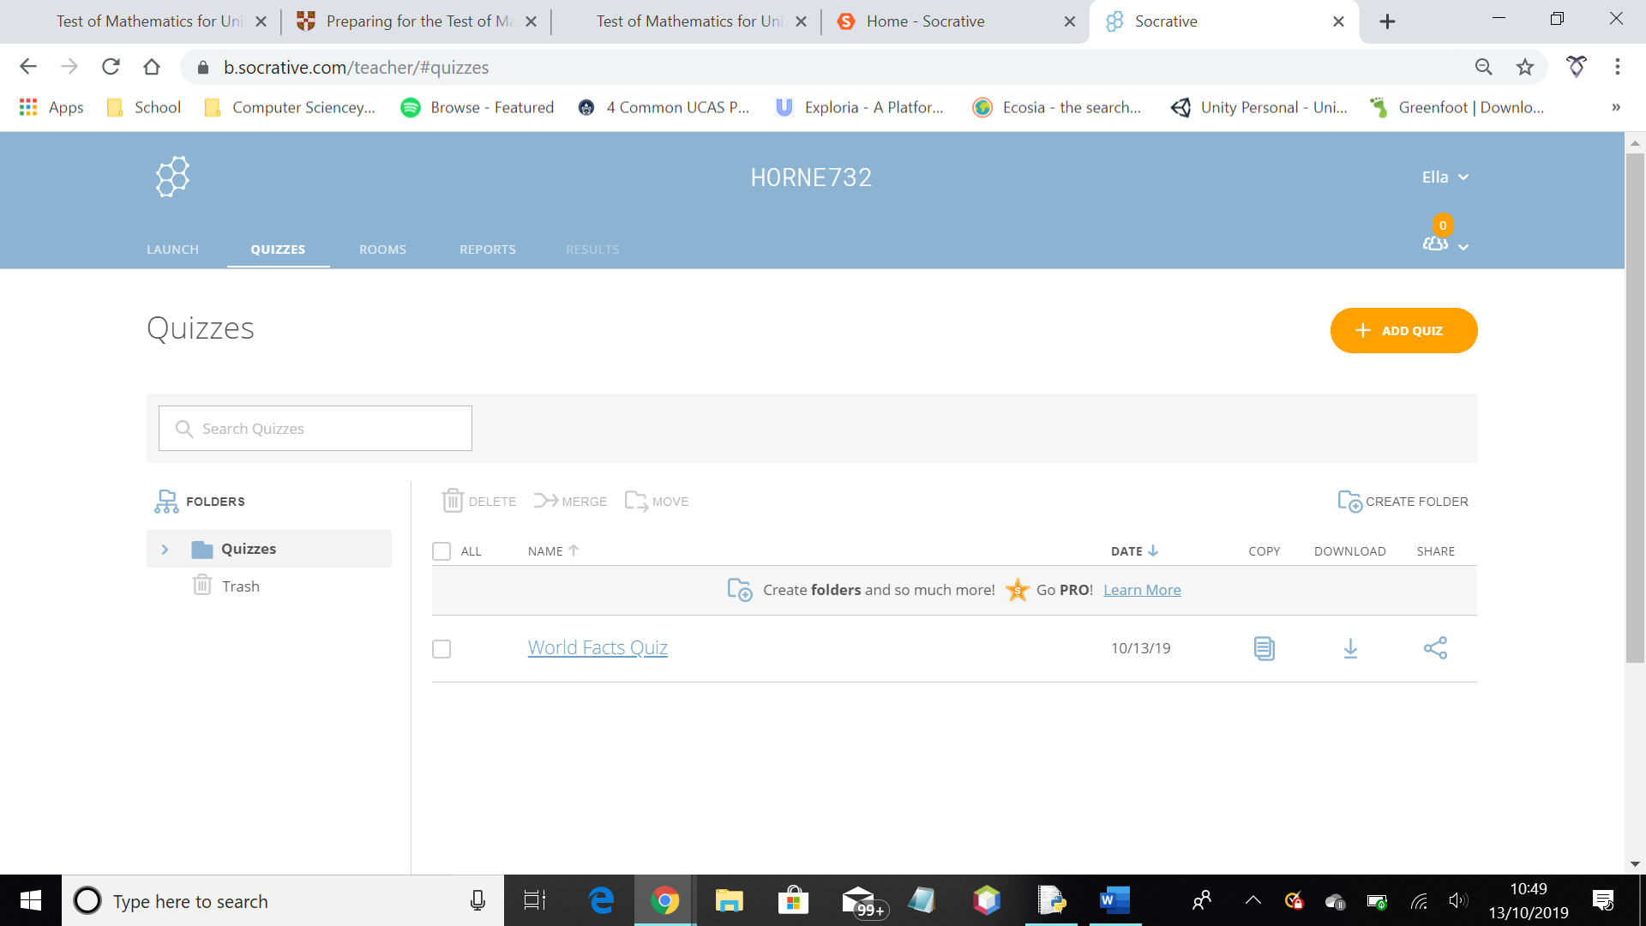

Figure 4i

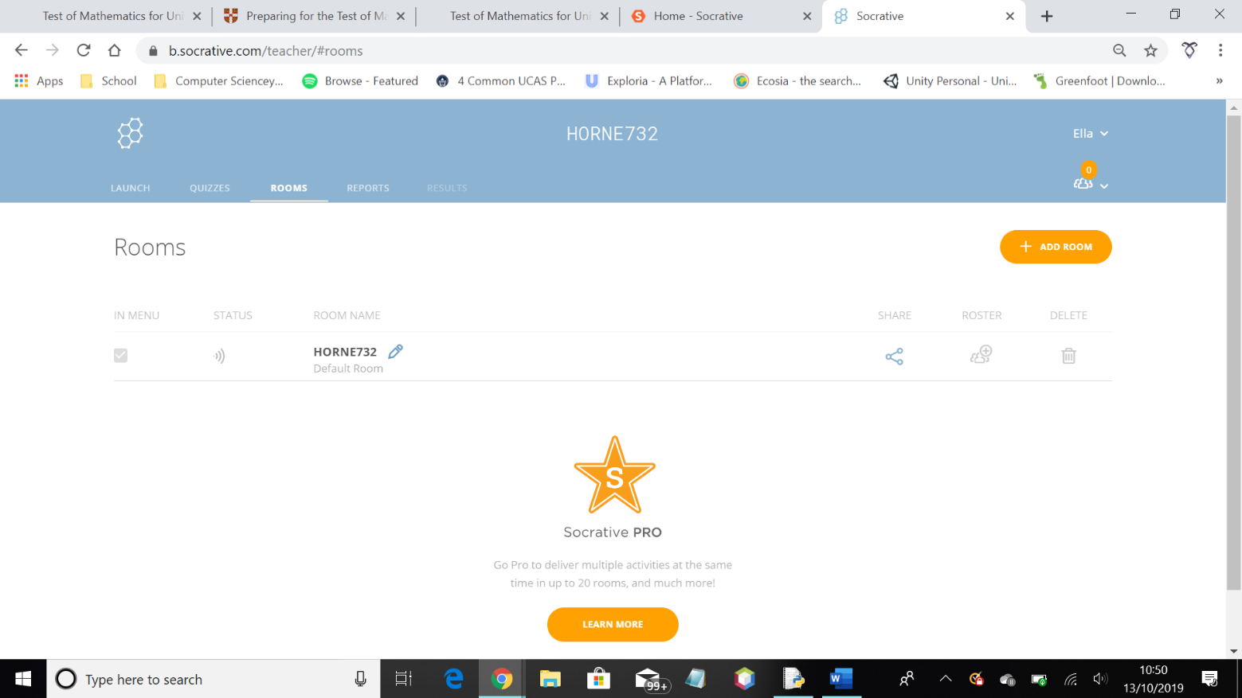

Figure 4j

This shows the user what rooms they have running. Rooms are groups students can join to take part in quizzes. However, it seems to have more than one room at any one time, you must subscribe to the website. You are able to control who has access to a room.

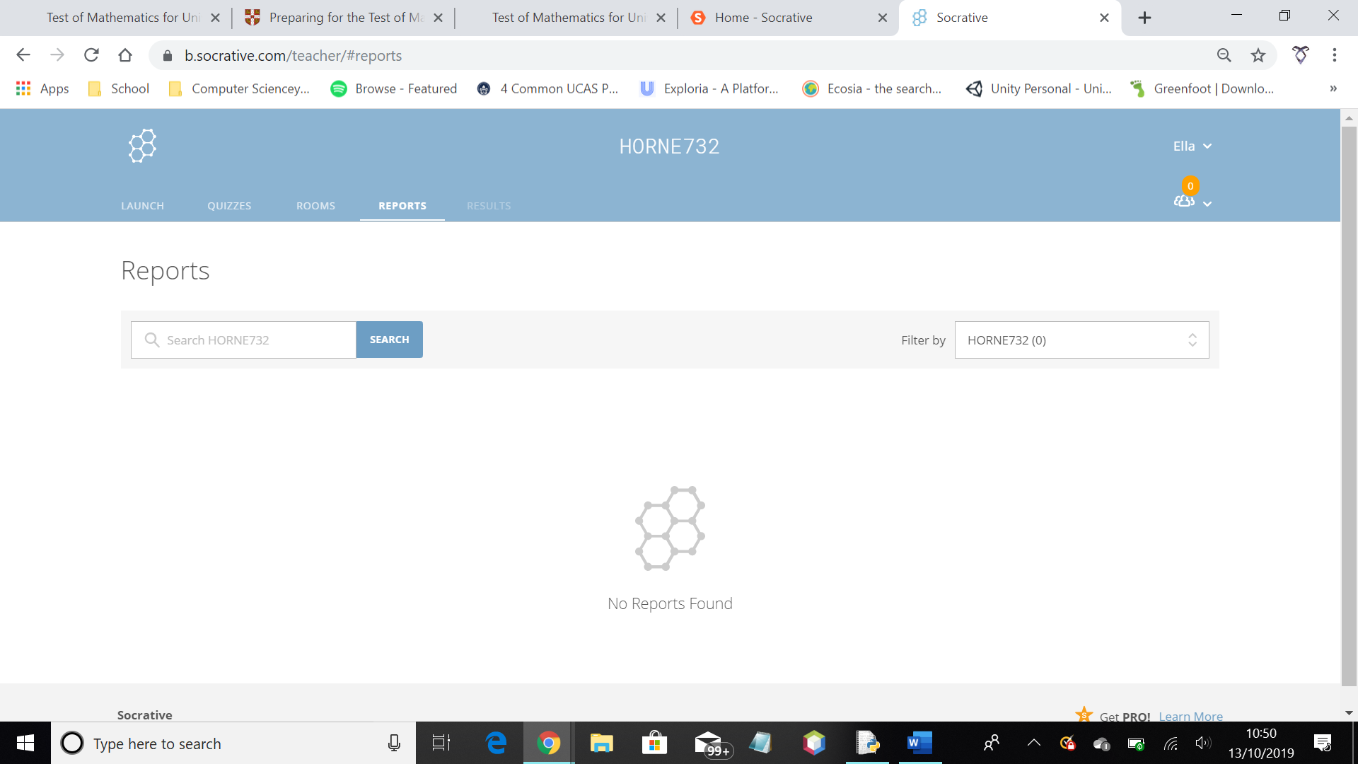

Figure 4k

The reports show the teacher results from past quizzes. This can be useful to evaluate student progress, however, as the students don’t have permanent log ins, it can be difficult to compare results for different quizzes. It is based off of what the student user enters as their name, which is not necessarily consistent, for example, if their name changes.

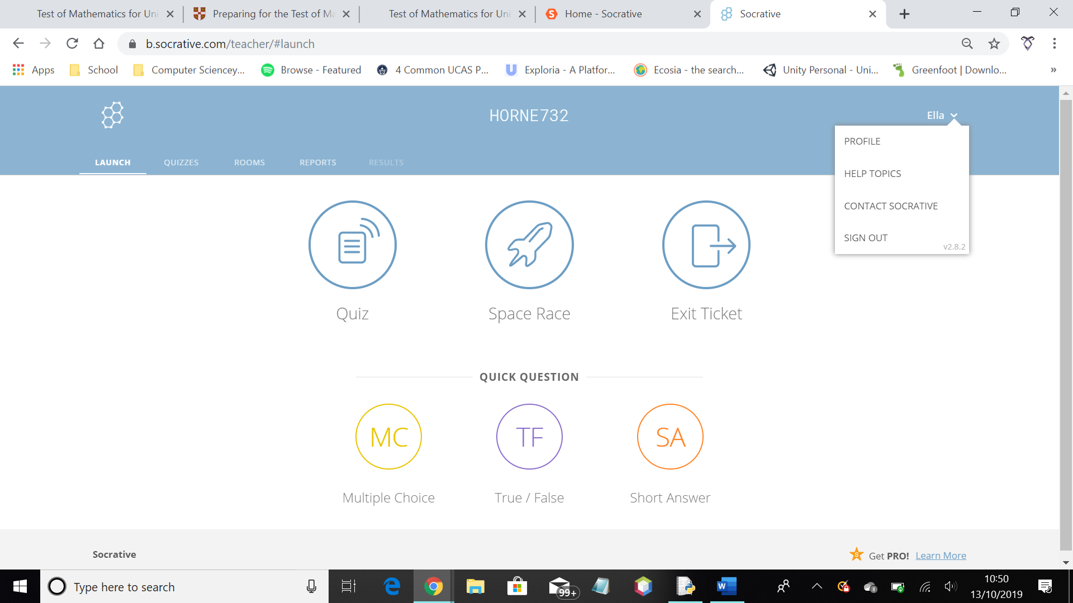

Figure 4l

This screenshot shows what options there are to do with the user log in. You can view your profile, sign out, ask for help or contact the Socrative team. This improves user experience and helps with ease of use.

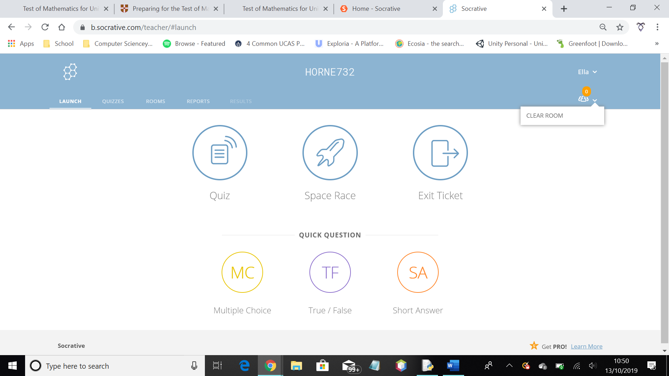

Figure 4m

This gives the user the option to remove all students from their room. This improves how easy it is to use the website.

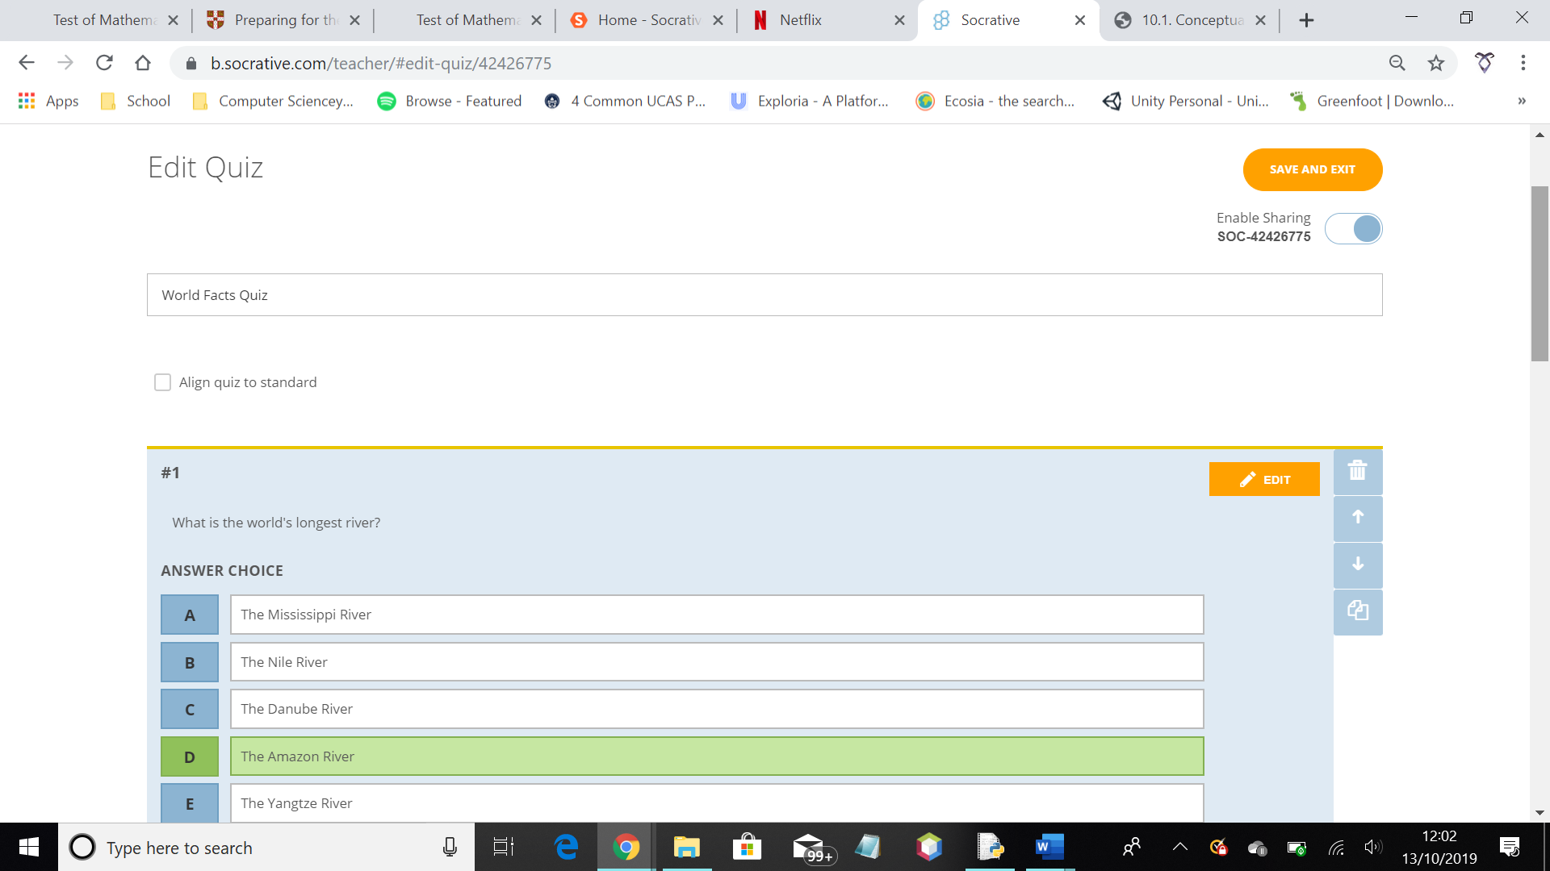

Figure 4n

This is what the user is presented with when wanting to edit a quiz. There is the option to edit questions, as well as delete, copy or move the question around.

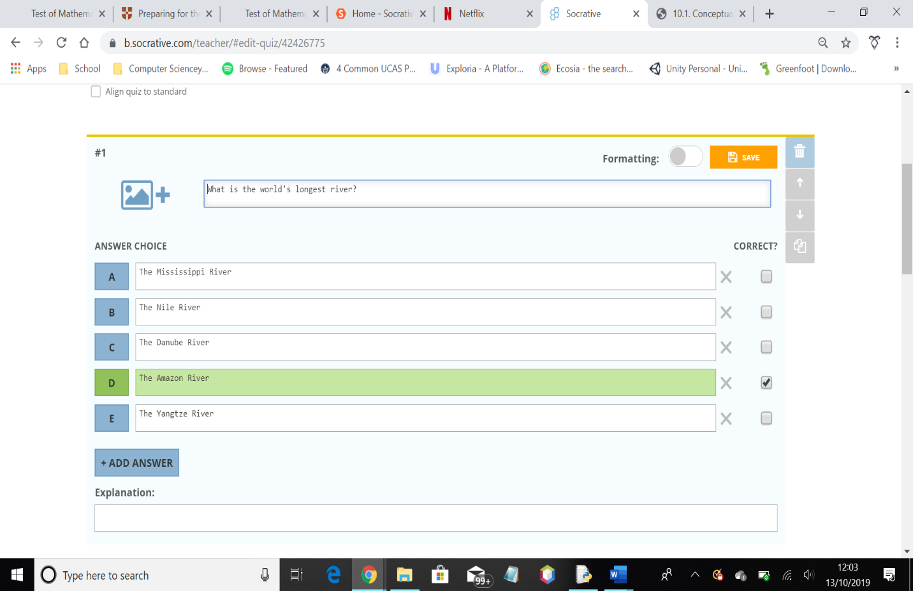

Figure 4o

There are different options for types of questions. The types offered are: multiple choice, true or false, and short answer. While this does cover the main types of questions used in a lot of exams, it doesn’t allow for a lot of variety in this quiz system.

When editing questions, the user can change the question or answers offered. They can also provide an explanation to support students struggling.

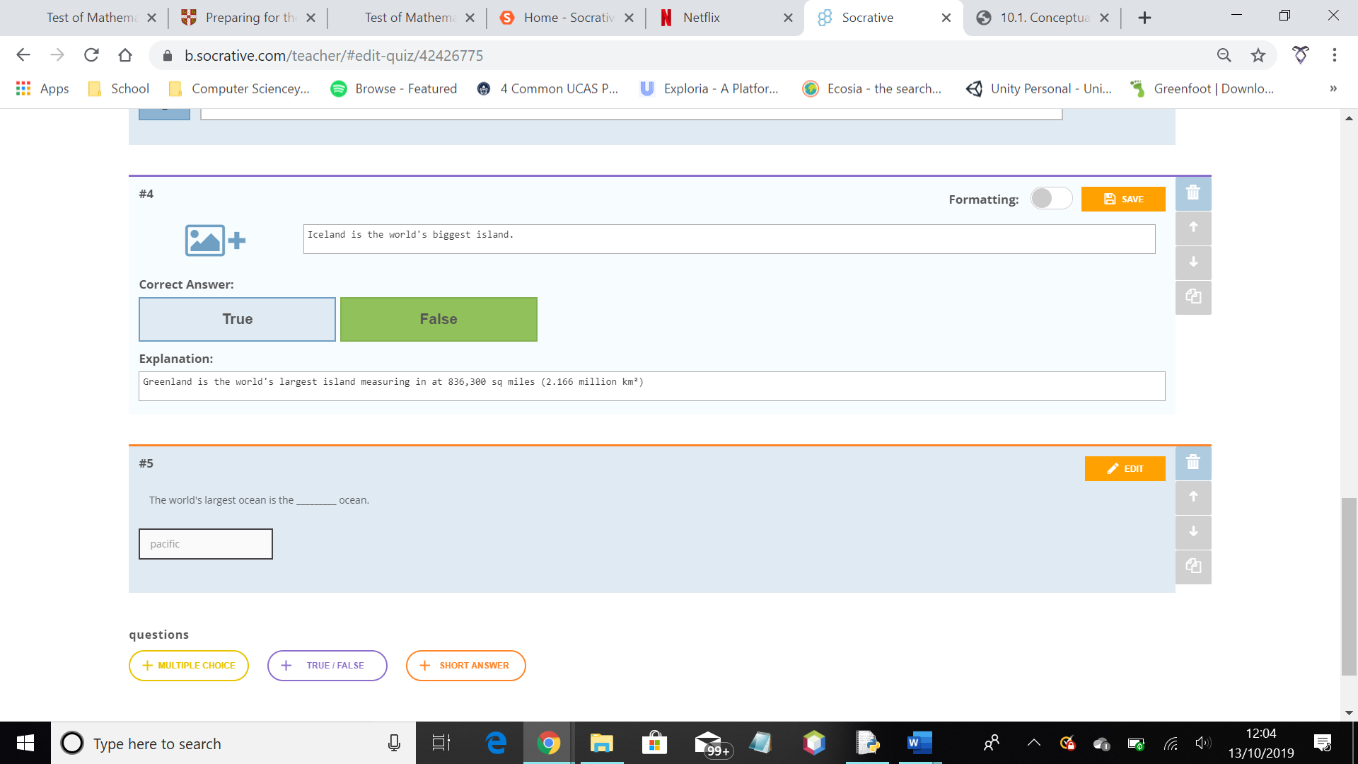

Figure 4p

There are three buttons at the bottom of the quiz when editing which makes it easier to add questions to the quiz.

It is important to note that this system was established in 2011, meaning it has had 8 years to develop and grow. It is unlikely that my system will meet the same standard, due to the time constraint on my project.

While this system allows for variety in what the user can do, and has multiple different formats for the quiz, it does not offer student log ins, meaning students using this system cannot look back and view their progress. This system also accommodates multiple subjects and levels, which limits the question types that can be used. My system will be subject specific and focus on helping GCSE students as well. My system will prioritise helping GCSE students first because of this, and my client, a teacher, can offer opinions based on what he has viewed in Computer Science classes. I can also ask for feedback from GCSE classes to allow for a broad range of perspectives.

Analysing Socrative has helped me research and discover the features that may be important to implement in my system. I also found by analysing Socrative that while teachers might need help assessing student progress, students also need help analysing their own progress. Socrative already offers a system to support teachers, so I will offer a system to primarily support students studying Computer Science GCSE.

### Types of question

Below are samples from the 2018 AQA Computer Science Paper 1 and 2 – the only past papers other than specimen available at the time of research.

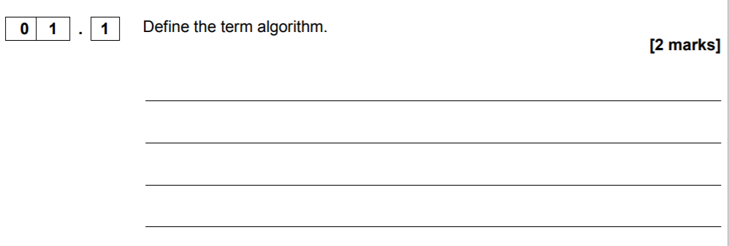

Here is an example of a define question, which is limited in the number of answers that can be accepted as correct as a result.

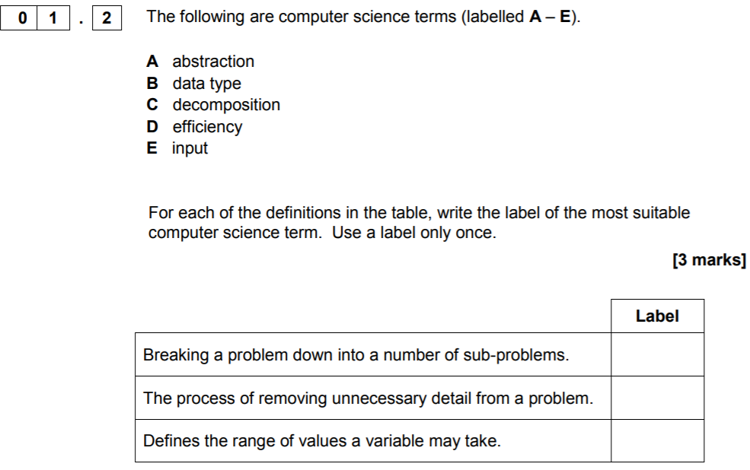

Here is an example of a matching question type – this involves matching the relevant word to the description. This could be possible as a design format, as there is only one correct answer for each description.

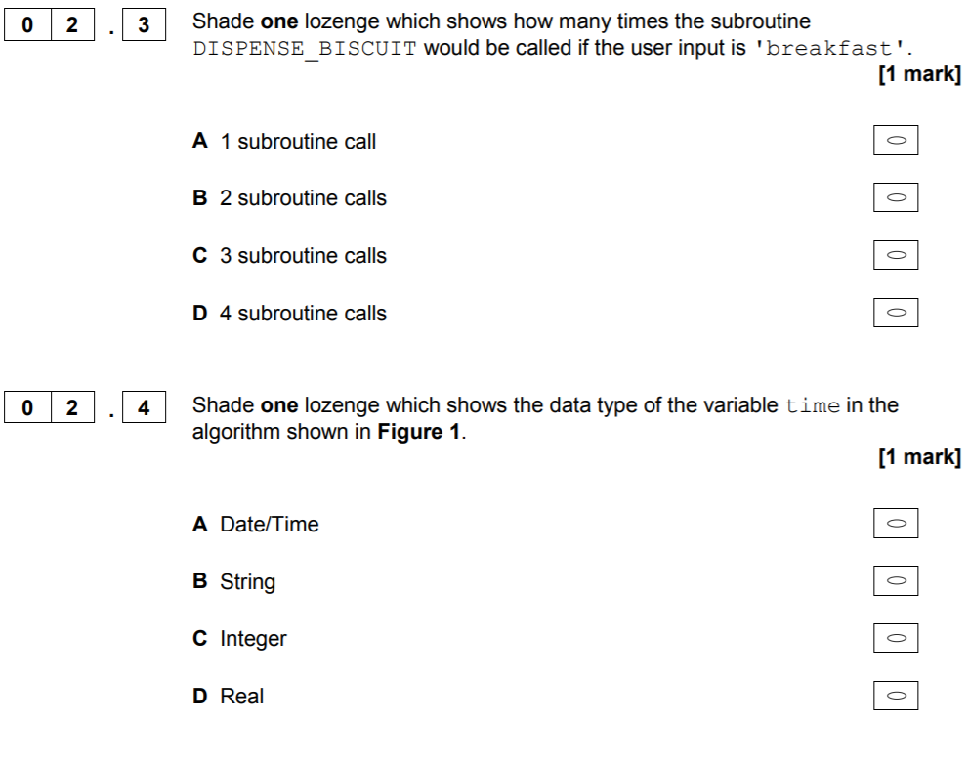

This is an example of a multiple choice question, as the possible answers are presented to the user, and the user has to select the correct one.

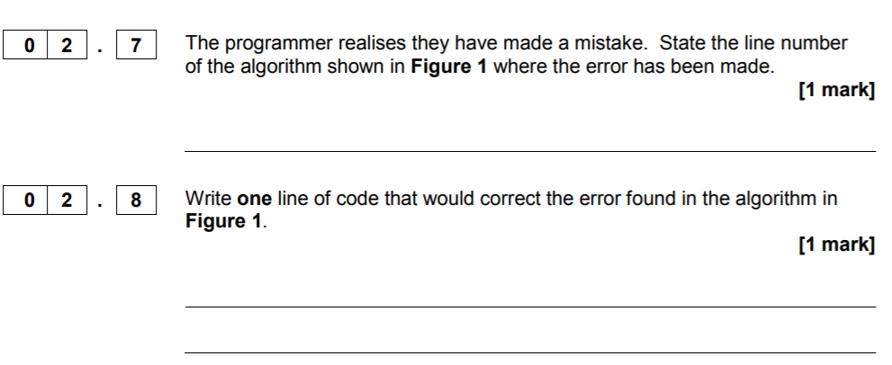

These are examples of state questions where there is only one correct answer. This answer could be presented in various ways but, if correct, it should always refer to the same concept/point.

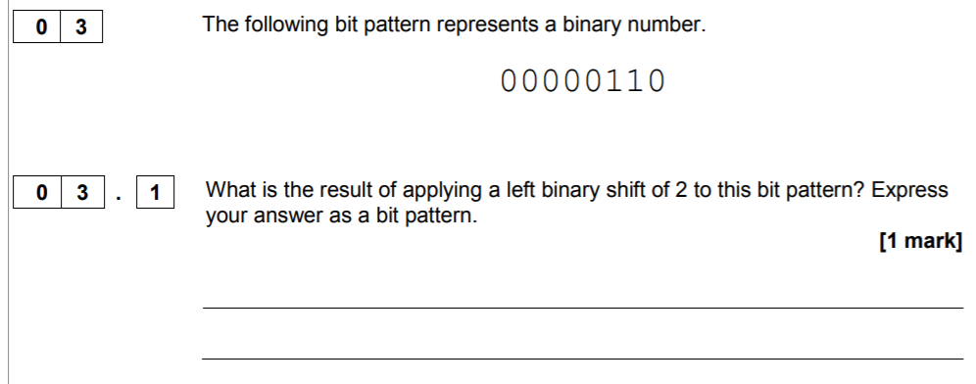

This is an example of a calculation question that can be given to GCSE students in a paper. Calculation questions are very similar to state questions, in the sense of there only being one correct answer, however, sometimes, working must also be provided for marks, which can make it different to state questions.

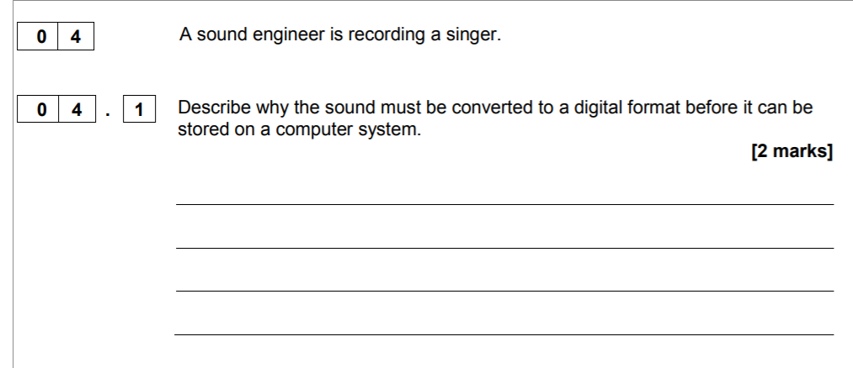

This is an example of a describe question. These types of question often require long answers, and have various different possible answers or ways of interpreting the question. This can make it harder to mark.

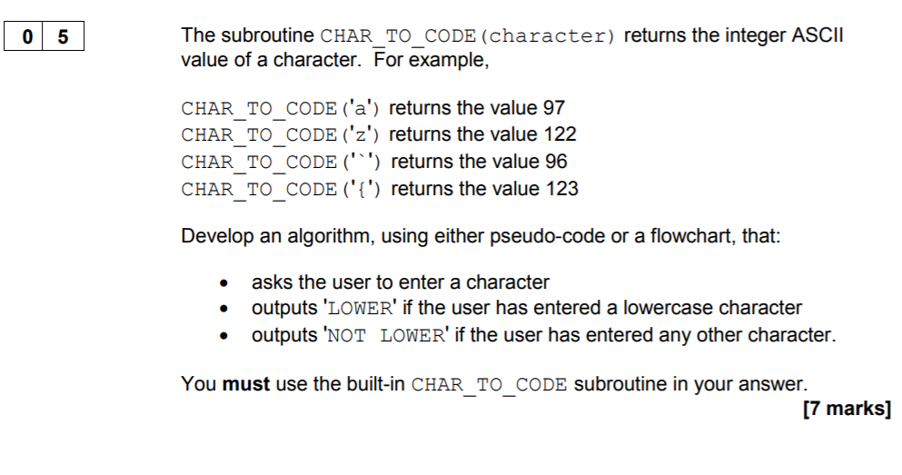

This is an example of a pseudocode question. This kind of question can vary a lot in the approach a student takes as well as the format used to present it. This can make it harder to mark, as the marks depend on whether the solution works, and if the structure is acceptable.

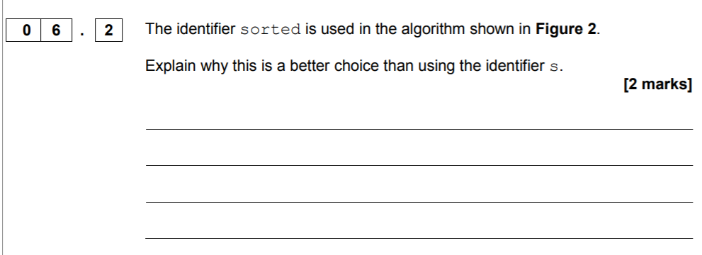

This is an explain question, which usually requires justification for a point made. As these are longer answered questions, various different points can be made.

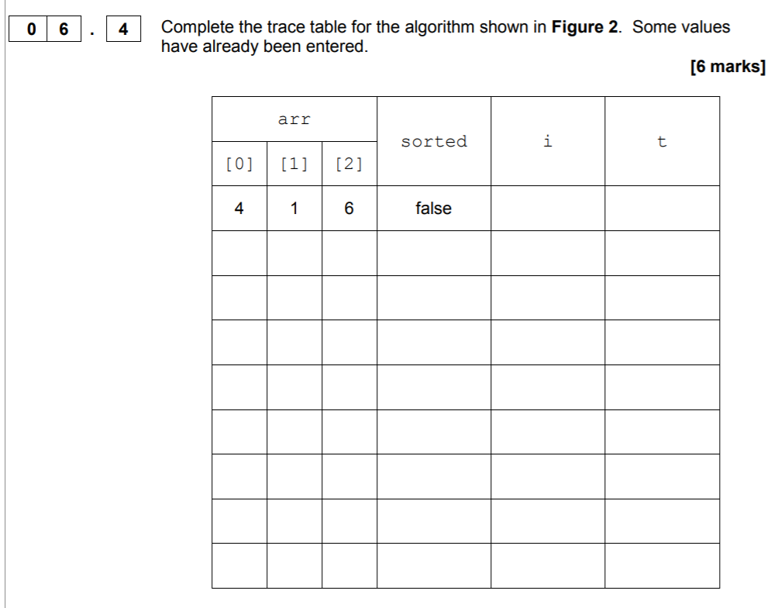

Trace table questions can be presented to students for them to solve. These are often marked by column, so the student must have all of the correct values in each column in the correct order in order to get the marks. These therefore often only have one answer possible that is correct.

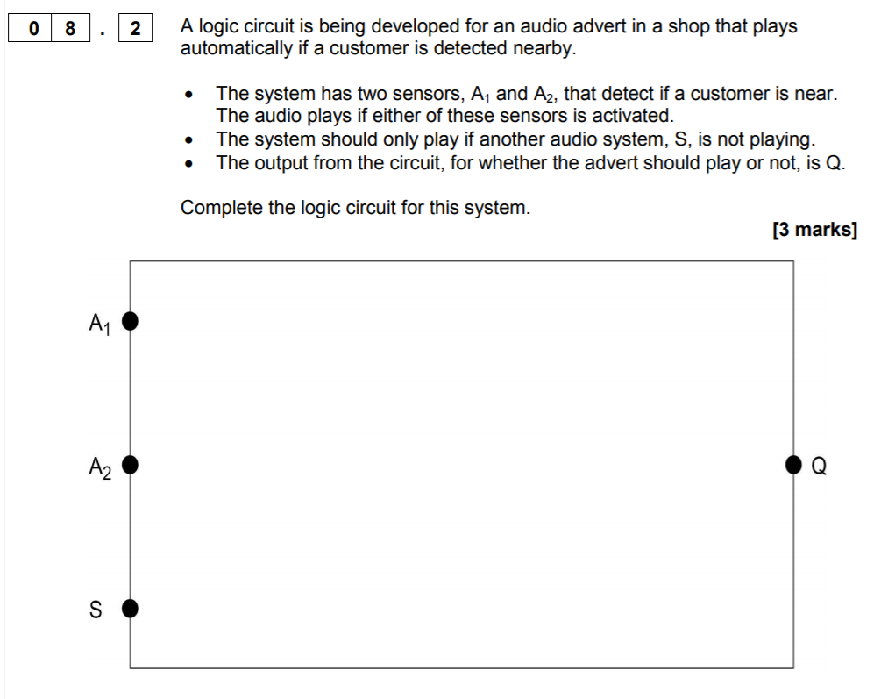

This is an example of a question that requires the student to draw/sketch out the solution. This question involves logic gates that the student must remember.

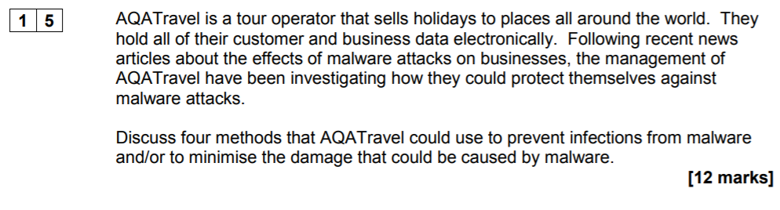

This is an example of an ethics/discuss question. These questions are hardest to mark overall, due to the number of marks that can be awarded, as well as the different stances various students can take, as this question is based on opinion as well as facts.

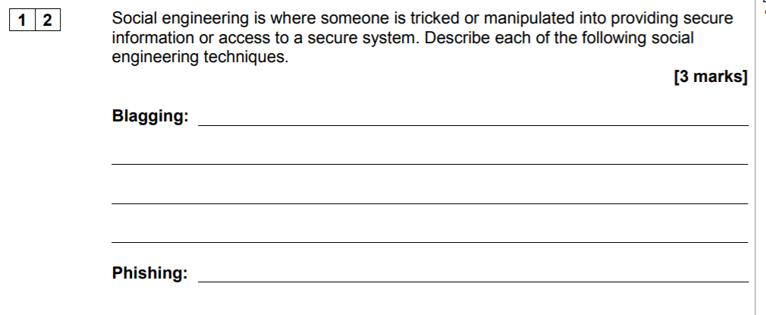

This is an example of a question that requires various answers for different points. It is a step up from the describe question previously mentioned.

## Objectives

1. Create a log in page to allow users to log in to existing accounts
   1. Create an option where the student can log out of their account
   2. The log in page should not show the password as it is typed in for security reasons.
   3. The system should take the user to their individual menus once logging in
   4. The system should have an option to create an account
   5. Create a teacher log in so they can manage the students in terms of what questions they can answer
   6. The system should require a minimum of 6 characters when creating a username, and 6 characters when creating a password
2. Have questions from a database appear to the students
   1. The questions should be in the correct format for the system
      1. The questions should be able to be formatted by using a GUI creator
   2. The stored questions in the database should be clear for the students answering them
   3. The questions should be organised by topic within the system
3. The system should let students answer questions
   1. The users should be able to choose when they submit an answer when completing a question
   2. There could be a way for class teachers to assign questions depending on difficulty and student
   3. There could be a way for the teacher to manage the relevant students within the system
   4. The system could let teachers add, edit and delete quizzes
      1. This would be useful in keeping the question relation in the database up to date
   5. The system could allow for a variety of question types
      1. These questions should be similar to the exam questions set by AQA Computer Science at GCSE
   6. There should be an element of randomization to the quizzes and questions given to the students
   7. The system could allow for spelling mistakes when students answer a question
   8. The system could use an algorithm to analyse longer responses for key words/phrases in order to determine the marks received
      1. There could be questions with different numbers of marks depending on complexity
   9. The system could analyse a data source to gather questions
      1. This would mean the system could stay up to date with the changing curriculum
      2. This would most likely involve an AI algorithm designed to scan for specific information
4. The system should automatically mark completed questions using data from a database
   1. The system should store a student’s answer when it has been submitted, along with the mark received, and when the question was submitted
   2. The system should note what areas the student struggled in over a period of time
5. The system should automatically save completed questions to the student’s account in order to monitor progress
   1. The system could provide brief notes on each topic for students.
      1. These can be used to help a student review a topic quickly before answering questions
      2. These could be viewed by clicking a help button when on each topic page
6. The system should display progress to individual users
   1. Progress should show the percentages for questions and topics
      1. How many attempts at a question were correct vs how many attempts were made
      2. For example, someone answered a question 10 times however only got 3 of those attempts correct. Their percentage would be 30% for that question
   2. The system could allow teachers to view student progress over time
   3. The system could recommend areas that need focus by analyzing past progress
   4. Student progress could be exported to a separate text file if requested by the student
   5. The student progress results could be mapped on a graph
      1. Use a bar graph to show the percentages for each topic
      2. A line graph could be made to show the user’s progress over time
         1. The progress over time could be by month or by week or by day depending on how long they have been attempting questions for
7. The database should organise questions within the database based on difficulty
   1. The system could use one of each difficulty to initially analyse the student’s knowledge
   2. The system should use past question marks to consider what question to next give the student.
   3. The system could comment on the progress of the student

## Solution Overview

The solution, as a summary, is a project based on supporting both students and teachers for Computer Science GCSE. The primary concern is the students however, the teachers could also benefit from the system. The student should be able to answer questions randomly on the system, and view their progress. The system should help them to learn content and also gain confidence in uncertain areas, whether that be topics or questions. This system will randomly generate questions, however, in regular intervals, questions will be generated based on the user’s previous areas of struggle. The teacher should be able to amend the difficulty level for each individual student, view their progress, and add questions to the database/amend the question table within the database. This can help teachers with setting homework and managing class time, as they will be able to better understand where their students struggle, and how they might be able to help them.

# Design

## Overall System Design

|  |  |  |  |
| --- | --- | --- | --- |
| Inputs | Processes | Storage | Outputs |
| Log in | Scoring | Student details | Score |
| Answer | Logging in | Questions | Answers |
| Add question | Progress report | Answers | Main menu |
| Edit question |  | Scores | Progress |

When starting my project, the initial IPSO chart looked like the one above. This is because I hadn’t thought about the solution as much, and therefore didn’t have a good idea of what the final result should look like

|  |  |  |  |
| --- | --- | --- | --- |
| Inputs | Processes | Storage | Outputs |
| Username | Logging in | Student details | Main menu |
| Password | Marking quesrions | Teacher details | Marked question |
| Type of user | Generating progress graph | Questions | Progress graphs |
| Answer | Adding questions | Answers | Activity graphs |
| Add question - question | Editing questions | Assigned questions | Questions |
| Add question - answer | Deleting questions | Question types | Assigned questions |
| Add question - topic | Assigning questions |  |  |
| Add question - difficulty |  |  |  |
| Add question – options/marking points |  |  |  |
| Change student difficulty |  |  |  |

My final IPSO chart involves processes and inputs for the teacher as well as the student. This is after I expanded my idea, and thought more about the teacher involvement in the program.

## Modular Design

### Form based design

This was my initial idea for the system when keeping limitations in mind, however, after spending more time thinking about the project, I expanded on this idea into the hierarchy chart below

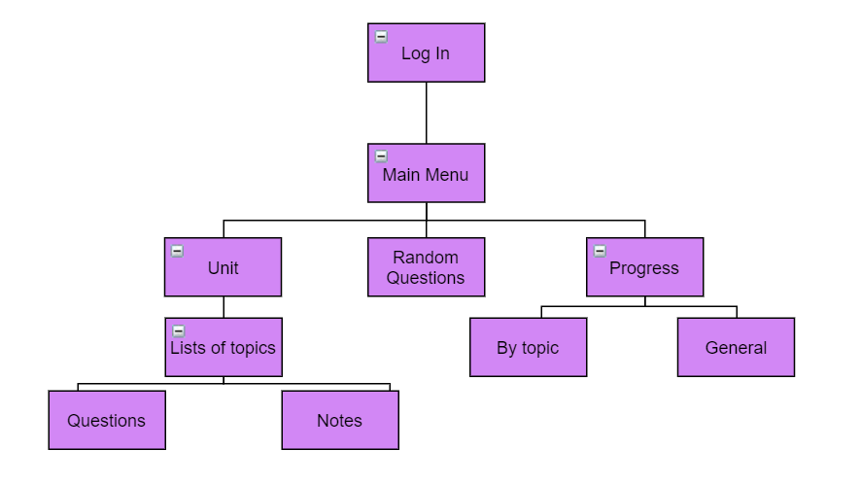

Figure 5a

This is the hierarchy chart for the student user interface design. When the user logs in, they should be directed to the main menu, from which they can choose where to go within the program. If they choose to go into the units area, they can choose a topic to answer questions on, or read quick notes about. If they select the random question area, they will be prompted to answer a question randomly generated by the system. If they select the progress area, they can view their progress by topic, or their overall progress.

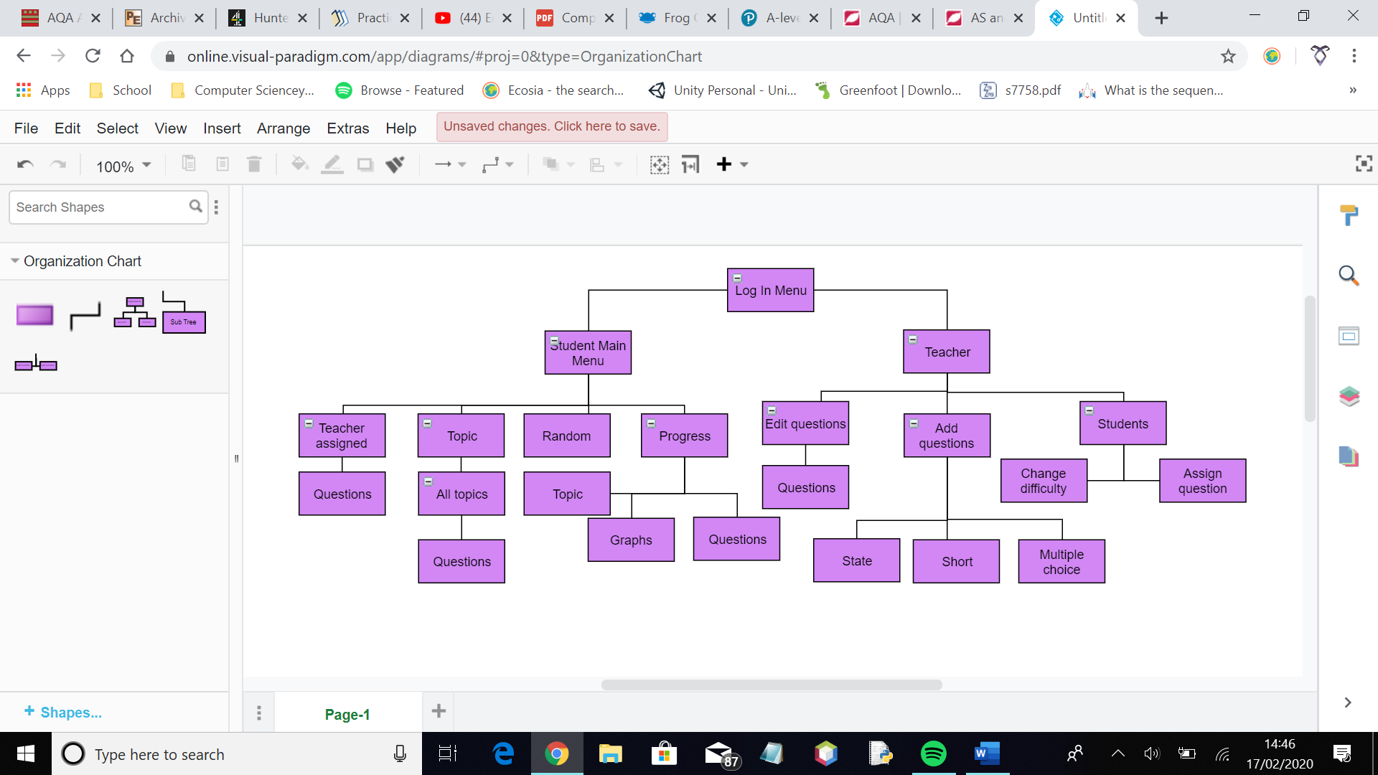

Figure 5b

## Definition of Data Requirements

After developing my solution, the data requirements for inputs and processes changed and expanded.

|  |  |  |  |  |  |
| --- | --- | --- | --- | --- | --- |
| Field Name | Field Purpose | Field Type | Field Size | Example | Validation |
| Student ID | Uniquely identify the student | Integer | 4 | 1234 | Not empty |
| First Name | Stores name of user | String | 30 | John | Is a string with no integers |
| Last Name | Stores name of user | String | 30 | Smith | Is a string with no integers |
| Username | Uniquely identifies user | String | 30 | JSmith1 | Matches a username in the existing database |
| Password | Verifies unique user | String | 30 | Pass12.3 | Matches a password and the relevant username in the existing database |
| Class | Groups together students for the teacher | String | 3 | SKR | Not null |
| Level | Used to identify how easy the student finds the subject/ how good they are at it | Integer | 1 | 2 | Check is an integer – have restricted options – drop down menu |
| Difficulty level | Used to work out what level of difficulty questions should be given to each student | Integer | 1 | 3 | Not null |
| Question – multiple choice | Questions that give the student a choice of answers that might be correct | String | 200 | Which is an example of binary? | Options not empty |
| Response – multiple choice | Can only respond with one character per answer | Character | 1 | A | At least one checkbox is ticked |
| Question – state | A question type in exams where the answer is one word | String | 200 | State the arithmetic effect of applying a left binary shift of 3 to a binary number. | Answer not empty. Question not empty. |
| Response - state | Student only needs to answer question with one word or a very short answer – max 10 words | String | 100 | Multiplying by 8 | Textbox not empty |
| Question – adding | Used to add the question string to the database | String | 100 | What is an algorithm? | Not empty, not an integer |
| Answer – adding | Used to add the answer of a question to the database | String | 50 | Sequence of instructions | Not empty |
| Topic – adding | Used to add the topic of a question to a database | Integer | 1 | 5 | Not empty, not too big a number, not a string |
| Difficulty – adding | Used to add the difficulty of a question to a database | Integer | 1 | 2 | Not empty, not a string, not a string |
| Marking points/options – adding | Used to add multiple choice options or marking points to the database | String | 50 | Function | Should at least have one |
| Search bar – questions | Used to find the question the user wants | Integer | 3 | 12 | Check it is an integer |

## Definition of Record Structure

I am using text files to organise my topics for the GCSE. I will use one text file that holds the name of each topic according to the GCSE AQA syllabus. This takes up less storage space than if they were saved in a database. In this file, each line holds a different topic number and name.

I am also using textfiles to store data about where a student can find help for a question if they are stuck. This means the system is more useful when helping the student revise. In this file, each line holds the page numbers a student can go to for help depending on each topic.

## Validation

|  |  |  |  |  |  |  |
| --- | --- | --- | --- | --- | --- | --- |
| Validation Check | Description | Field | Data type | Valid data | Erroneous data | Caught |
| Presence | Check that data has been entered | Username registration | String | Abcdef2345 | Sjf6 | Yes – program does not proceed without having something entered for every field |
| Presence | Check the user doesn’t already exist | Registration | String, integer | Something not in the table | Something in the table | Yes – defined a method to check for existing user ids. |
| Length, presence | Check the class name field is not empty and is vallid | Registration | String | AGE | He2k | Yes – uses dropdown |
| Presence | Check the user has entered a username and password, as well as the status – teacher or student | Login | String | Sdave1 | Null | Yes - Does not continue until all fields have been completed |
| Presence | Check the user has entered something into the field | Answering questions | String | Variable | Null | Yes – checks the user input is not empty but does not loop back to the question |
| Lookup | Checking the level of the student is 1, 2 or 3 | Teacher modifying student level | Integer | 1 | 50 | Yes – only allows those values due to using a drop down menu |
| Lookup | Checking the topic entered is within range – 1, 8 | Teacher adding question | Integer | 6 | 15 | Yes – only allows those values due to using a drop down menu |
| Presence | Checking an answer and question have been submitted for a multiple choice or state question | Teacher adding question | String | CPU, What is an algorithm? | Null, null | Yes – however, fields that have been completed are erased |
| Presence | Check values have been entered for at least one option/marking point | Teacher adding question – short, multiple | String |  | Null | Yes – however, fields that have been completed are erased |
| Lookup | Checking the difficulty entered is within range | Teacher adding question | Integer | 3 | 9 | Yes – only allows those values due to using a drop down menu |
| Datatype | Check data is an integer for topic or difficulty entering | Changing student difficulty or adding a question | Integer | 4 | Hello | Yes – only allows those values due to using a drop down menu |
| Presence | Check none of the fields are empty when modifying questions | Modifying questions | String, Integer |  | Null | Yes – self defined method to do so |
| Presence, datatype | Check the user has entered an integer when searching for a question | Modifying questions, assigning questions | Integer | 7 | Null, hello | Yes – datatype is checked |
| Presence | Make sure the user doesn’t try to submit an answer to the same question more than once – would create an integrity error in the database | Submitting answers to questions | String, button | 100 | A second piece of data | Yes – try except loop catches any errors and user is informed |
| Presence | Make sure teacher doesn’t assign a question to a student twice | Assigning to student | Button | Pressing button once | Pressing button twice | Yes – using a try except statement to catch integrity error |

## File Organisation and Processing

My files that I am using do not take up much storage and do not require much processing and memory as a result.

## Database Design including Normalised Relations

Figure 6a

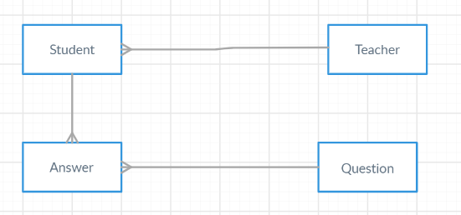

This is the initial entity relationship diagram for my system. A student can only have one teacher – in this case – and a teacher can have multiple students – a class. A student can have multiple answers to a question, however, each answer in the answer table is unique to one student, even if there are exact same answers for questions made by different students. One question can be answered multiple times, but each answer can only be to one specific question.

Answer table original

|  |  |  |  |
| --- | --- | --- | --- |
| *StudentId* | *QuestionId* | Answer | Score |
|  |  |  |  |
|  |  |
|  |  |

However, this database is not normalised, so it needs to be modified. A student could answer the same question multiple times, which would cause repeats in this system.

A new unique identifier is needed. We are going to use the date the question was answered. For this table to be normalised, the time the question was answered must also be stored with the date, as a student could answer the same question more than once in a day.

|  |  |  |  |  |
| --- | --- | --- | --- | --- |
| StudentId | QuestionId | Date | Answer | Score |
|  |  |  |  |  |

This is in first normal form as the data is atomic. Here, while the score does depend on the question, student who answered it, and when they answered it, the score also depends on the answer the user input. This means that the answer must also be a primary key. This also means that the user must enter an answer.

|  |  |  |  |  |
| --- | --- | --- | --- | --- |
| StudentId | QuestionId | Date | Answer | Score |
|  |  |  |  |  |

This is now in second normal form, as all attributes have a key dependency, and in third normal form as all attributes depend on the key, the whole key, and nothing but the key.

Question table

|  |  |  |  |  |  |  |  |  |  |
| --- | --- | --- | --- | --- | --- | --- | --- | --- | --- |
| QuestionId | Question | Answer | Topic | Question_type | Difficulty | Option1 | Option2 | Option3 | Option4 |
|  |  |  |  |  |  |  |  |  |  |

This is already in first normal form as all data is atomic. However, the options depend on the question type as well as the id, meaning this table is not in second normal form, as there are partial key dependencies.

|  |  |  |  |  |
| --- | --- | --- | --- | --- |
| QuestionId | Question | Answer | Topic | Difficulty |
|  |  |  |  |  |

|  |  |  |  |  |  |
| --- | --- | --- | --- | --- | --- |
| *QuestionId* | QuestionType | Option1 | Option2 | Option3 | Option4 |
|  |  |  |  |  |  |

These tables are in third normal form as all attributes depend on the key, the whole key, and nothing but the key. There are also no partial key dependencies, as the options attributes depend on what the type of question is, as well was what question it is. The tables were split up as the answer, question, topic and difficulty did not depend on the question type, therefore, question_type could not have been made a primary key in the original table.

Student table

|  |  |  |  |  |  |  |
| --- | --- | --- | --- | --- | --- | --- |
| StudentId | Firstname | Surname | Username | Password | Class | Level |
|  |  |  |  |  |  |  |

This is already in third normal form as it has atomic data and all attributes depend on the key, the whole key, and nothing but the key.

Teacher table

|  |  |  |  |
| --- | --- | --- | --- |
| TeacherId | Username | Password | Name |
|  |  |  |  |

This is already in third normal form as well, as all attributes depend on the key, the whole key and nothing but the key. There are also no repeating attributes.

Figure 6b

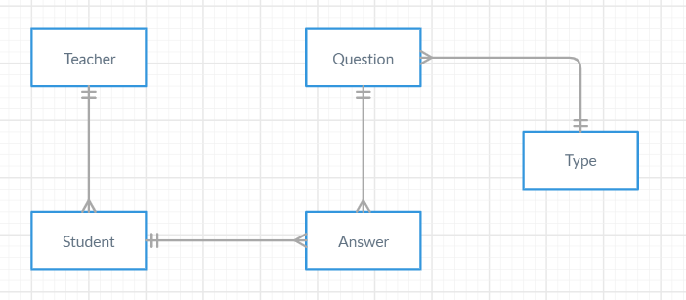

This is the entity relationship now that the tables have been normalised.

Figure 6c

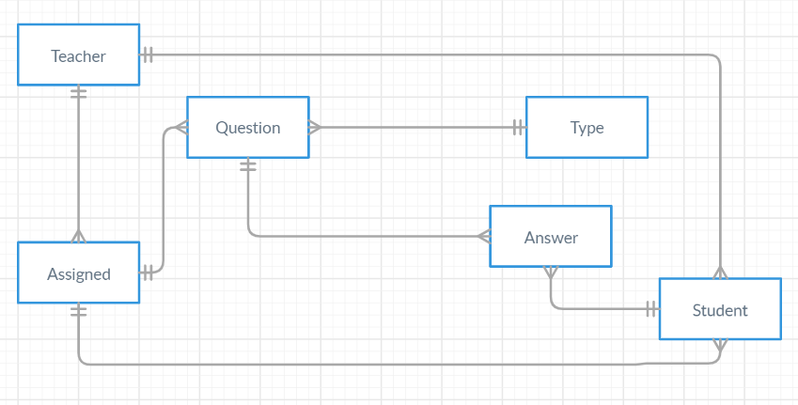

This is my final entity relationship diagram after finishing the tables in my database. This database involves an assigned table which holds the questions a teacher has set for individual students. Elements disappear from this table once the associated question has been answered.

|  |  |  |
| --- | --- | --- |
| *StudentId* | *QuestionId* | *Initials* |
|  |  |  |

Here, foreign keys are used to make up the composite primary key. This table is used to keep track of what questions are assigned to what student.

## Samples of Planned SQL queries

### Select

Teacher class

|  |  |
| --- | --- |
| Purpose | Finds relevant details when assigning a question to a student |
| Statement | SELECT QUESTION, ANSWER, TOPIC FROM QUESTION WHERE QUESTIONID = ? |

|  |  |
| --- | --- |
| Purpose | Used to calculate the questionid that should be assigned to the question being added to the database |
| Statement | SELECT MAX(QUESTIONID) FROM QUESTION |

|  |  |
| --- | --- |
| Purpose | Used to display the questions in the database to the user |
| Statement | SELECT QUESTION FROM QUESTION ORDER BY QUESTIONID ASC |

Process class

|  |  |
| --- | --- |
| Purpose | Finds the student id from the table |
| Statement | SELECT STUDENTID FROM STUDENT WHERE USERNAME = ? AND PASSWORD = ? |

|  |  |
| --- | --- |
| Purpose | Used to find all of the questions in the database |
| Statement | SELECT COUNT(*) FROM QUESTION |

Progression class

|  |  |
| --- | --- |
| Purpose | Used to help work out how many times a student has answered questions from a topic |
| Statement | SELECT ANSWER.QUESTIONID FROM QUESTION, ANSWER WHERE QUESTION.TOPIC = '%s' AND ANSWER.STUDENTID = '%s' AND QUESTION.QUESTIONID = ANSWER.QUESTIONID |

Question class

|  |  |
| --- | --- |
| Purpose | Finds the question in the database to be displayed |
| Statement | SELECT QUESTION FROM QUESTION WHERE QUESTIONID = ? AND DIFFICULTY <= ? |

Marking class

|  |  |
| --- | --- |
| Purpose | Used to find the answer to a multiple choice or state question |
| Statement | SELECT ANSWER FROM QUESTION WHERE QUESTIONID = ? |

### Insert

|  |  |
| --- | --- |
| Purpose | Used to add the user’s response to the relation of responses |
| Statement | INSERT INTO ANSWER(ANSWERS, STUDENTID, QUESTIONID, DATE_DONE, SCORE)  VALUES ?, ?, ?, ?, ? |

|  |  |
| --- | --- |
| Purpose | Used to add a state or multiple choice question to the relation for questions |
| Statement | INSERT INTO QUESTION(QUESTIONID, QUESTION, ANSWER, TOPIC, DIFFICULTY)  VALUES ?, ?, ?, ?, ? |

|  |  |
| --- | --- |
| Purpose | Used to add to the type relation for short or multiple choice questions |
| Statement | INSERT INTO TYPE(QUESTIONID, QUESTION_TYPE, OPTION1, OPTION2, OPTION3, OPTION4)  VALUES ?, ?, ?, ?, ?, ? |

### Update

|  |  |
| --- | --- |
| Purpose | Used to edit a multiple choice or state question in the question relation |
| Statement | UPDATE QUESTION  SET QUESTION = ?  ANSWER = ?  DIFFICULTY = ?  TOPIC = ?  WHERE QUESTIONID = ? |

### Delete

|  |  |
| --- | --- |
| Purpose | Used to delete a question from the database when the user wants to |
| Statement | DELETE FROM QUESTION, TYPE WHERE QUESTION.QUESTIONID = ? AND TYPE.QUESTIONID = ? AND QUESTION.QUESTIONID = TYPE.QUESTIONID |

|  |  |
| --- | --- |
| Purpose | Used to delete the assigned question that has been completed by the student from the assigned relation |
| Statement | DELETE FROM ASSIGNED WHERE QUESTIONID = ? |

### Data Definition Language

Creating student table

CREATE IF NOT EXISTS STUDENT

STUDENTID INT(4) PRIMARY KEY NOT NULL

FIRSTNAME VARCHAR(30) NOT NULL

SURNAME VARCHAR(30) NOT NULL

USERNAME VARCHAR(30) NOT NULL

PASSWORD VARCHAR(30) NOT NULL

CLASS CHAR(3) NOT NULL

LEVEL INT(1) NOT NULL;

Creating type table

CREATE IF NOT EXISTS TYPE

QUESTIONID INT(5) NOT NULL

QUESTION_TYPE CHAR(2) NOT NULL

OPTION1 VARCHAR(100)

OPTION2 VARCHAR(100)

OPTION3 VARCHAR(100)

OPTION4 VARCHAR(100)

FOREIGN KEY (QUESTIONID) REFERENCES QUESTION(QUESTIONID),

PRIMARY KEY (QUESTIONID, QUESTION_TYPE)

Creating answer table

CREATE IF NOT EXISTS ANSWER

ANSWERS VARCHAR(100)

STUDENTID INT(3) NOT NULL

QUESTIONID INT(5) NOT NULL

DATE DATE NOT NULL

SCORE BOOLEAN NOT NULL

FOREIGN KEY (QUESTIONID) REFERENCES QUESTION(QUESTIONID)

FOREIGN KEY (STUDENTID) REFERENCES STUDENT(STUDENTID)

PRIMARY KEY (QUESTIONID, STUDENTID, DATE)

## Types of question to be expected

|  |  |  |
| --- | --- | --- |
| Question type | Summary | Will it be included in my system |
| State question | Questions that require a one or two word answer, and have no room for leniency | This will be included as it an easy problem to solve, and can help students with key terminology and simple facts of the specification |
| Multiple choice question | These questions give a few answers for the student to choose from. They can appear in the GCSE papers, where it asks the student to shade the correct lozenge | This will be included as it is relevant to the exam format, and can be quite common. It also helps a student get the hang of a concept or topic/key terminology. |
| Calculation question | These questions can be rare in papers for computer science at GCSE, often only occurring when a data representation question is asked. | This type of question can be included, however, it wont be specifically mentioned to the user. |
| Short answer question | These questions often use words such as describe or define. They are fairly common in GCSE Computer Science papers. | This type of question will be included to help vary the question types the student can answer. |
| True/false question | These types of question have a similar format to the multiple choice question, therefore meaning it should require a similar output and processing as multiple choice questions. | This will be included as it is very similar to the multiple choice format, so it should be possible to include. |
| Explain question | These types of questions require justification and various points to be made. This can make them difficult to automatically mark without an algorithm to analyse a whole piece of text. | This type of question will likely not be included in my final design due to the complexity of the problem and the solution to solve it – this would require more time to work on solving the problem, and more investigation in to AI algorithms. |
| Trace table | These types of question often only appear in the paper 1 of the GCSE Computer Science exams, and may only appear once or twice. They involve displaying a table and algorithm to the student, and having them complete the table by running through the algorithm. The table is then marked by column. | While this type of question could be possible with more work on the interface, it may not be the most beneficial to the student, and may require more time to look in to how it could be output for the user to answer the question, using tkinter as the output for the user interface. |
| Diagrams | Often, students can be asked to complete diagrams for logic circuits. This requires the student to remember symbols, and think logically about how the problem may be solved. | This can be difficult to output within the system, as it requires the form of output to be looked into in more detail, as well as having various solutions in some situations. This can be hard for my system to automatically mark. |
| Algorithms | This requires the student to solve a problem using pseudocode or flowcharts. As algorithms can be very varied, there are a lot of different solutions for one problem, so there is not always just one correct answer. | This question will not be included in my system due to the complexity of the marking and solution to various problems. Due to knowledge and timer constraints, it will not be possible to include. |
| Matching | These types of questions involve matching the correct word to the correct definition. There is only one correct answer for each definition as a result. | This type of question could be possible to use in the system if formatted in the same way as a multiple choice question. |

Could have tips button for teacher user as to what they can have with each type of question format

## Identification of Suitable Algorithms for Data Transformations

* Highlight different sections in final version that have been changed
* Show in more detail how it has changed
* USE ADD TO FOR APPEND
* USE FOR EACH IN FOR for I in list

|  |
| --- |
| Algorithm – log in - original |
| SUB login(Log, u, p)  GLOBAL stu  IF u.get() = "" OR p.get() = "" THEN  lbl_1 🡨 LABEL (Log, text 🡨 "Please enter your details.")  ELSE  ("SELECT * from STUDENT WHERE username = '%s' AND password = '%s'" %(u.get(), p.get()))  IF fetchone() IS NOT NONE THEN  m_window(Log, root)  ELSE  lbl_1 🡨 Label(Log, text 🡨 "Invalid")  ENDIF  ENDIF  ENDSUB |
| Explanation |
| This allows a student to log in as the data is only verified in one database. This algorithm therefore worked for earlier designs of my solution that did not involve the teacher |

|  |
| --- |
| Algorithm – log in |
| SUB login(window, u, p, s)  status 🡨 s.get()  lbl 🡨 ""  IF u.get() = "" or p.get() = "" THEN  PASS  ELIF status = "Teacher"  ("SELECT * FROM TEACHER WHERE usert = '%s' AND passt = '%s'" %(u.get(), p.get()))  IF cursor.fetchone() IS NOT NONE THEN  teacher_1 🡨 Teacher(u, p)  teacher_1.tm_window(window)  ELSE  sleep(1)  window.destroy()  l_window("Incorrect username or password. Please try again.")  ENDIF  ELIF status = "Student":  ("SELECT * FROM STUDENT WHERE username = '%s' AND password = '%s'" %(u.get(), p.get()))  IF cursor.fetchone() IS NOT NONE THEN  student_2 🡨 Student(u, p)  student_2.m_window(count_t, count_r, window)  ELSE  sleep(1)  window.destroy()  l_window("Incorrect username or password. Please try again.")  ENDIF  ENDIF  ENDSUB |
| Explanation/changes |
| This allows a student or teacher to log in to the system. This algorithm was designed once the teacher menus had been established and created. In this system, the user determines whether they are a teacher or student. The student identifier fetched was made global to make it more accessible throughout the program |

|  |
| --- |
| Algorithm - search |
| SUB search_questions(question_id, window)  TRY:  ("SELECT * FROM QUESTION WHERE QUESTIONID 🡨 '%s'" %(question_id))  information 🡨 cursor.fetchall()  ("SELECT * FROM TYPE WHERE QUESTIONID 🡨 '%s'" %(question_id))  typ 🡨 fetchall()  RETURN information, typ  EXCEPT IndexError  LABEL (window, text 🡨 "That question number does not exist. Please try again")  EXCEPT ValueError  LABEL (window, text 🡨 "You did not enter anything")  EXCEPT TypeError  LABEL (window, text 🡨 "You did not enter an integer")  ENDSUB |
| Explanation |
| This allows a user to search a table for a specific question. This is useful for the teacher, when they want to assign questions or find a question to change or delete. |

|  |
| --- |
| Algorithm – activity graph |
| SUB activity_graph()  ("SELECT DATE_DONE FROM ANSWER WHERE STUDENTID = '%s' ORDER BY DATE_DONE ASC" %(student))  dates 🡨 fetchall()  date_o 🡨 []  FOR EACH i IN dates:  date_and_time 🡨 i[0].split(" ")  date_o.append(date_and_time[0])  ENDFOR  prev 🡨 [ ]  activity 🡨 [ ]  FOR EACH i IN dates_o:  act 🡨 date_o.count(i)  IF i IS IN prev THEN  PASS  ELSE  prev.append(i)  activity.append(act)  ENDIF  ENDFOR  PLOT (prev, activity)  XLABEL ("Date")  YLABEL ("Activity (questions answered per day)")  TICK_PARAMS (axis = "x", rotation = 45)  SHOW  ENDSUB |
| Explanation |
| This is the algorithm involved in displaying user activity in the past to the user. This is just for the student, and is based on how many questions are answered in a day. Therefore, high activity correlates with high amount of answered questions. This method makes use of the matplotlib library in python, in order to easily display the graph required without getting too involved in the graphics behind it. |

|  |
| --- |
| Algorithm – generating question - original |
| SUB questions(window, c, cursor):  GLOBAL a, que, number  btn_back 🡨 Button(window, text 🡨 "Back", command 🡨 partial(Back, window, root)).pack()  ("SELECT COUNT(*) FROM QUESTION;")  e 🡨 fetchall()  e_2 🡨 e[0][0]  number 🡨 random.randint(1, int(e_2))  ("SELECT Question FROM QUESTION WHERE QuestionID = '%s'" %(number))  que 🡨 fetchone()  lbl_q 🡨 Label(window, text 🡨 que[0]).pack()  ("SELECT Question_Type FROM QUESTION WHERE QuestionId = '%s'" %(number))  q_t 🡨 fetchall()  q_t_1 🡨 q_t[0]  a 🡨 StringVar()  an 🡨 Entry(window, textvariable 🡨 a).pack(side 🡨 BOTTOM)  ("SELECT AnswerM FROM QUESTION WHERE QuestionID = '%s'" %(number))  ans_1 🡨 cursor.fetchone()  ans 🡨 ans_1[0]  enter 🡨 Button(window, text 🡨 "Submit", command 🡨 partial(mark, window, ans, a, number, c, cursor)).pack()  ENDSUB |
| Explanation |
| This was the original code to generate a question when I was just working with state questions. At this point, the code only accepted one answer, and only had one format to output as. As I developed my solution, and more question types got involved, my function had to develop to accommodate them. |

|  |
| --- |
| Algorithm – generating question |
| SUB question(subtopic, count)  IF (STRING_TO_INT(count) MOD 3) <> 0 THEN  question_id, question_type 🡨 normal_question()  ELIF (STRING_TO_INT(count) MOD 3) = 0 THEN  IF type = "R" THEN  question_id, question_type 🡨 tailored()  ELSE  question_id, question_type 🡨 normal_question()  ("SELECT TOPIC FROM QUESTION WHERE QUESTIONID = '%s'" %(question_id))  ENDIF  topic 🡨 fetchone()[0]  TRY  IF question_type[0] = "S" or question_type[0] = "SH" THEN  s 🡨 get_state_question(question_id)  opt, variables 🡨 " ", " "  ELIF question_type[0] = "M"  variables, opt 🡨 get_multiple_question(question_id)  s 🡨 " "  ENDIF  EXCEPT Exception  PASS  info_button(window, topic)  marking(count, subtopic, s, opt, variables)  ENDSUB |
| Explanation |
| This is more concise and separates different parts of the problem by method. This method brings all the different functions together to complete the task at hand. |

|  |
| --- |
| Algorithm – marking multiple choice |
| SUB multiple(opt, variables)  selected 🡨 selected(opt, variables)  ("SELECT OPTION1, OPTION2, OPTION3, OPTION4 FROM TYPE WHERE QUESTIONID = '%s'" %(question_id))  options 🡨 fetchall()[0]  IF LEN(selected) <> 1 THEN  LABEL (window, text = "Error. Incorrect number of checkboxes selected. You may only select one.")  LABEL (window, text = answer)  ELSE  user_answer = options[selected[0][0]]  calculating(user_answer, answer, date)  ENDIF  ENDSUB  SUB selected(options, variables):  selected = [ ]  FOR o 🡨 0 TO LEN(variables)  IF variables[o].get() = 1 THEN  selected.append((o, 1))  ENDIF  ENDFOR  RETURN selected |
| Explanation |
| This involves assigning variables to each option for the user, and checking whether they have been selected or not. This means each value has to be checked, and things such as selecting two or more options need to be verified and accounted for. |

|  |
| --- |
| Algorithm – short answer marking |
| SUB short(var)  ("SELECT OPTION1, OPTION2, OPTION3, OPTION4 FROM TYPE WHERE QUESTIONID = '%s'" %(self.question_id))  points 🡨 cursor.fetchall()[0]  points 🡨 0  count 🡨 0  input 🡨 var.get()  FOR EACH i IN points  IF i IS NOT NONE THEN  points 🡨 points + 1  IF i 🡨 input TO input THEN  Count 🡨 count + 1  ENDIF  ENDIF  IF points = count:  LABEL (window, text = "Correct")  value 🡨 TRUE  ELSE  LABEL (window, text = "Incorrect")  value 🡨 FALSE  ENDIF  IF type <> " "  next_button(input, value)  ENDSUB |
| Explanation |
| This is how the short answer question is marked. There are marking points stored in the database, which can be used to check whether the student should get a mark or not. Currently, the user must mention all marking points in order to be awarded a mark. |

|  |
| --- |
| Algorithm – assigning questions |
| SUB assign_to_database(student_id, question_id, window)  ("SELECT * FROM ASSIGNED WHERE QUESTIONID = '%s' AND STUDENTID = '%s'" %(question_id, student_id))  TRY  initials 🡨 self._get_initials()  ("""INSERT INTO ASSIGNED(STUDENTID, QUESTIONID, INITIALS)  VALUES(?, ?, ?)""", (student_id, question_id, initials))  assign(student_id, window)  EXCEPT sqlite3.IntegrityError:  LABEL (window, text = "This question has already been assigned to this student.")  ENDSUB |
| Explanation |
| This is how the teacher can assign questions to individual students. The question is added to a relation along with the student id, so it can be displayed to the student when chosen. |

## Key Data Structures

* Queue – this is mainly for the tailored questions for the user – the queue means the user answers questions they have not done as well in more often.
* Multidimensional arrays – mostly used when fetching lots of data from sql tables
* Records/file handling – used for displaying the topics to the user, and the notes for the user’s assistance
* Sql queries – multitable – makes it easier to compare data. I have had a solution involving fetching data from separate tables and combining it, however, that made the program less efficient and was not beneficial towards my solution as a result
* Aggregate functions – COUNT, MAX – easier to find specific details about the elements of a table
* Classes – easier to organise the code and help with ease of use

## Class Definitions

While developing my solution, I decided to use classes as it helps to clarify the code and group the methods used so that it is easier to understand. I used the process class to group together the most common methods required. The progress relation contains methods that generate graphs and percentages for progress. The queue class is used for the tailored questions. The mark class contains methods that automatically mark different question types. The question class generates the different questions.

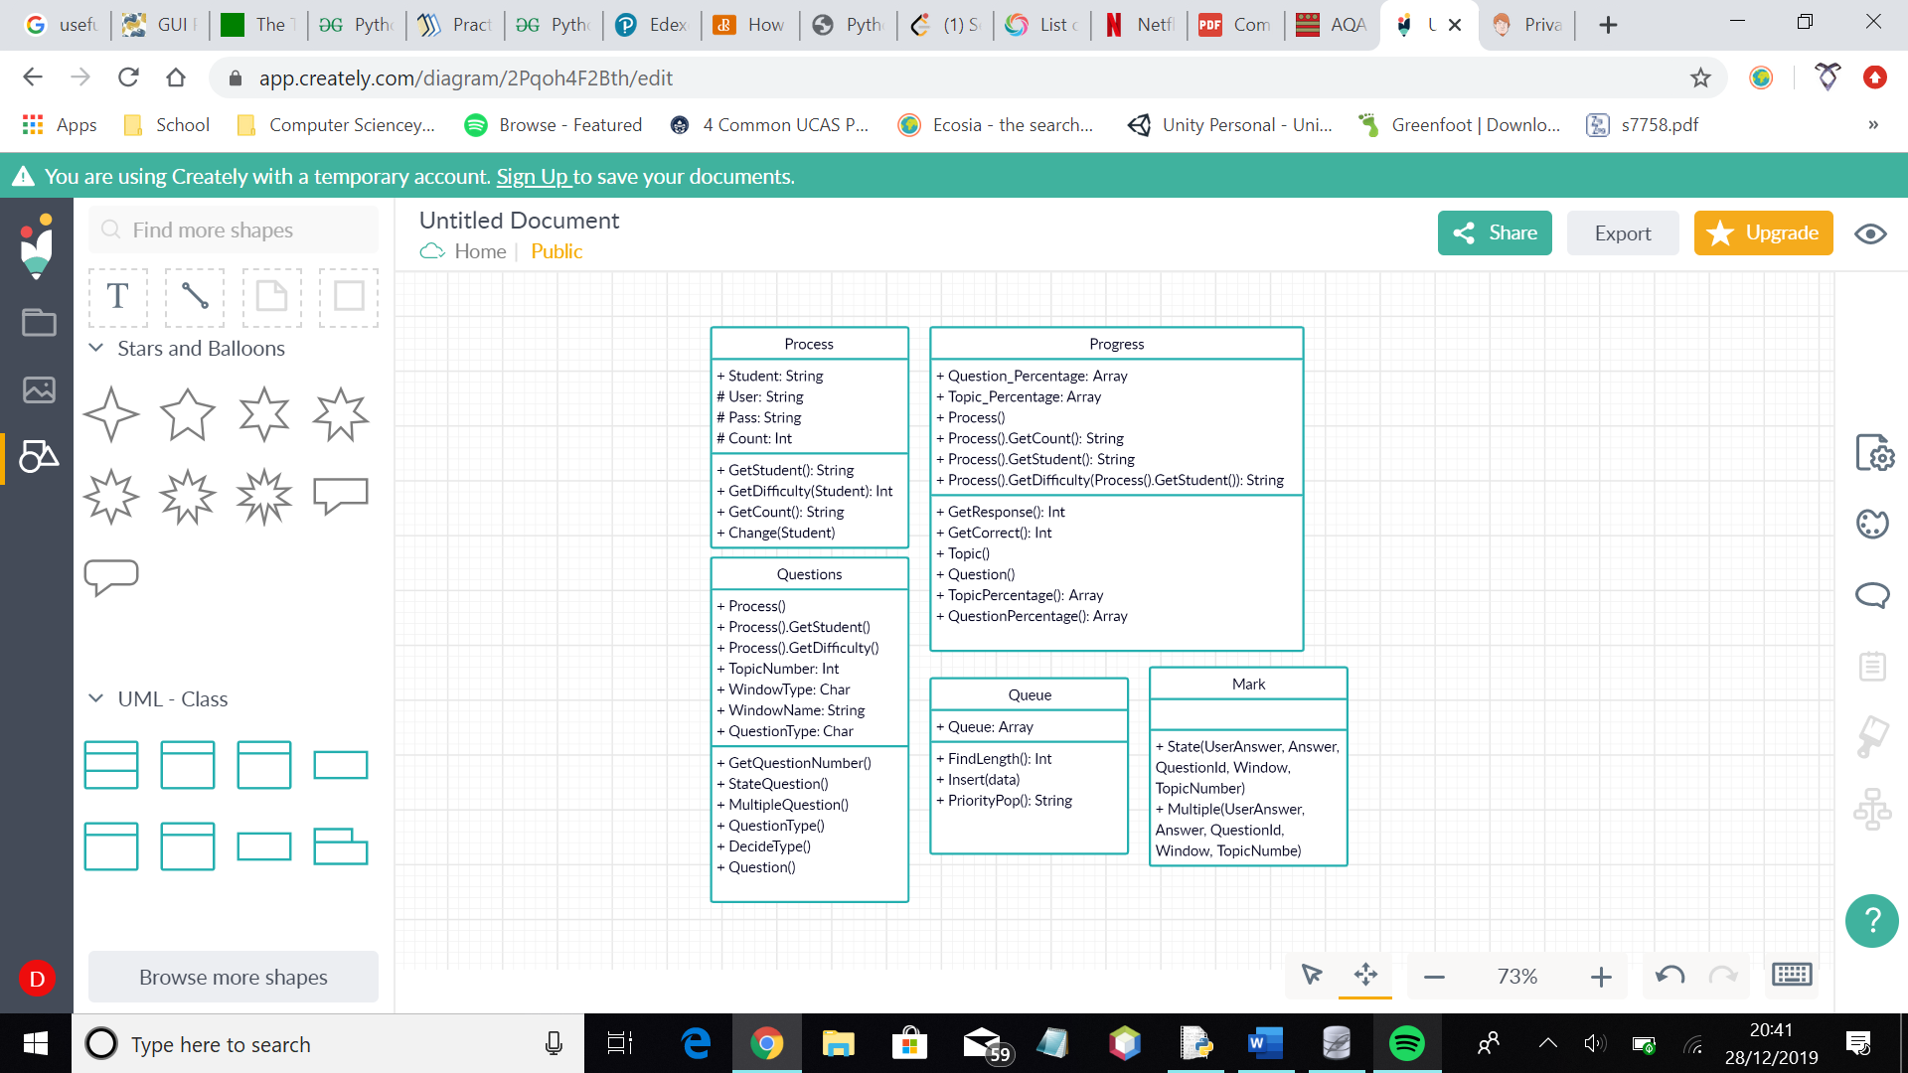

Figure 7a

These are my new classes. A priority queue class is inheriting from the queue class, in order to generate the worst answered questions for the user. The question class has some more methods to allow for different question types, and the mark class has methods to accommodate this. Methods have now been organised by teacher and student, to clear up the menus and how the windows link together.

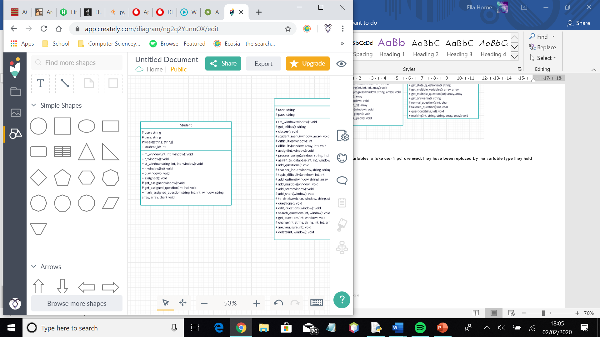

Figure 7c

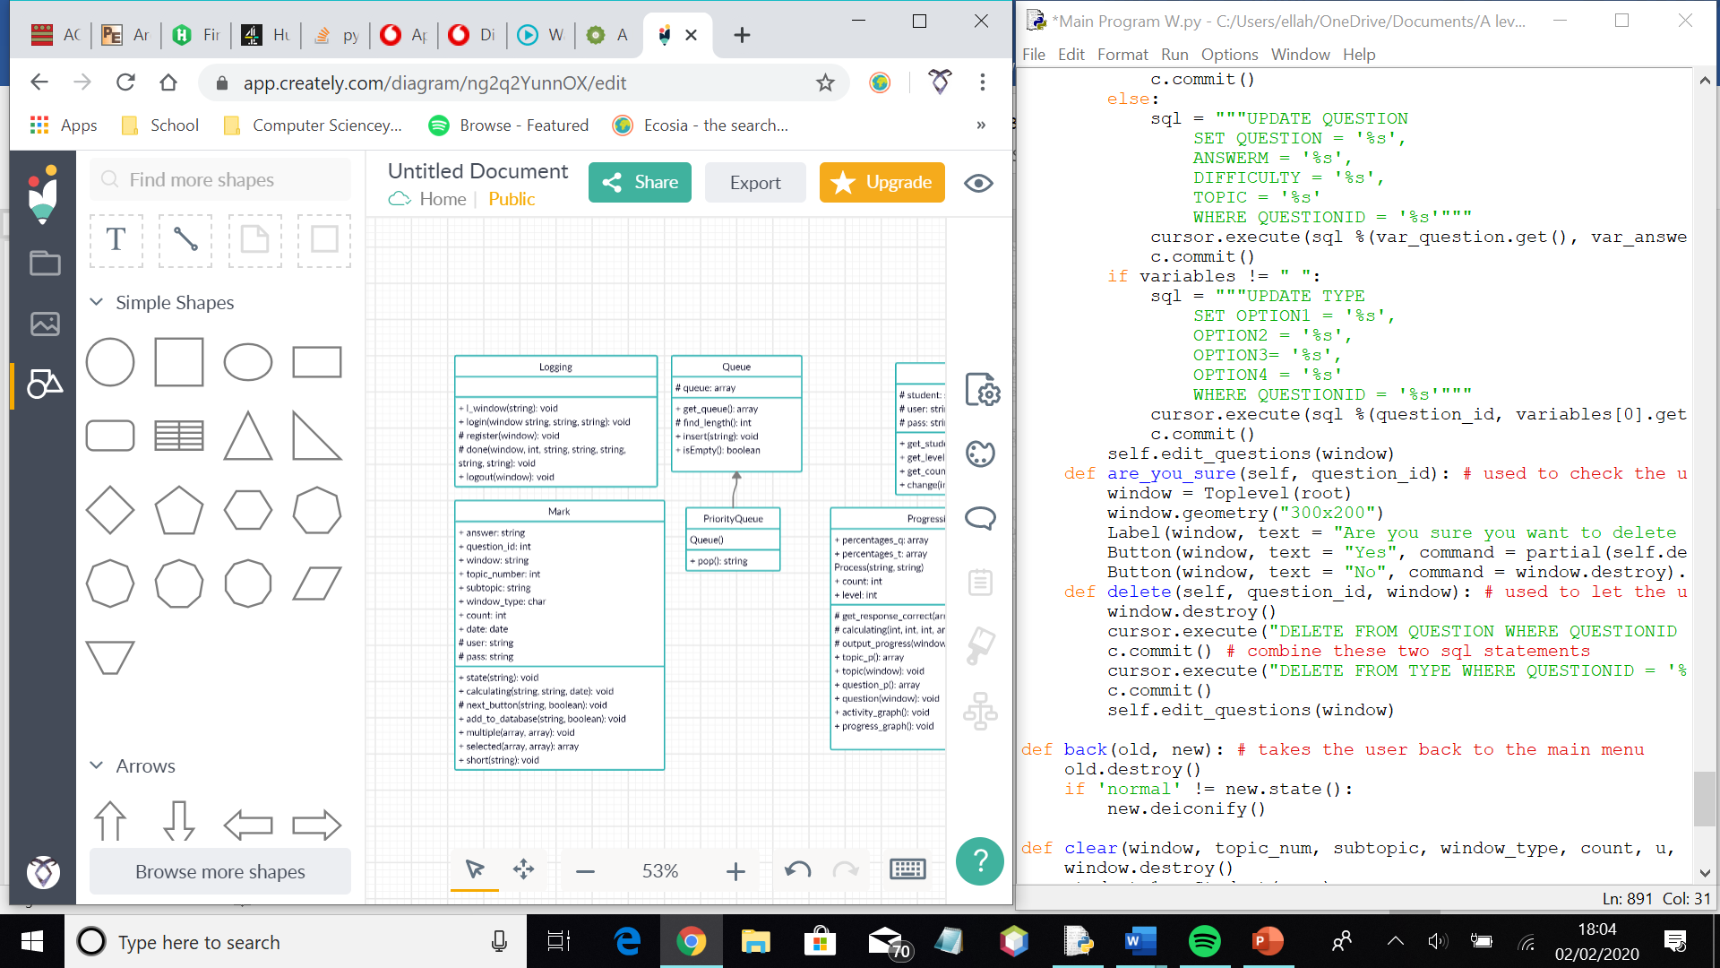

Figure 7b

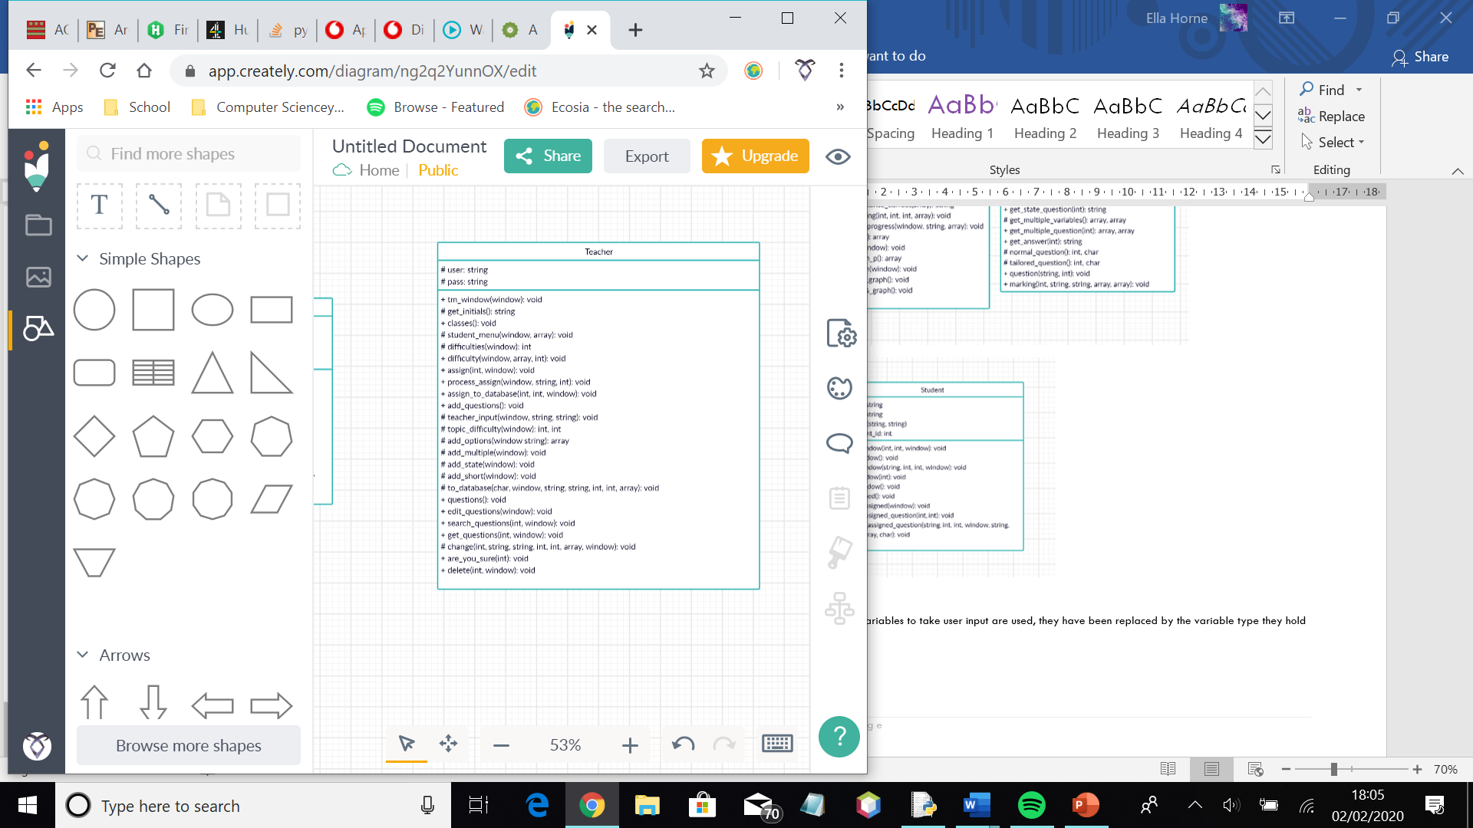

Figure 7d

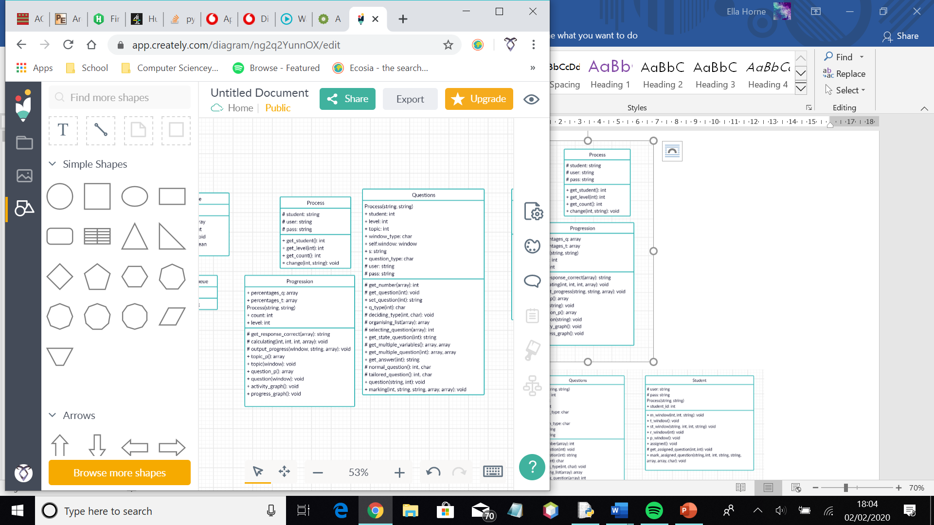

Figure 7e

Figure 7f

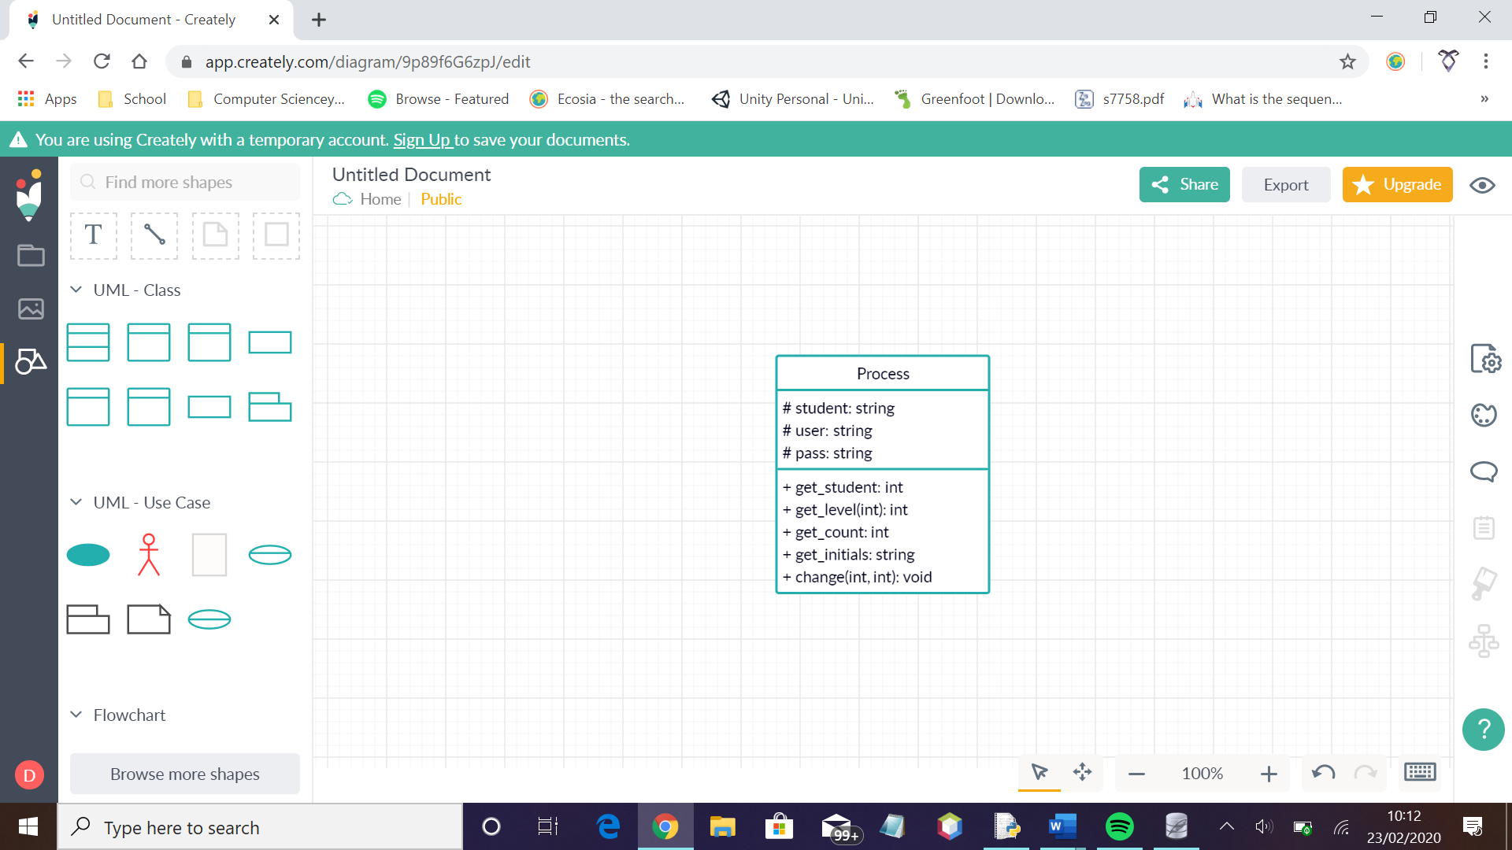

Here, I modified the process class to allow for teacher users as well. This class now has a method to access the teacher unique identifier.

Here, I added a method to help with the flow of the program, as well as generating tailored questions.

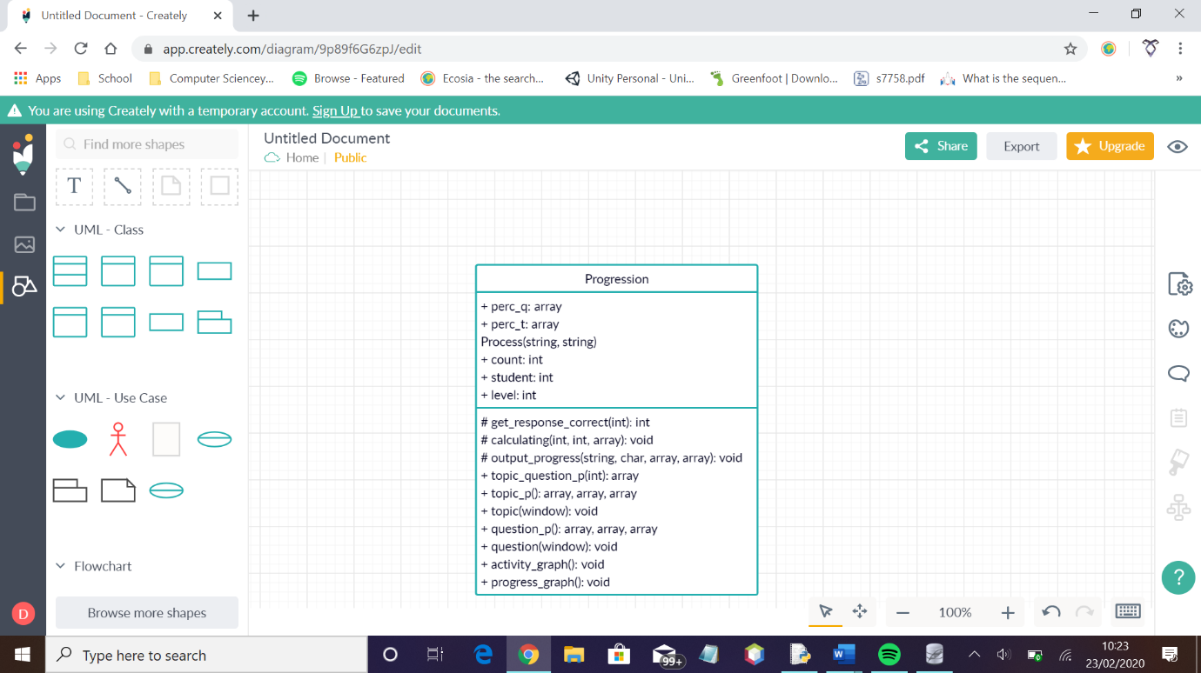

Figure 7g

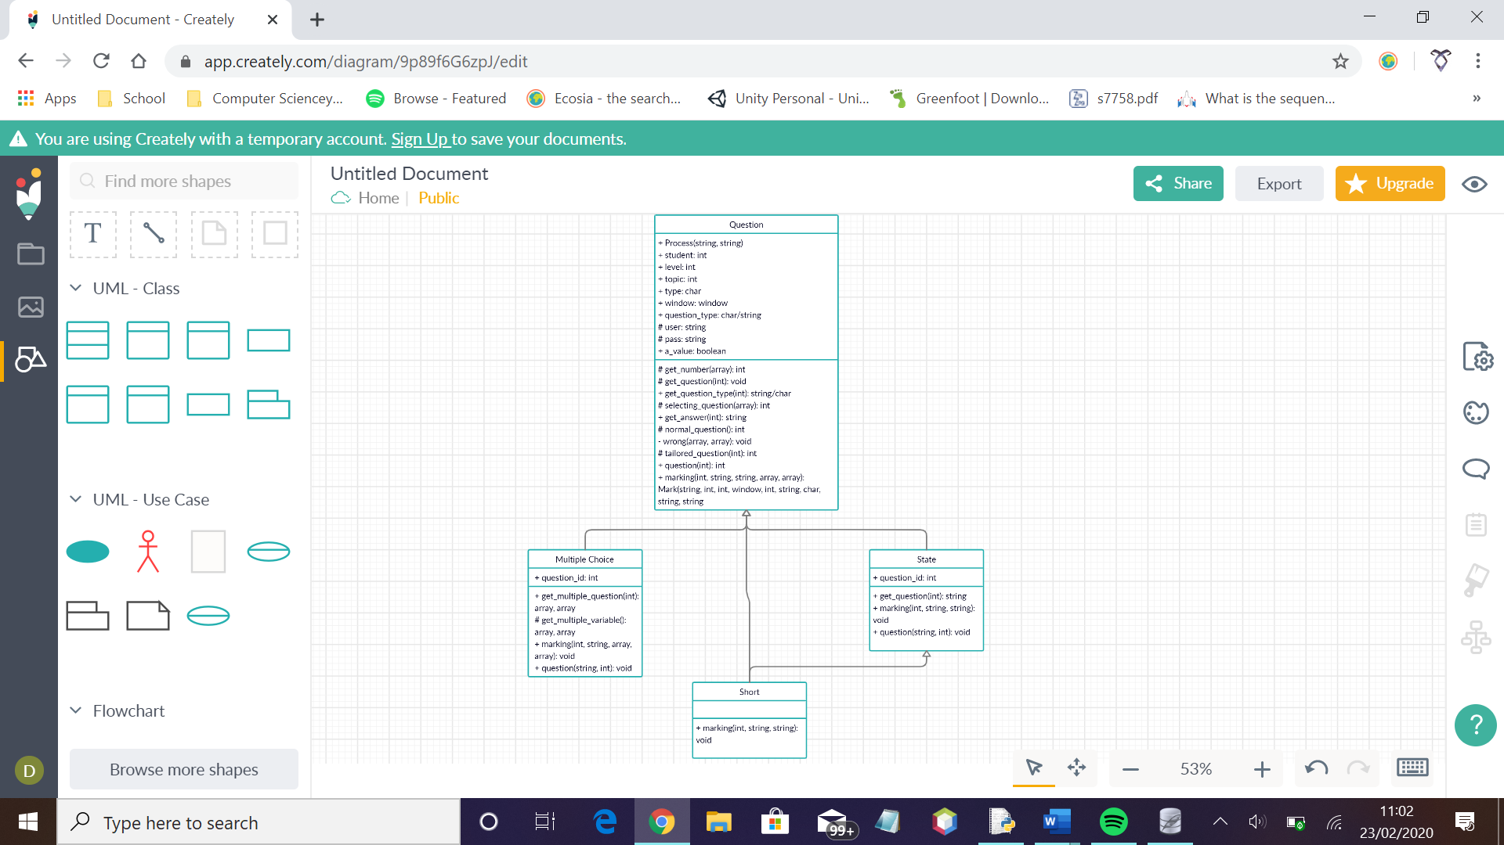

Figure 7h

Here, I modified my question class to include inheritance for the different question types.

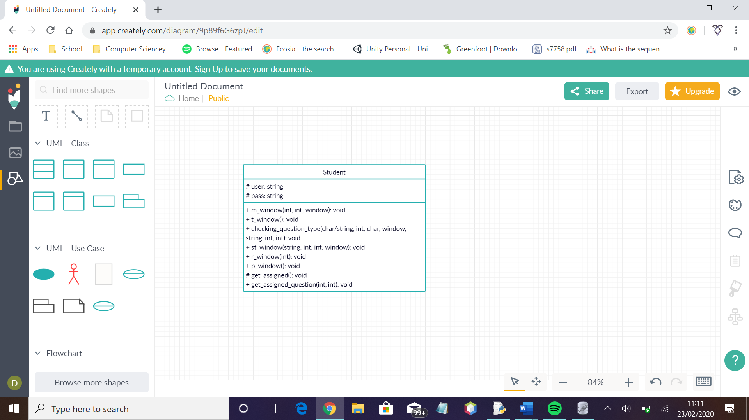

Figure 7i

Here, I added the checking_question_type method to handle the different inherited question classes.

## User Interface Design Rationale

Below is a sample of user interfaces from my project. They all use the same colour scheme and formatting, in order to keep the focus on the purpose of the program, being a quiz system.

Figure 8a

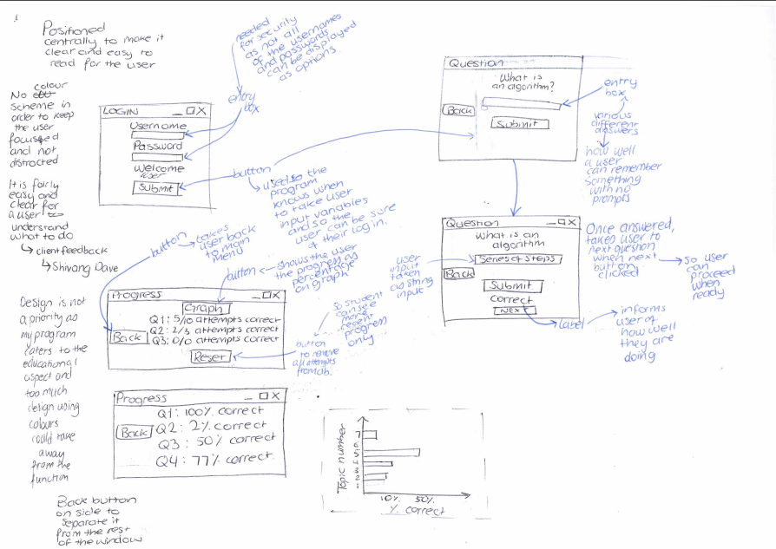

Here is the design for the log in menu. The program would take user input from the text boxes as strings, and use them to determine whether the information is correct by checking the relevant relation. The boxes are central to keep the user focused on them, and make them clear.

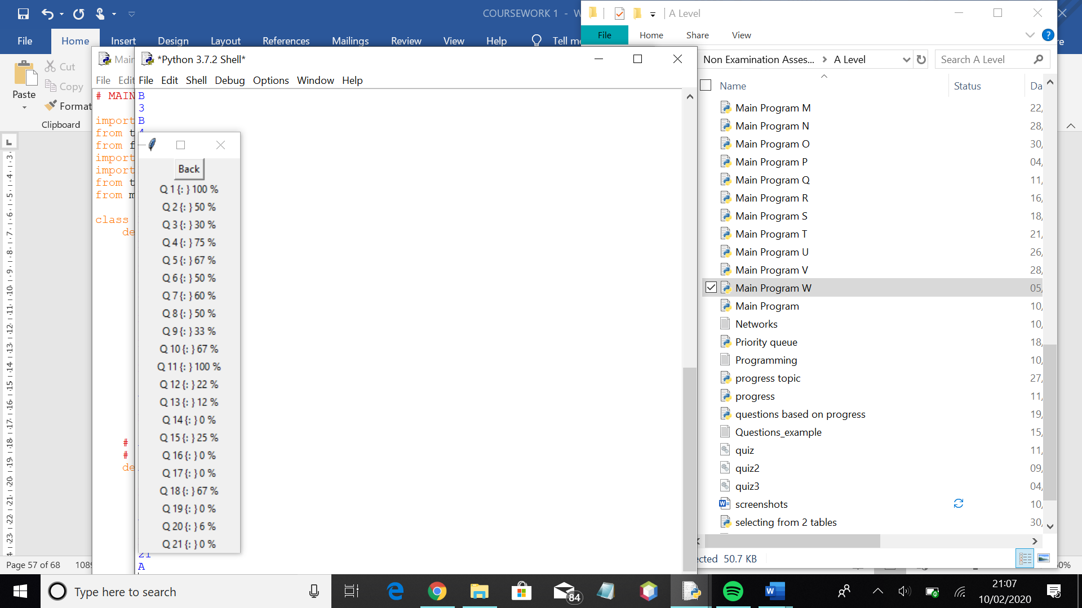

Figure 8c

Figure 8b



This is the initial design for the progress menu. The percentages show how many attempts at the question have been correct. In figure 8c, there is a version of this interface designed using tkinter.

This is an example of what the format of a question window will look like. It will start with the top window, then move on to the bottom window once the submit button has been used. The back button is to the left to keep it separate from the purpose of the window.



Figure 8d

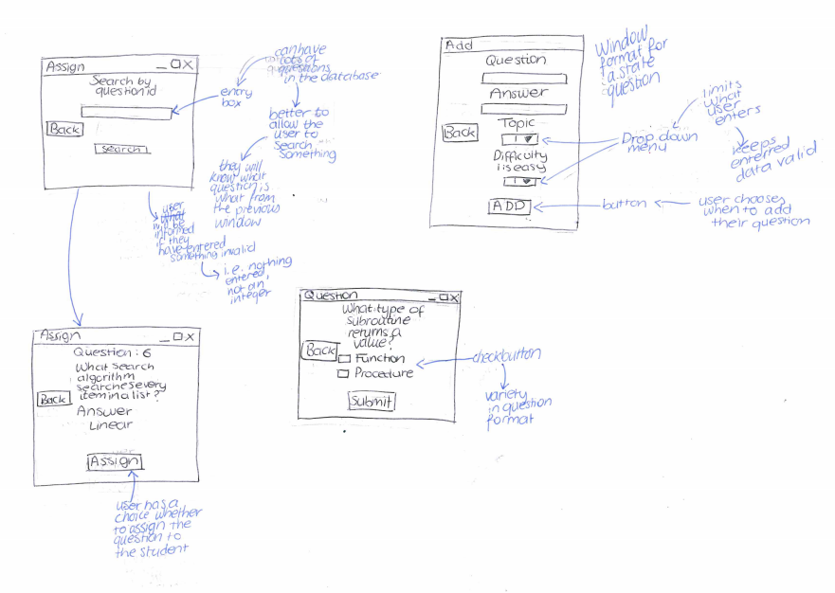

Figure 8e

This is how the teacher can search for questions when assigning them to students. The user can also search questions to edit if they are on that menu. The assign and search buttons are at the bottom to make sure it is the last thing the user does in the window – it makes sure they are not distracted when using the window.



Figure 8f

This is an example of a multiple choice question that the student might answer. It uses checkbuttons rather than radiobuttons as it is easier for a user to use – radiobuttons cannot be deselected while checkbuttons can.



Figure 8g

This is an example of the interface for a teacher adding a question to the database. The required fields for a state question are the question, answer, topic number ad difficulty level. A multiple-choice question would require the options to be displayed to the user, and a short answer question would require the marking points to be filled.

## Client communication

During the project, I continued going to my client for feedback on the system design and what they though of how the system worked. This helped to better the system and make it more suited to both the clients and the target market

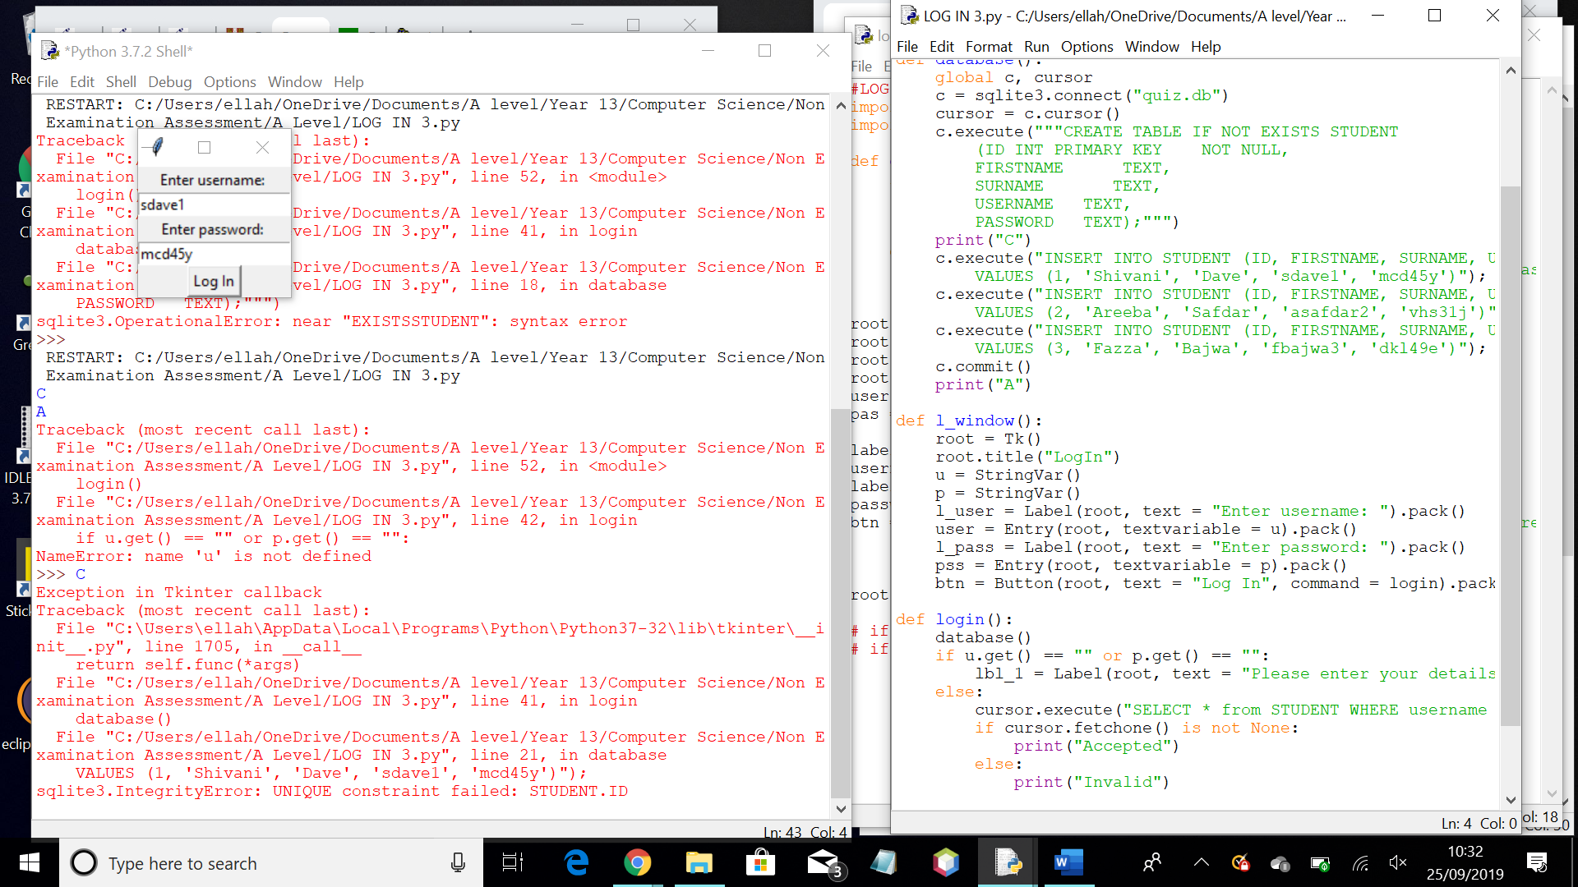Original log in page

Client feedback – the password could be hidden for security purposes. There could be an option to register an account

New log in page

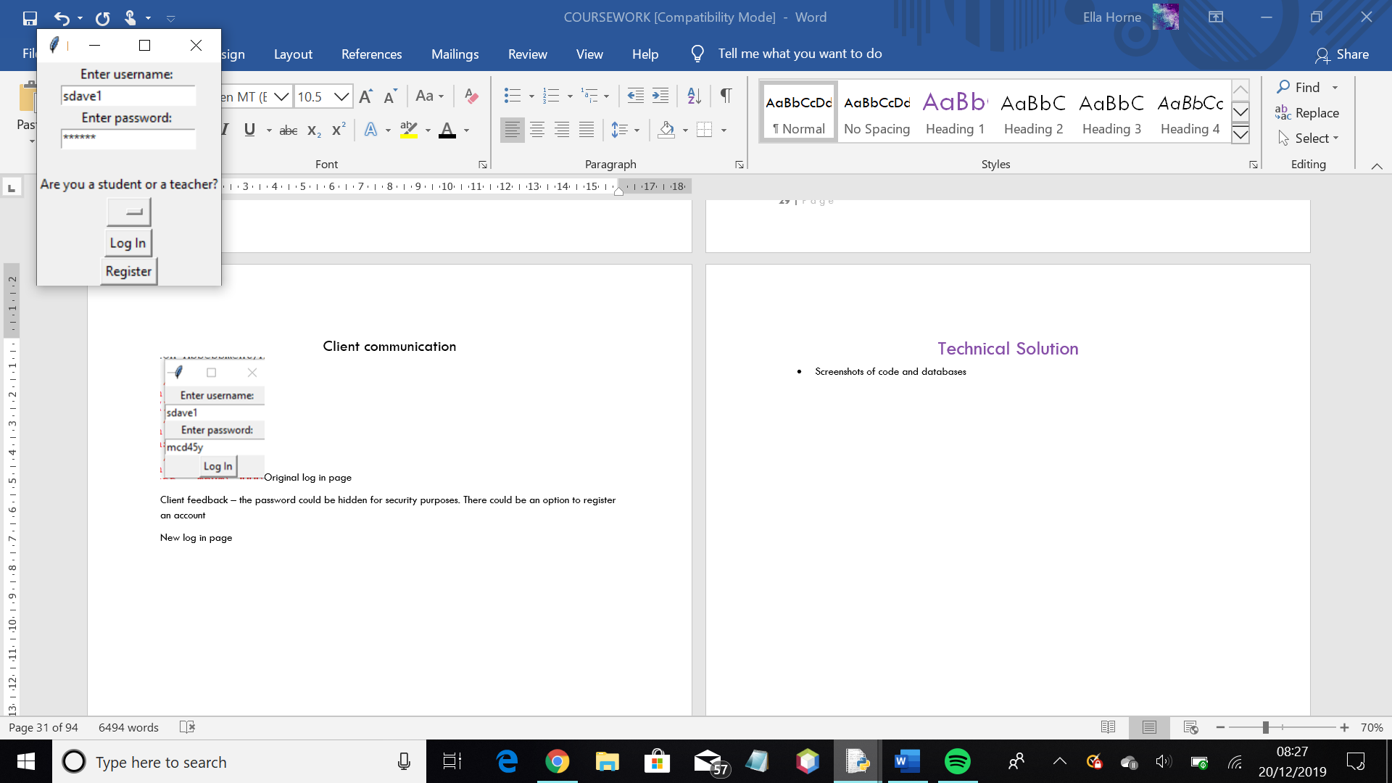

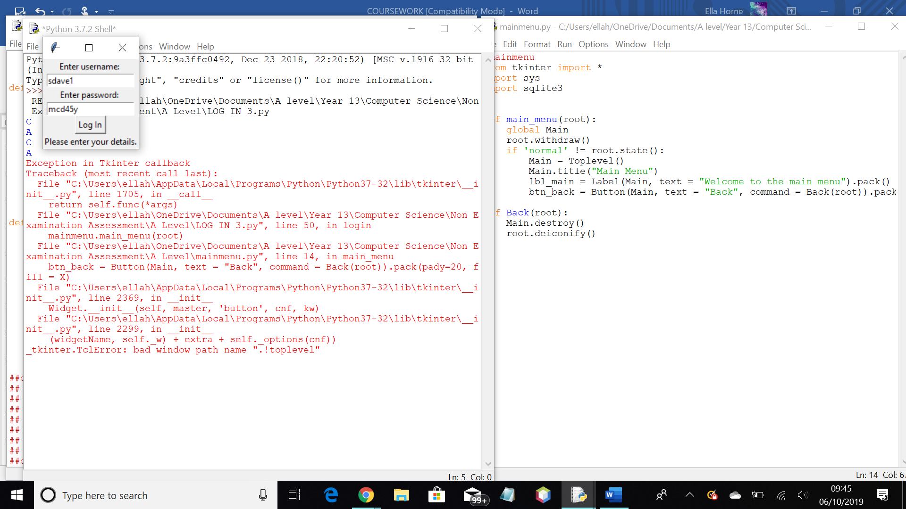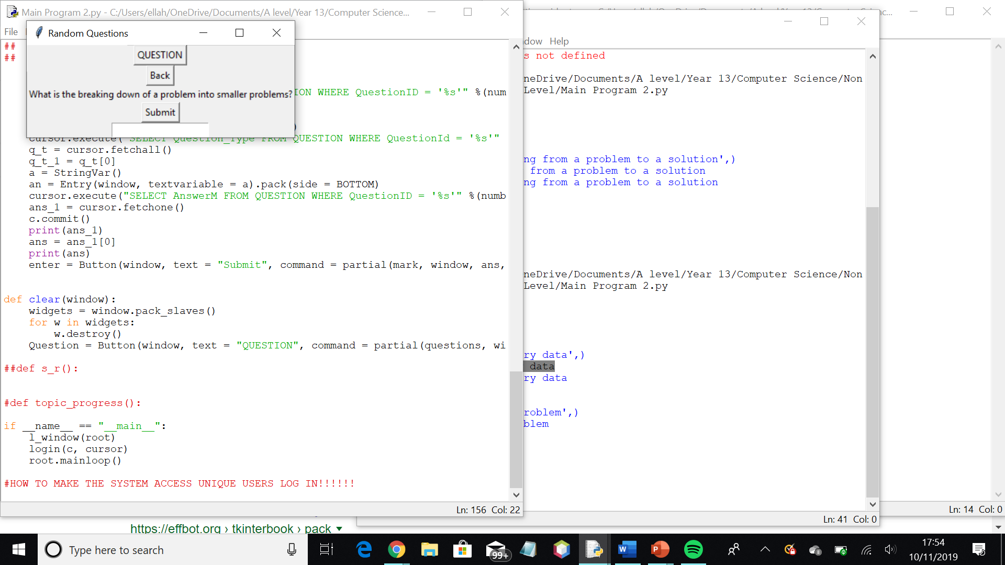

Client feedback – the window sizes are quite small and vary a lot. It would be nice to have them as set sizes and constant. It would also be nice having them bigger so that they are easier to look at

New window sizes – 300x300 or 100x100

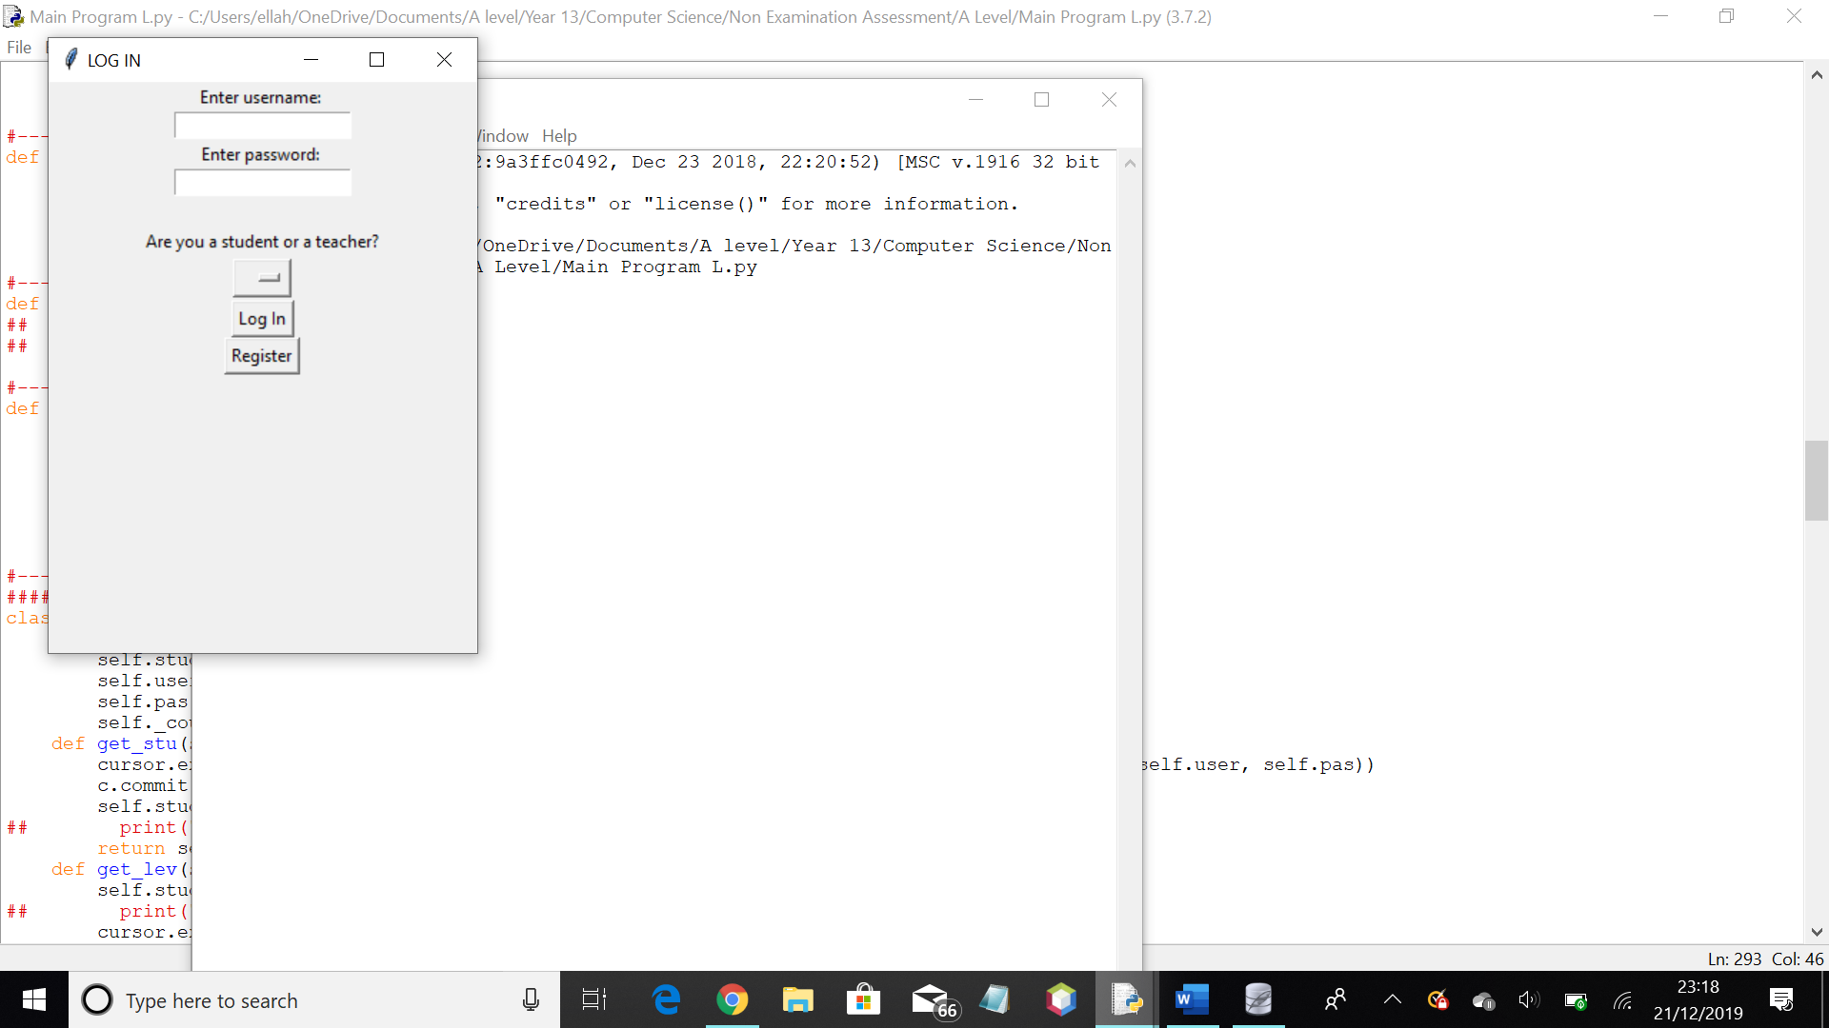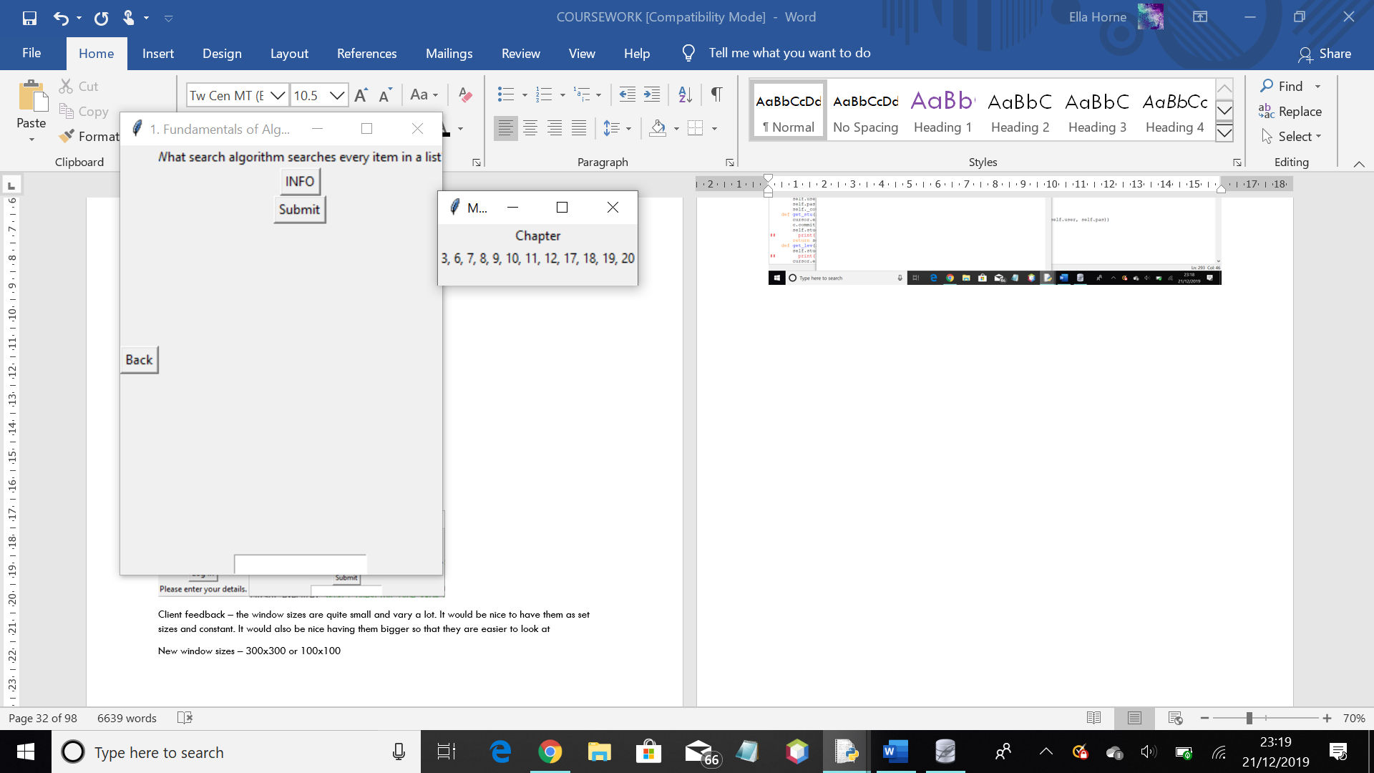New window sizes

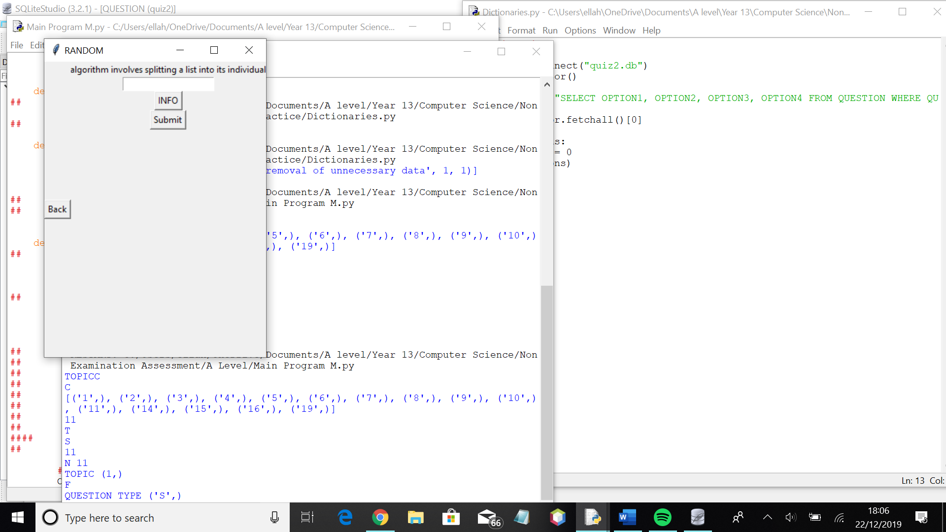 Need to make it wider than it is long

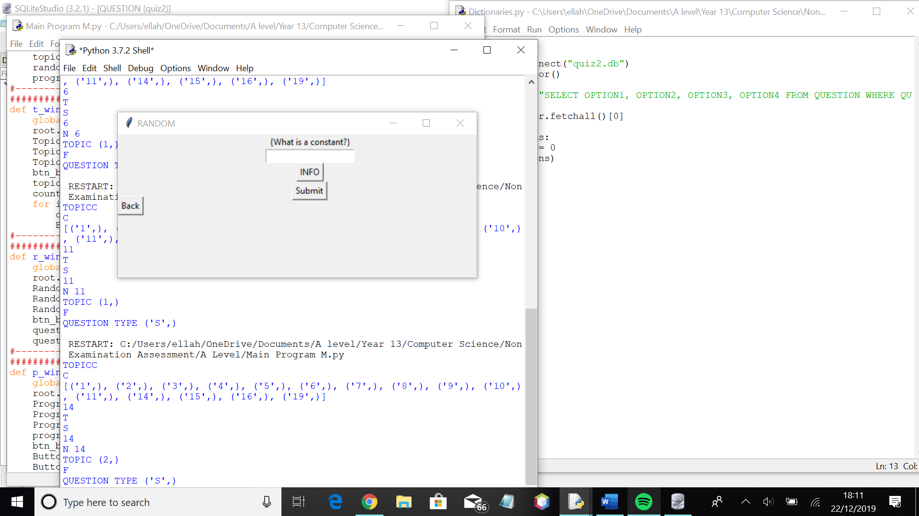Agreed with clients that this is a better window size

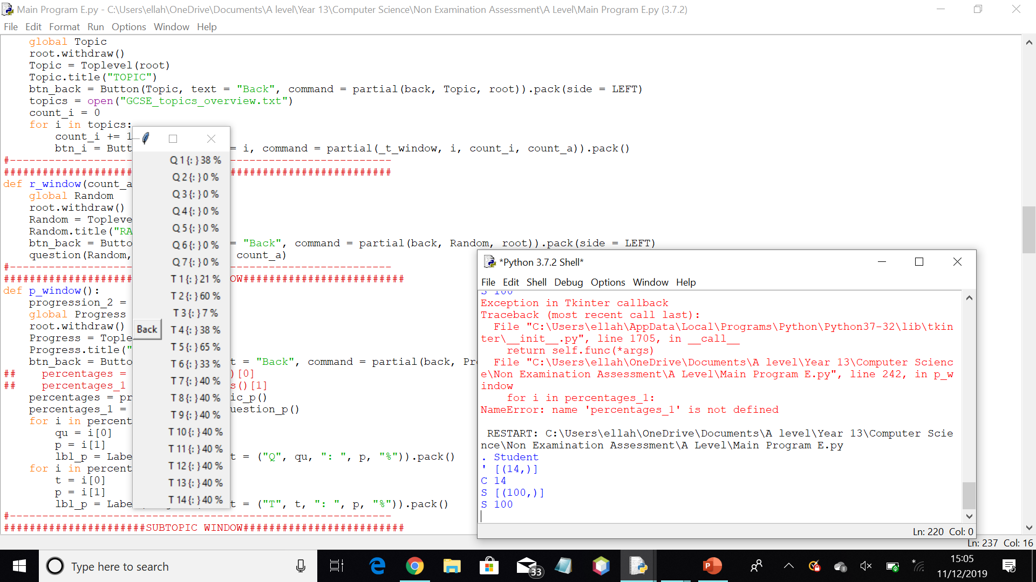Client feedback; This window could be better designed. It isn’t very clear and looks quite messy. Also, there isn’t much point in showing the questions when you don’t know what the question is just by looking at it

Response

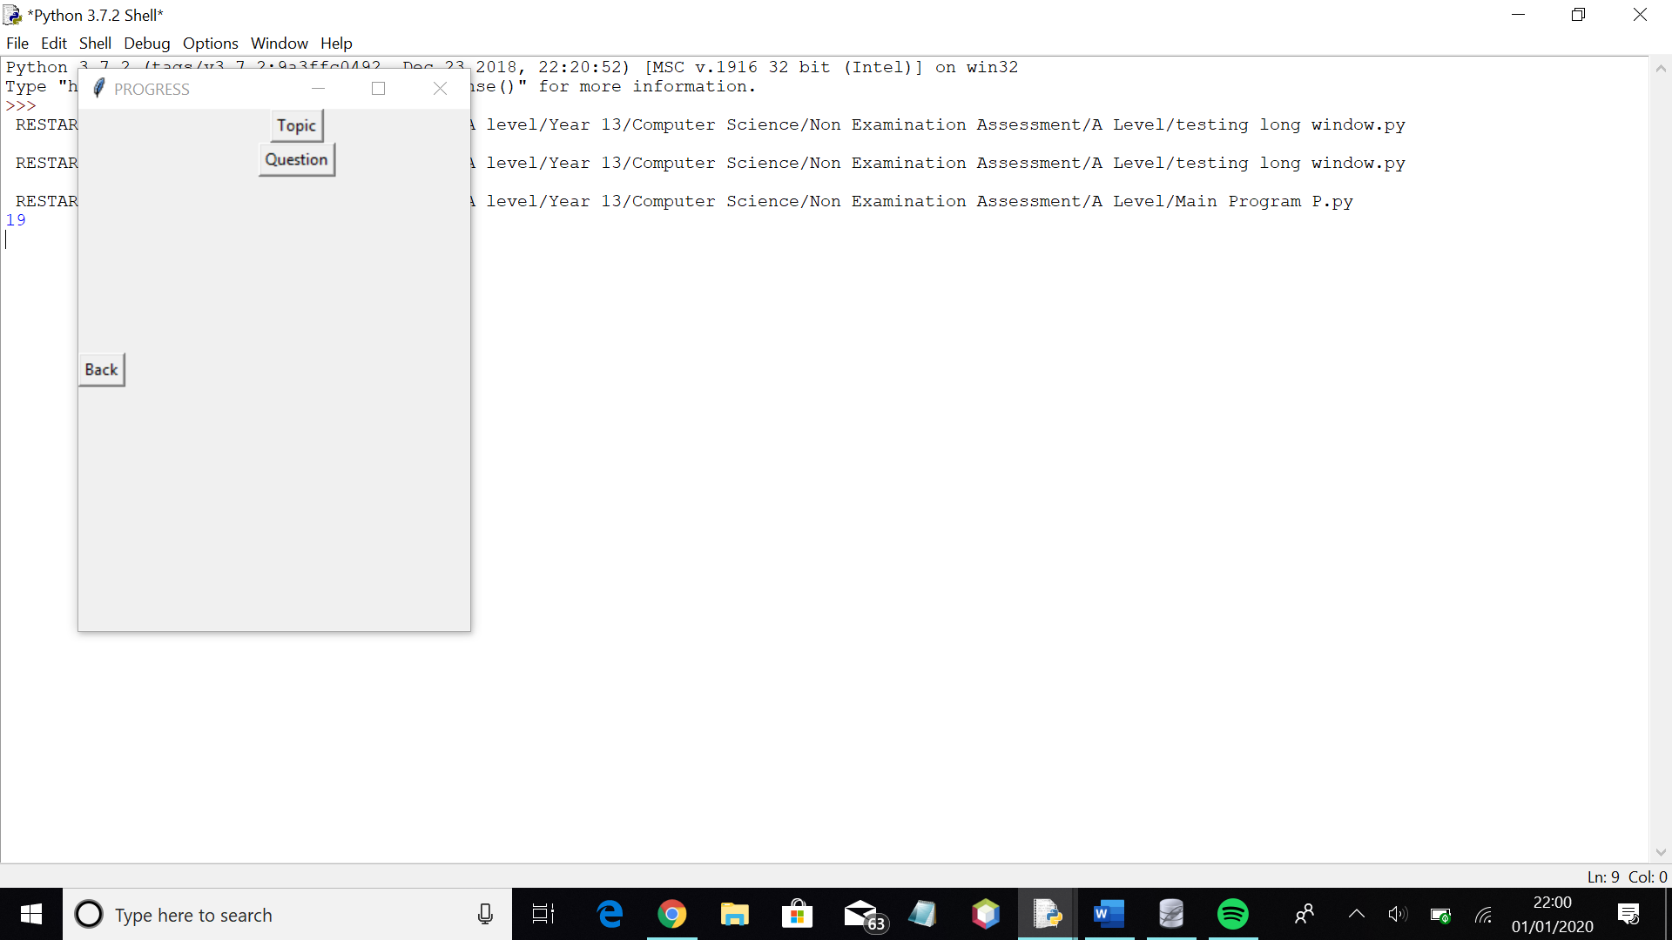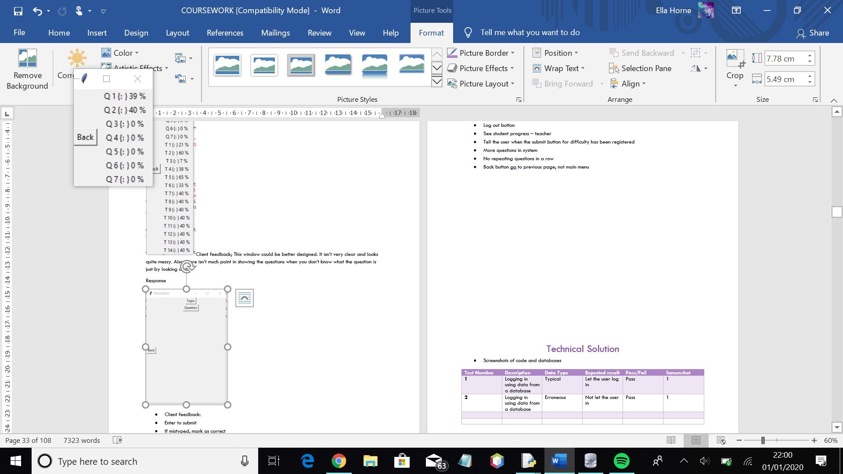Client – much easier to read and much clearer. Easier to understand, especially when you are familiar with the topics of the specification

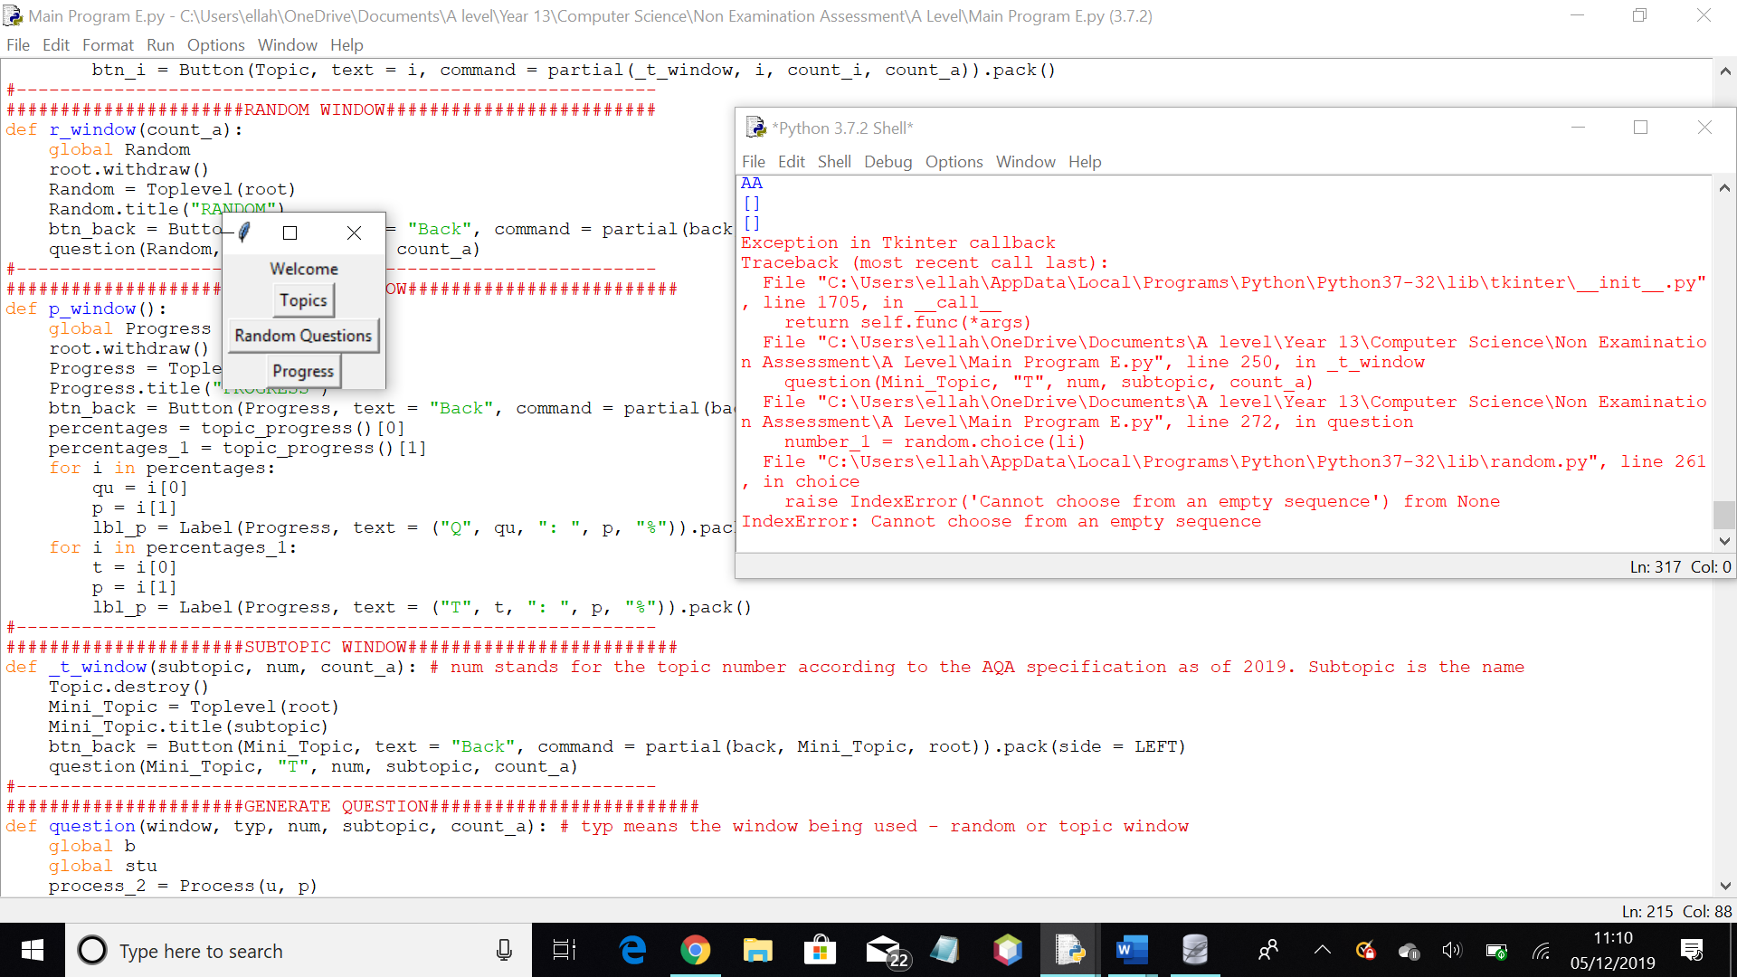Client feedback; have a log out button for ease of use, in case someone else wants to use the program straight after you, for example. I like the random question button, it forces you to answer questions and work out what areas of the syllabus you aren’t sure in

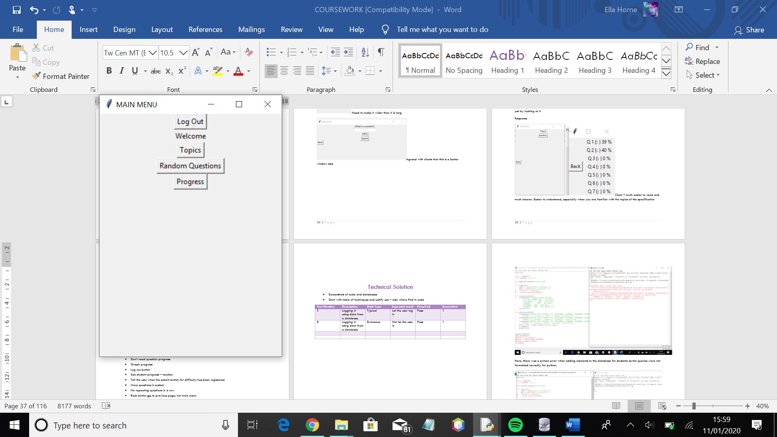Implemented the log out button to allow the user to return to the log in menu

* Client feedback:
* Enter to submit
* If mistyped, mark as correct
* Say password twice when registering
* Likes the random question button
* Don’t need question progress
* Graph progress
* See student progress – teacher
* Tell the user when the submit button for difficulty has been registered
* More questions in system
* No repeating questions in a row
* Back button go to previous page, not main menu
* State questions can be phrased in a sentence

# Technical Solution

* Start with table of techniques and justify use – also where find in code
* Copy and paste code

|  |  |
| --- | --- |
| Technique used | Explanation |
| Complex sql statements – aggregate | Used to easily fetch relevant data from relations, such as the number of elements in a relation or the maximum value of an integer attribute |
| Complex sql statements – calling from multiple tables | Used to easily fetch the needed data, for example, when finding what questions the user has answered from the question relation, and are present in the answered relation |
| Classes | Used to help with method organisation, and to help with ease of use, as using classes makes it easier to make the program have routes between windows |
| Class inheritance - queues | Means there are two types of queue – normal, and priority – mostly helps with organisation |
| Graph plotting and calculations – progress calculations | Involves various calculations and logical applications |
| File handling | Used to display topics and information for user |

Could split up questions class to have different types of question - inherit

# Testing

|  |  |  |  |  |  |
| --- | --- | --- | --- | --- | --- |
| Test No. | Description | Data Type | Expected | Actual | Correcting/Comments |
| 1 | Logging in | Typical: All fields filled in correctly | Allow user to log in | As expected |  |
| Erroneous: Incorrect username or password | Informs user they have an incorrect username or password | As expected |  |
| Erroneous: Incorrect user status entered | Informs user they have an incorrect username or password | As expected |  |
| Extreme: User not in database | User informed have incorrect username/password | As expected |  |
| Extreme: A field not completed | Informed of incorrect username/password | User not allowed to proceed |  |
| 2 | Answering a question | Typical: Correct answer entered | User informed they are correct |  |  |
| Erroneous: Incorrect answer | Tell user they are incorrect |  |  |
| Erroneous: Blank field | User informed they are incorrect |  |  |
| 3 | Registering | Typical: All fields filled with correct data type | Process data and return user to log in page |  |  |
| Erroneous: Incorrect data types |  |  |  |
| Extreme: empty fields | Inform the user they have missed some fields and remain on page |  |  |
| 4 | Loading questions of correct difficulty | Typical: random question found from database | Load question of correct difficulty for student |  |  |
| Extreme: no existing questions in the database | Inform the user there are no questions in that topic for their difficulty |  |  |
| 5 | Loading tailored questions based on progress | Typical: questions have been answered | Loads the question that has the lowest percentage for time answered correctly |  |  |
| Erroneous: all percentages 100%/above threshold | Generate a random question instead |  |  |
| Extreme: No questions answered | Loads a random question for user to answer |
| 6 | Generating graph based on activity | Typical: user has had an account and has used it for a while | Process previous activity and plot on graph |  |  |
| Extreme: user just made account and therefore has no activity | A blank graph is displayed |  |  |
| 7 | Generating percentages | Typical: User has previously answered questions in the system on their account | Percentage worked out |  |  |
| Extreme: User has not answered any questions | Returns 0% |  |  |
| 8 | Generating graph based on percentages for each topic | Typical: questions have been answered | Percentages plotted  Nothing plotted on |  |  |
| Extreme: no questions have been answered | the graph |  |  |
| 9 | Answering assigned questions by teacher | Typical: | Question marked, user allowed to go back to main menu |  |  |
| Erroneous |  |  |  |
| 10 | Adding questions to the database | Typical: user enters correct data into all fields | Question appended to database |  |  |
| Erroneous: user enters incorrect data type | User informed of the error with their input |  |  |
| Extreme: nothing entered | User informed of their error |  |  |
| 11 | Editing questions in the database | Typical: correct data types entered into all fields | Changes made |  |  |
| Erroneous: incorrect data type in fields | User informed of error |  |  |
| Extreme: no data added | No changes made |  |  |
| 12 | Deleting questions from the database | Typical: user tries to delete | Question deleted |  |  |
| 13 | Changing student difficulty | Typical: user changes difficulty | Difficulty for student changed |  |  |
| Extreme: no change made | No changes made |  |  |
| 14 | Assigning question to student | Typical: user assigns a new question to a student | Question assigned to student |  |  |
| Extreme: question already assigned | User informed that the question is already assigned |  |  |
| 15 | Searching for existing questions | Typical: question exists in database relation | Question found |  |  |
| Erroneous: user enters data type that isn’t an integer | Incorrect datatype processed and user is informed |  |  |
| Erroneous: user enters a question id that doesn’t exist | User informed the question doesn’t exist |  |  |
| Extreme: nothing entered | User informed nothing is entered |  |  |

|  |  |  |  |  |  |
| --- | --- | --- | --- | --- | --- |
| Test No. | Description | Data Type | Expected | Actual | Correcting/Comments |
| 1 | Logging in | Typical: All fields filled in correctly | Allow user to log in | As expected |  |
| Erroneous: Incorrect username or password | Informs user they have an incorrect username or password | As expected |  |
| Erroneous: Incorrect user status entered | Informs user they have an incorrect username or password | As expected |  |
| Extreme: User not in database | User informed have incorrect username/password | As expected |  |
| Extreme: A field not completed | Informed of incorrect username/password | User not allowed to proceed |  |
| 2 | Answering a question | Typical: Correct answer entered | User informed they are correct |  |  |
| Erroneous: Incorrect answer | Tell user they are incorrect |  |  |
| Erroneous: Blank field | User informed they are incorrect |  |  |
| 3 | Registering | Typical: All fields filled with correct data type | Process data and return user to log in page |  |  |
| Erroneous: Incorrect data types |  |  |  |
| Extreme: empty fields | Inform the user they have missed some fields and remain on page |  |  |
| 4 | Loading questions of correct difficulty | Typical: random question found from database | Load question of correct difficulty for student |  |  |
| Extreme: no existing questions in the database | Inform the user there are no questions in that topic for their difficulty |  |  |
| 5 | Loading tailored questions based on progress | Typical: questions have been answered | Loads the question that has the lowest percentage for time answered correctly |  |  |
| Erroneous: all percentages 100%/above threshold | Generate a random question instead |  |  |
| Extreme: No questions answered | Loads a random question for user to answer |
| 6 | Generating graph based on activity | Typical: user has had an account and has used it for a while | Process previous activity and plot on graph |  |  |
| Extreme: user just made account and therefore has no activity | A blank graph is displayed |  |  |
| 7 | Generating percentages | Typical: User has previously answered questions in the system on their account | Percentage worked out |  |  |
| Extreme: User has not answered any questions | Returns 0% |  |  |
| 8 | Generating graph based on percentages for each topic | Typical: questions have been answered | Percentages plotted  Nothing plotted on |  |  |
| Extreme: no questions have been answered | the graph |  |  |
| 9 | Answering assigned questions by teacher | Typical: | Question marked, user allowed to go back to main menu |  |  |
| Erroneous |  |  |  |
| 10 | Adding questions to the database | Typical: user enters correct data into all fields | Question appended to database |  |  |
| Erroneous: user enters incorrect data type | User informed of the error with their input |  |  |
| Extreme: nothing entered | User informed of their error |  |  |
| 11 | Editing questions in the database | Typical: correct data types entered into all fields | Changes made |  |  |
| Erroneous: incorrect data type in fields | User informed of error |  |  |
| Extreme: no data added | No changes made |  |  |
| 12 | Deleting questions from the database | Typical: user tries to delete | Question deleted |  |  |
| 13 | Changing student difficulty | Typical: user changes difficulty | Difficulty for student changed |  |  |
| Extreme: no change made | No changes made |  |  |
| 14 | Assigning question to student | Typical: user assigns a new question to a student | Question assigned to student |  |  |
| Extreme: question already assigned | User informed that the question is already assigned |  |  |
| 15 | Searching for existing questions | Typical: question exists in database relation | Question found |  |  |
| Erroneous: user enters data type that isn’t an integer | Incorrect datatype processed and user is informed |  |  |
| Erroneous: user enters a question id that doesn’t exist | User informed the question doesn’t exist |  |  |
| Extreme: nothing entered | User informed nothing is entered |  |  |

Erroneous is wrong – would include blanks

Extreme is boundary

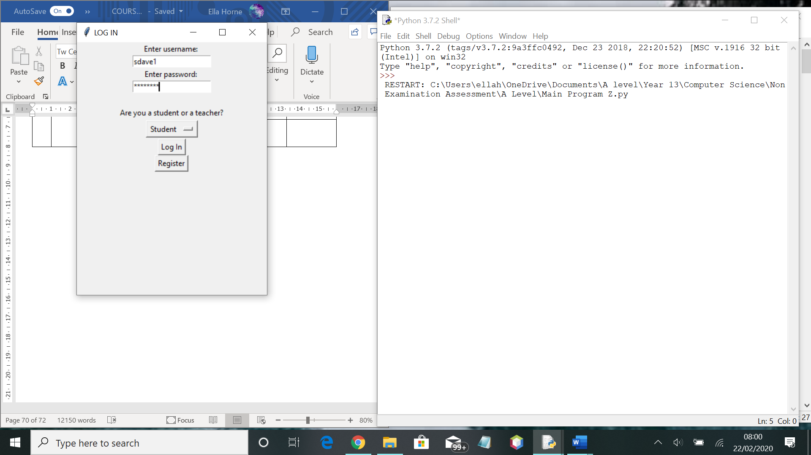

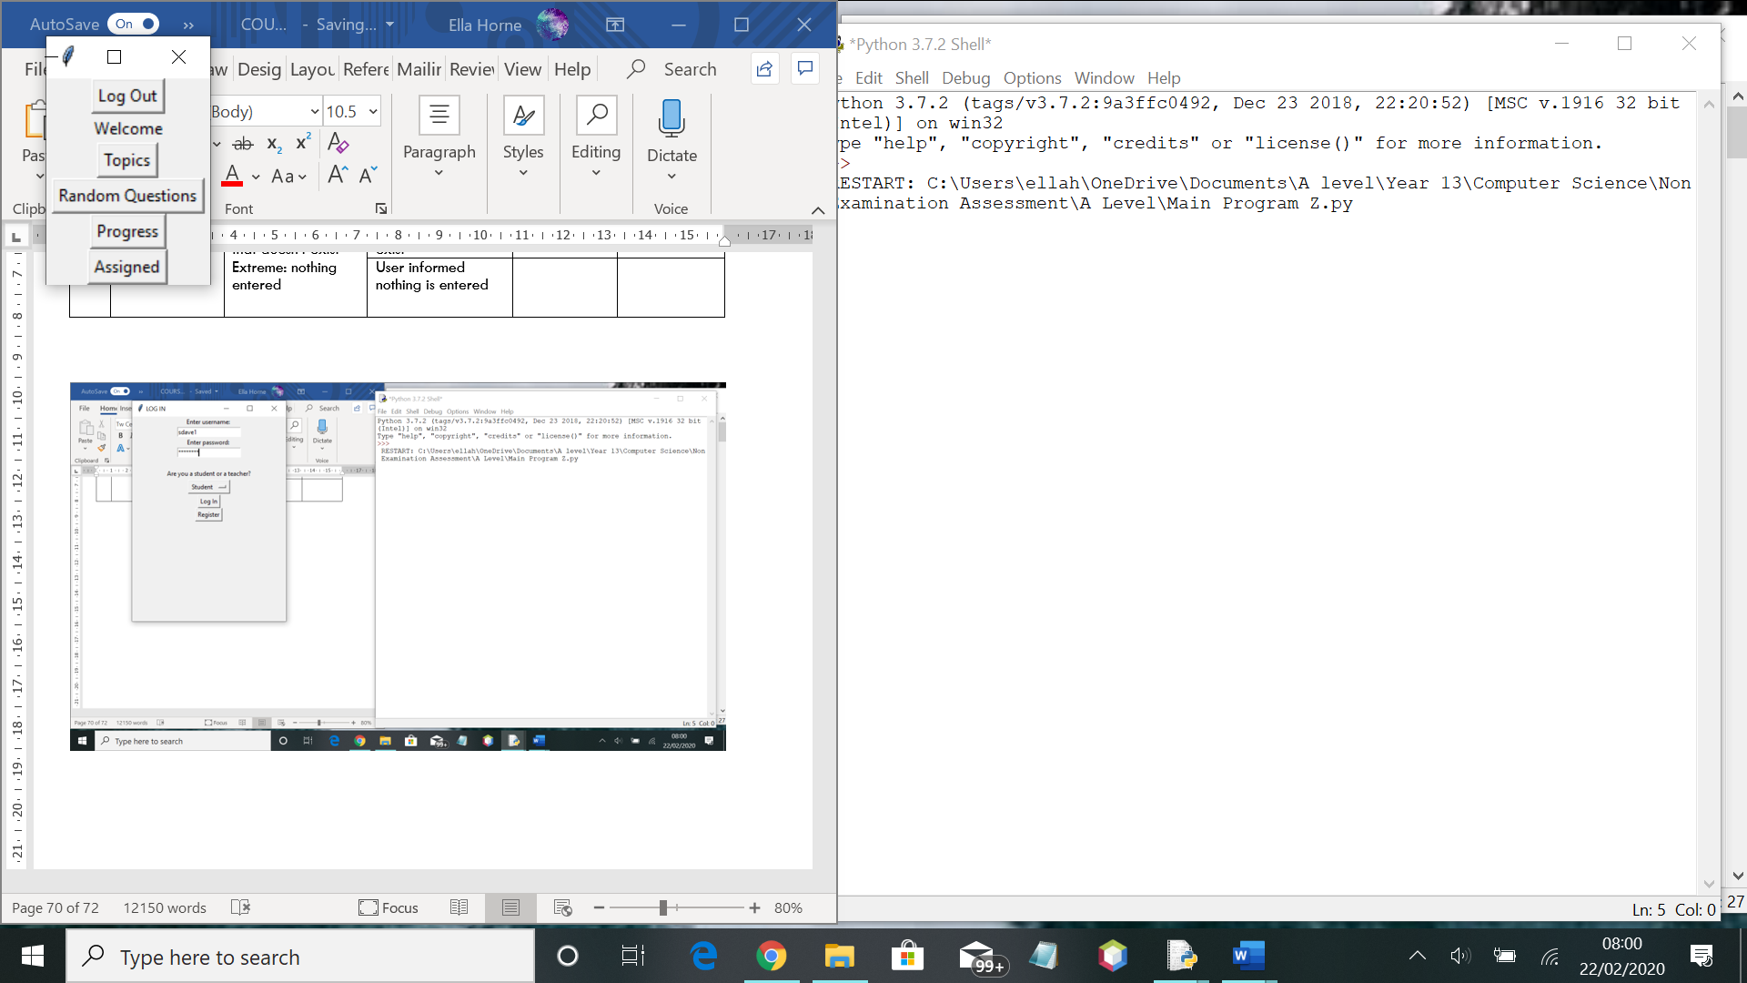

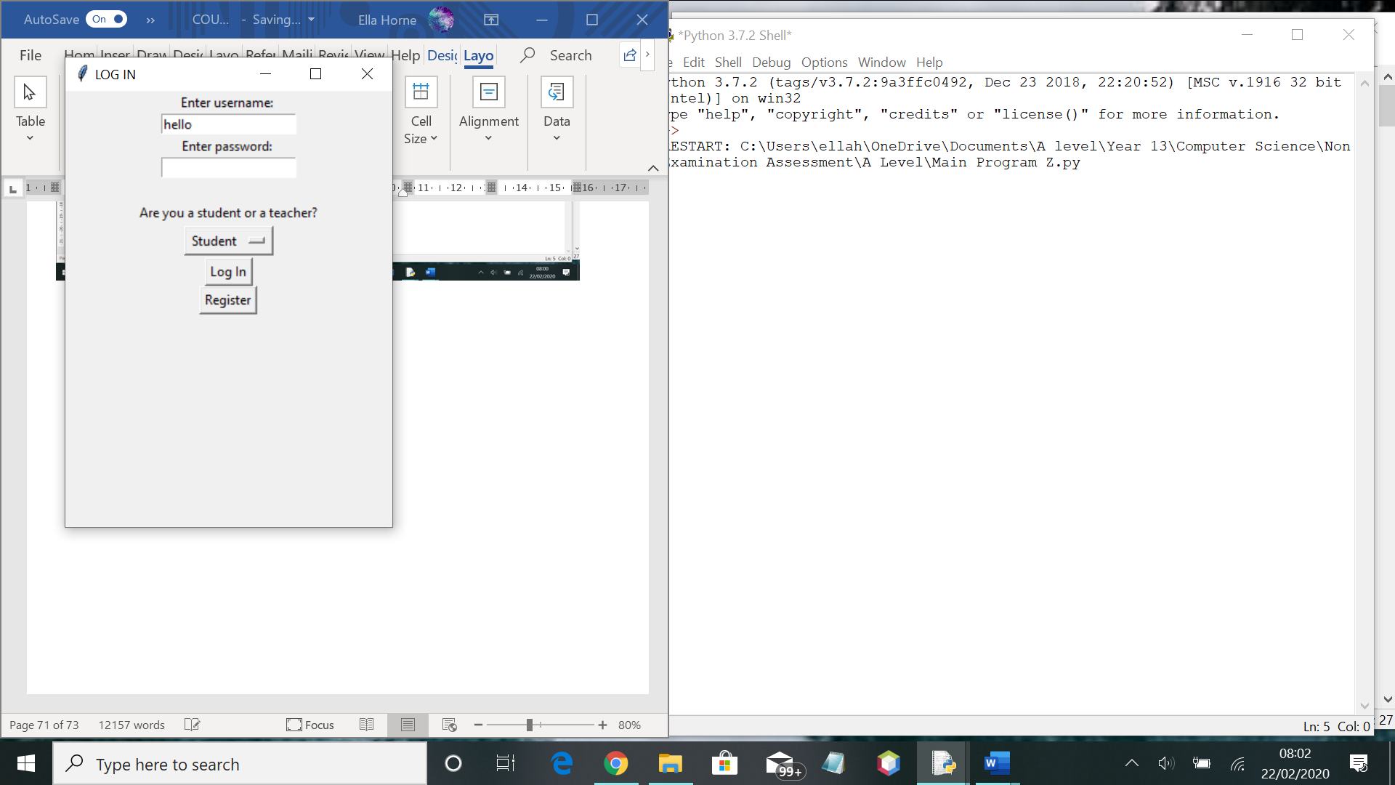

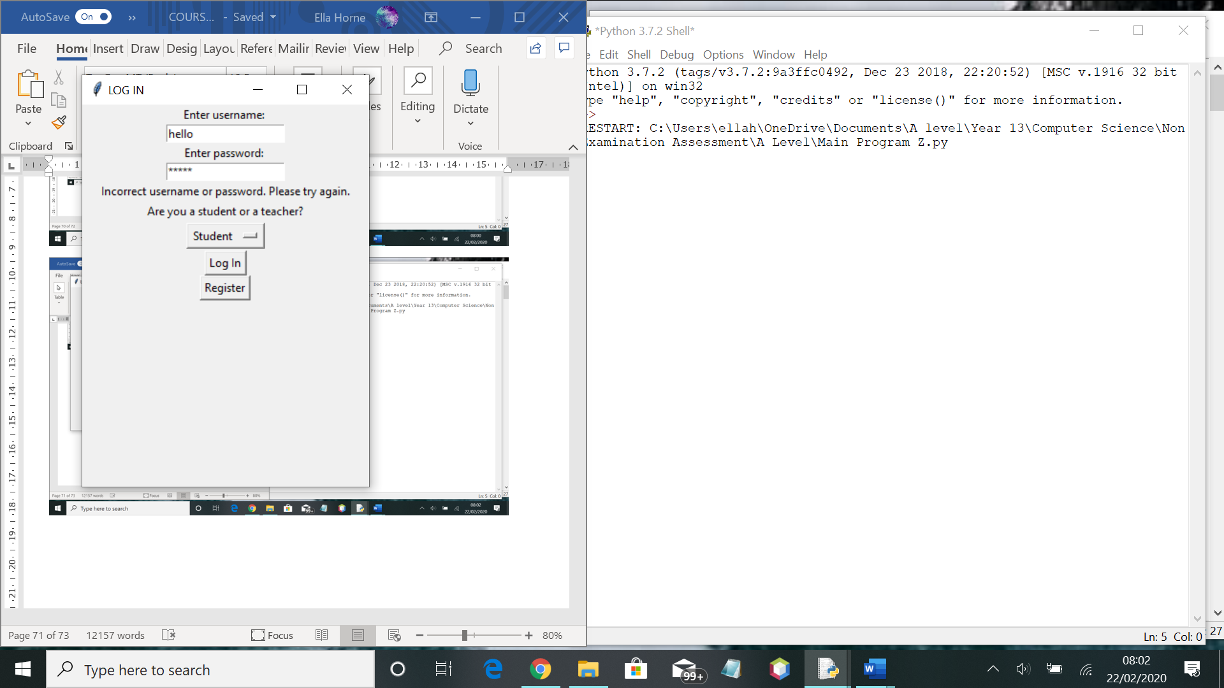

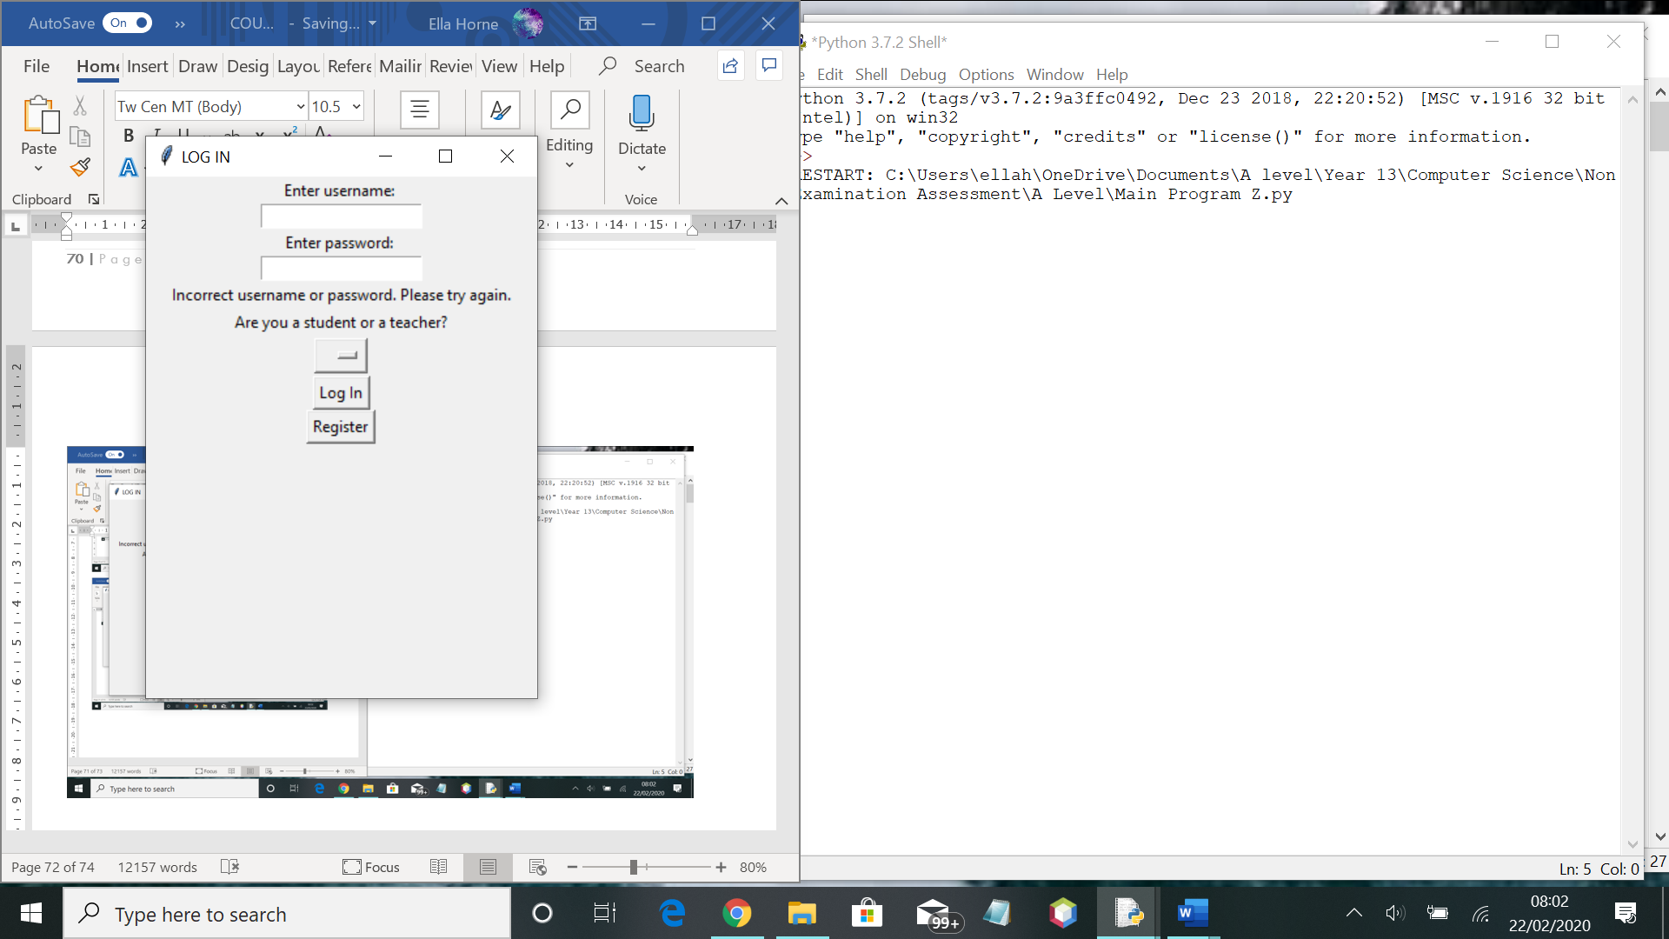

# Evaluation

Improving

* Delete progress from early on
* Get varying amount of marks for questions
* Notes
* Analyse whole sentences – current algorithm requires all of marking points in order to get mark. Would like to develop system so a mark is given per marking point – and develop it so there are technically multiple choice questions but none are shown to user – relation just holds the options
* Let user’s edit their details/classes
* Inheritance of process class
* Be able to add topic numbers and remove them in order to help with future changing spec
* Inheritance of question class

# References

<https://creately.com/lp/er-diagram-tool-online/>– used to create diagrams – ERD

TeachYourselfPython – used to aid with tkinter coding

Sourcecodester – used to work out changing between tkinter windows

Stackoverflow – to see if any errors I came across were solved by anyone else

<https://www.simplifiedpython.net/python-gui-login/> - to assist with creating a registration page

<http://effbot.org/tkinterbook/checkbutton.htm> - to assist with using checkbutton

<https://www.geeksforgeeks.org/python-dictionary/> - used GeeksforGeeks a lot to help with different coding concepts

<https://www.geeksforgeeks.org/priority-queue-in-python/> - priority queue

<https://www.programiz.com/python-programming/methods/dictionary/update>

<https://www.pythonforbeginners.com/dictionary/how-to-use-dictionaries-in-python/>

<https://online.visual-paradigm.com/app/diagrams/#proj=0&type=OrganizationChart>

<http://effbot.org/tkinterbook/scrollbar.htm>

<https://www.tutorialspoint.com/python/tk_scrollbar.htm>

<https://stackoverflow.com/questions/16188420/tkinter-scrollbar-for-frame>

<https://www.geeksforgeeks.org/python-program-for-merge-sort/>

<http://www.datasciencemadesimple.com/bar-plot-bar-chart-in-python-legend-using-matplotlib/>

<https://www.geeksforgeeks.org/python-matplotlib-pyplot-ticks/>

<https://python-tricks.com/scrollbar-in-tkinter/>

<https://www.tutorialspoint.com/python/tk_listbox.htm>

<https://stackoverflow.com/questions/58255950/bad-window-path-name-toplevel>

<https://stackoverflow.com/questions/20125967/how-to-set-default-text-for-a-tkinter-entry-widget>